Water supply and the settlement of rural and regional South Australia

Background
South Australian settlement and agricultural development took place against a background of a scarce and unreliable supply of fresh water. Apart from the central Mount Lofty Ranges and the South East, the State has low rainfall, and few rivers arise within its borders. The River Murray flows into the State and to the ocean but its catchments are almost entirely in the upstream States. Groundwater of suitable quality is generally confined to limited areas in the higher rainfall parts of the state.
From the earliest days of settlement finding a secure water supply was paramount. The location of Adelaide itself was in part determined by the access to water from the River Torrens. The early German settlers established their community and farms at Hahndorf in 1840 in part because water could be drawn from local creeks. The demand for water for towns and farms continued as settlement progressed. George Woodroofe Goyder, Surveyor-General from 1861 to 1894, who had a very significant influence on government policy in the latter 1800s, thought that the chief obstacle to the development of European settlement in South Australia was the lack of ‘sufficient and reliable’ rainfall. He believed that rainfall conservation was the only answer for a more reliable supply of water and that water conservation was a legitimate role of government.
This paper provides a short overview of the major surface water conservation initiatives in South Australia from the 1860s to the present day. These schemes underpinned the development of towns and industries in country South Australia, and also led to the expansion of livestock industries through the provision of stock drinking water to farms. Those water supply schemes that were predominately for metropolitan Adelaide water supply are excluded, as are the irrigation schemes, both government and private, along the River Murray. Most water conservation initiatives were Government funded, and constructed by the State Engineering Authority of the time. Small scale farm dam construction was privately initiated.
The Department of Agriculture had a key role in the development of the surface water resources, by providing economic information to support the expenditure of public funds for engineering works, in advocacy for regional development, in research and investigation for catchment management and for the design and overview of small scale engineering works including farm dams and catchment water harvesting.
The major water conservation initiatives since settlement that are relevant to agriculture and regional development (excluding groundwater extraction and desalination) have been (in chronological order of commencement):
- Farm dams (private construction)
- Stock water (bores, tanks, dams)
- River Murray towns and irrigation
- Beetaloo Scheme
- Bundaleer Scheme
- Barossa (Gawler) Scheme
- Pekina
- Yeldulknie Scheme (includes Ullabidinnie and Ulbana)
- Warren Scheme
- Moorook and Loxton country water supply schemes
- Tod River Scheme
- Baroota Scheme
- First Morgan-Whyalla pipeline
- Mannum - Adelaide pipeline
- Aroona Dam
- Tailem Bend – Keith pipeline
- Second Morgan – Whyalla pipeline
- Middle River Scheme
- Swan Reach – Stockwell pipeline
- Willunga Basin Scheme
- Virginia Pipeline Scheme
- Barossa Infrastructure Scheme
- Tailem Bend – Narrung Peninsula pipeline
- The Creeks pipeline.

Farm dams
Many farms in the agricultural zone and pastoral properties further north depend on water stored in dams to provide stock water. In the higher rainfall parts of the State, particularly in the Clare, Barossa and Mount Lofty Ranges areas, dams also provide for storage for irrigation.
From the 1970s until around 2010 the Department of Agriculture provided a service to landholders for catchment yield assessment and for advice on the siting and construction of farm dams. This service facilitated the development of irrigated vineyards in particular across these regions.
The Department also assisted in the design and construction of roaded catchments to increase water runoff and storage, although only a few such water conservation structures were constructed in South Australia.

Stock water -1860 to 1880s
The early agricultural development of the state was predominately for wheat rather than livestock, partly because the carrying of any number of livestock required a reliable drinking water supply, and droving stock to market also required reliable sources of water along the stock routes. Farm dams relied on local rainfall and reliable sources of surface water across South Australia were just not available. From the 1860s Goyder, as Surveyor-General, assisted farmers and pastoralists by establishing stock routes along which stock could be driven from farms or pastoral areas to markets. The government subsequently allocated funds for the construction of wells and reservoirs along roads and stock routes where groundwater was often the only source of water.
Construction of wells or bores was recognized as being necessary even during the earliest exploration and survey of the Far North. For example Goyder’s team in his 1859-60 trigonometrical survey of the land south of Lake Eyre included experienced well sinkers but only salt water was found, as reported by The Register on 20 December 1860: “The Far North.- Mr. Goyder, the Surveyor-General, returned from the neighborhood of Chambers Creek on the 17th instant….we learn that the well-sinkers have completed four wells, all of which contain salt water, and that the party has consequently been broken up, all hopes having been abandoned of obtaining fresh water from Glen's to the Muntowadon”.
So important was water for the pastoral industry (and perhaps reflecting the political influence of the industry at the time) that in 1881 the government budgeted $500,000 to develop water resources, including the purchase of diamond drilling equipment from America (once again, by Goyder). The general policy was to provide a water supply at 20 mile intervals along major stock routes, and other places both within and outside Hundreds. In 1888 Parliament was advised there were 130 reservoirs, 24 tanks, 62 wells, 22 well borings, 150 station dams resumed, 21 tanks repaired, and 125 wells improved; and by early 1900s there were over 500 water conservation works, including the West Coast, with drilling for artesian water at many remote locations including mines (source: Parliamentary Reports). The actual level of effort was even greater, as more than half of the bores and wells dug might have failed, and are not included in these numbers. On farms and pastoral properties private water storages, dams, wells and tanks also provided water.
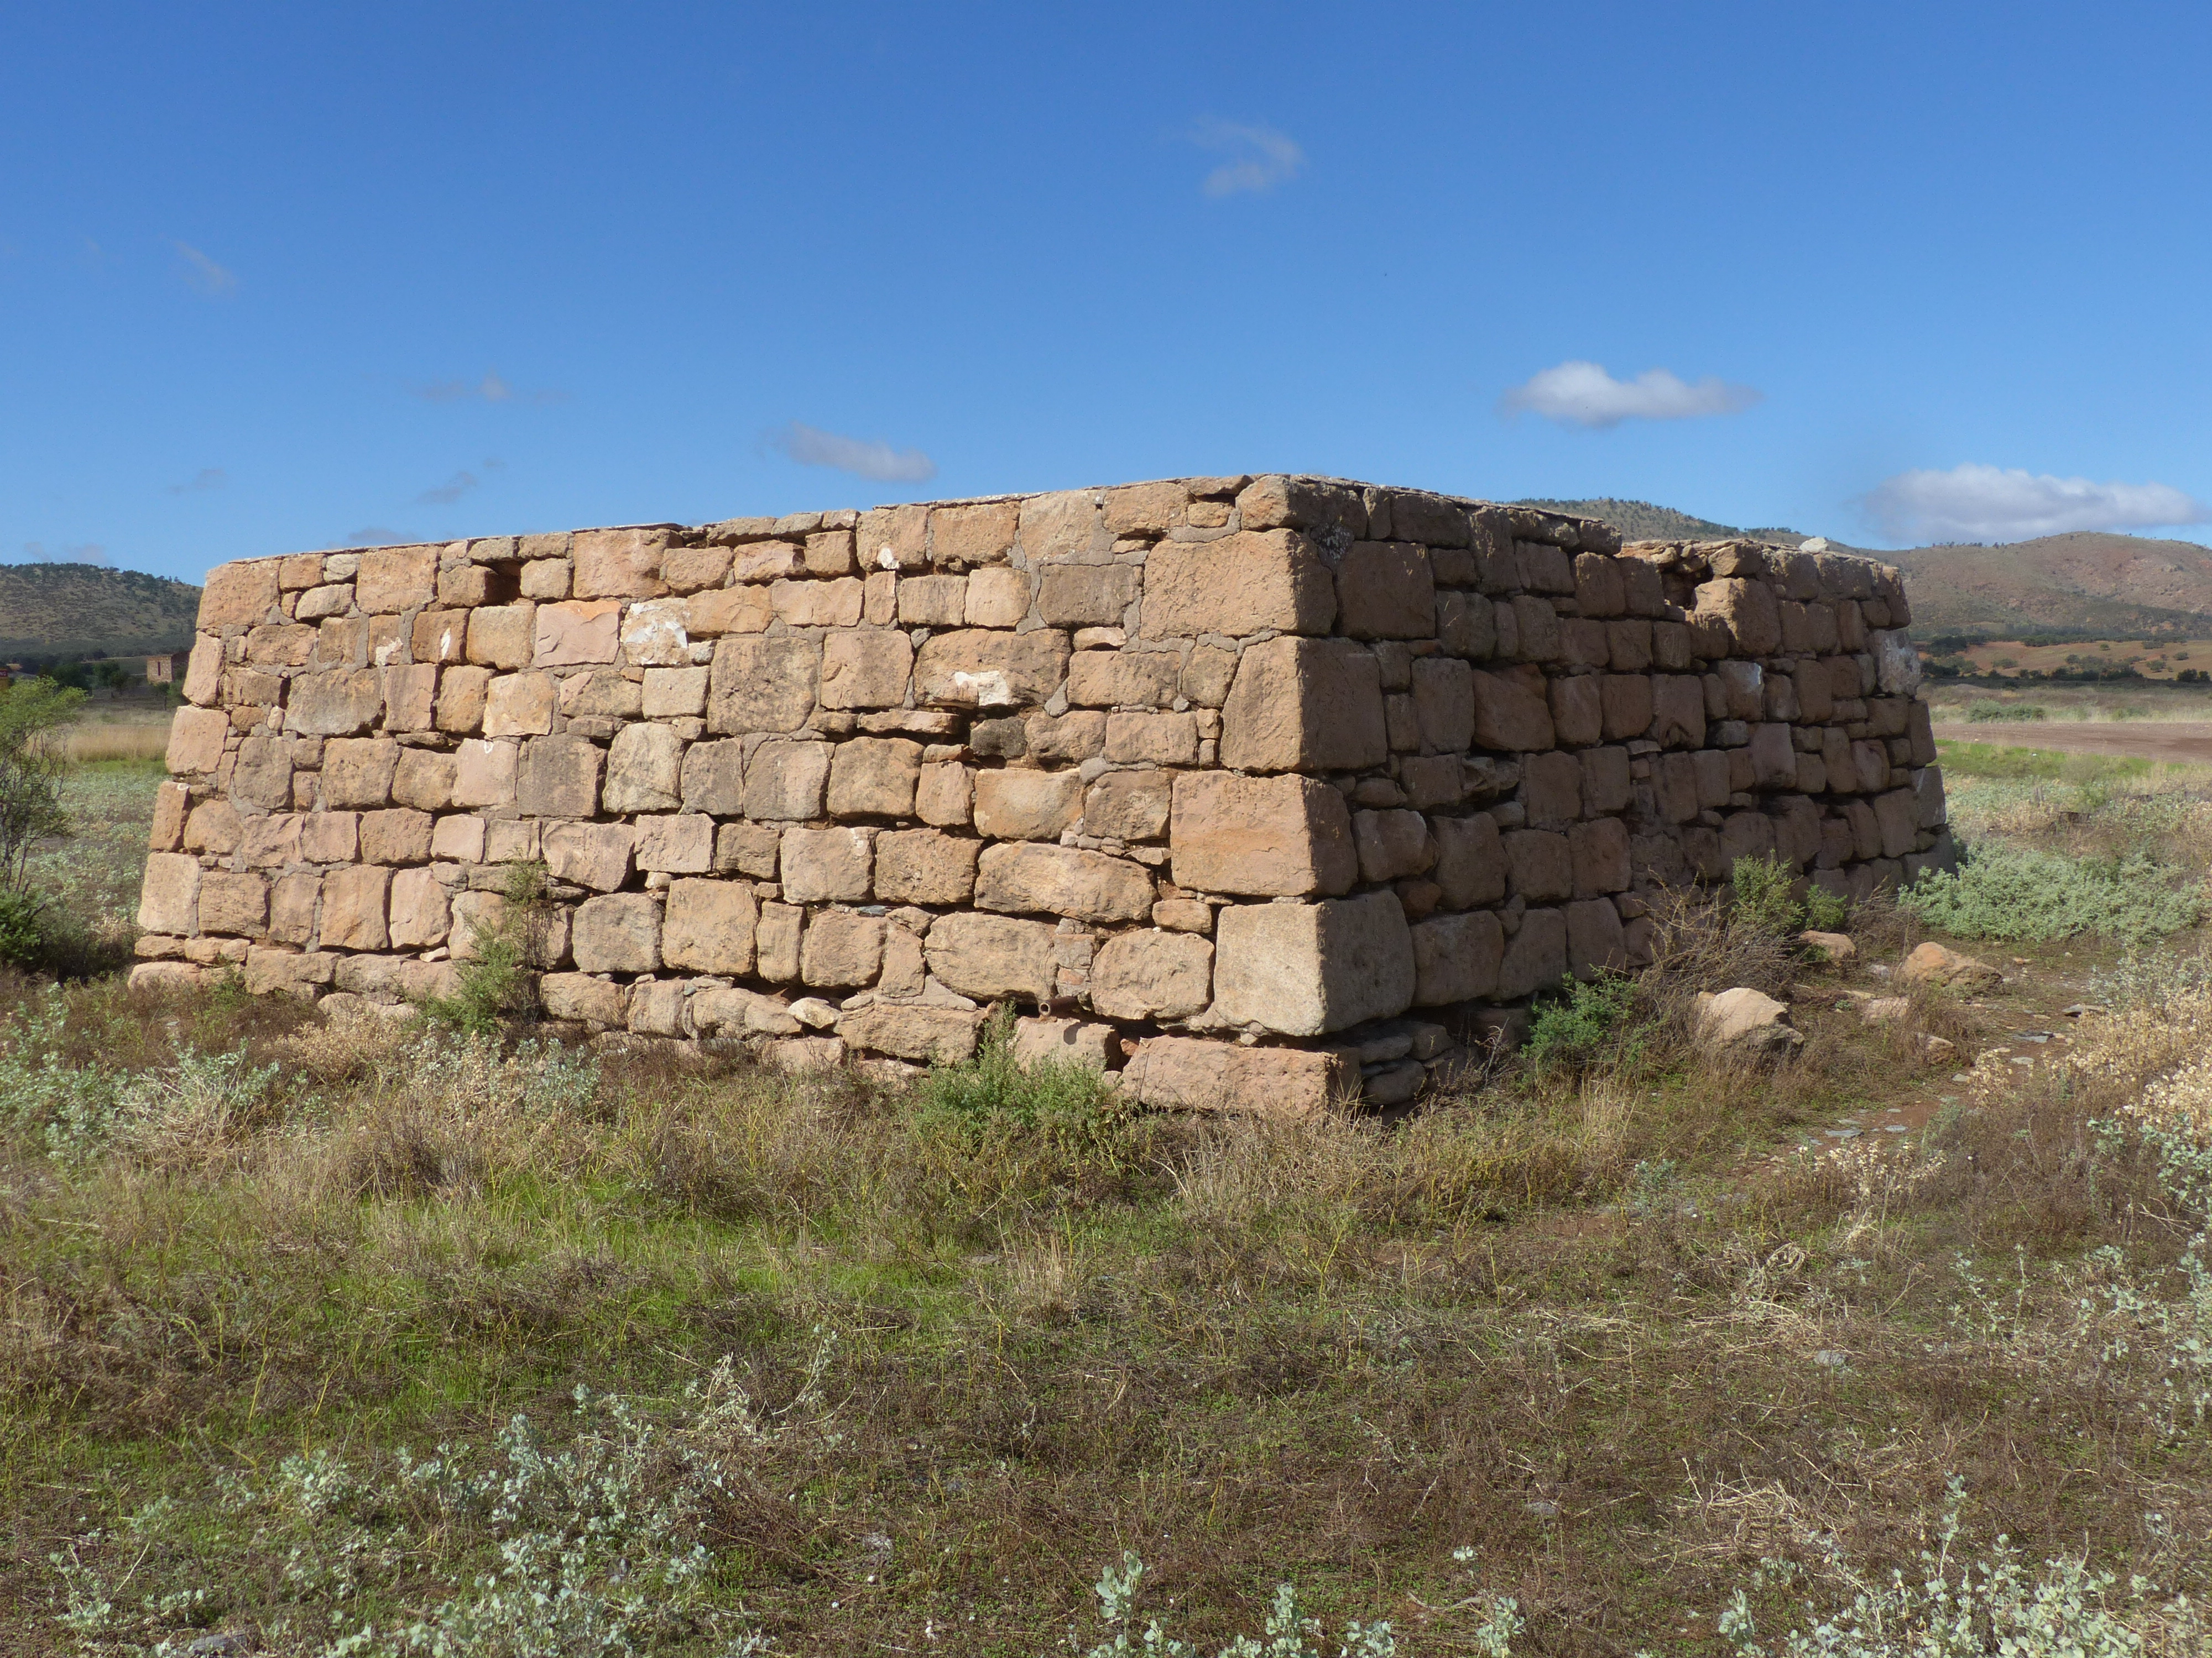
Above: Stone tank at Wilson, on the Willochra Plain north of Quorn (2017). Water was supplied to an adjacent stock trough. The tank may have been replenished by water brought in rail, as there was no natural water source close by.

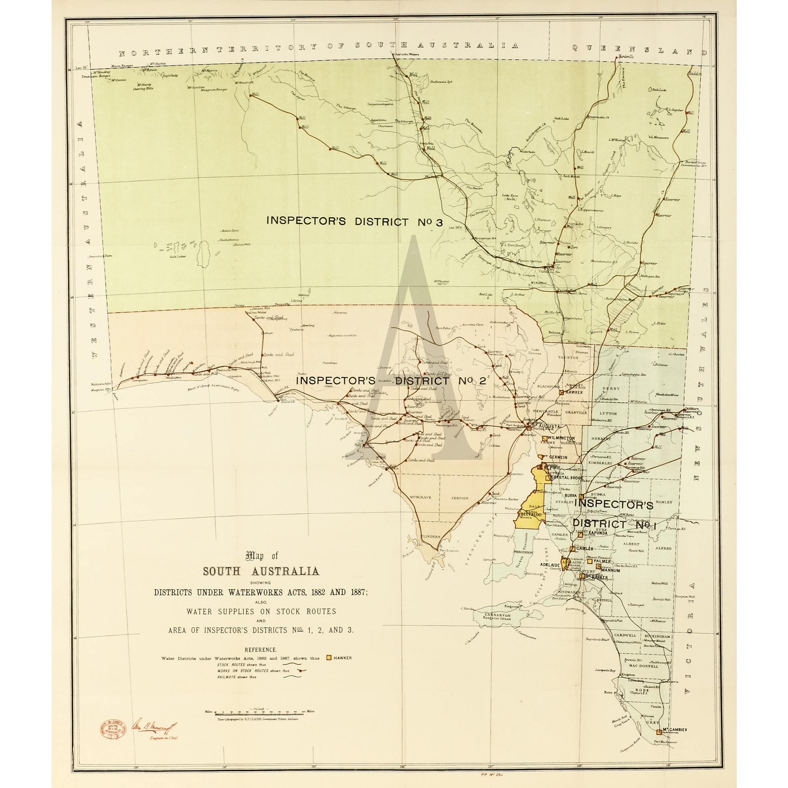
Above: Map showing water supplies along the major stock routes (Engineer-in-Chief, 1890s).

Town and country water supply - 1880s – 1970s
The growth of towns, rural communities, industry and mining across the settled part of South Australia depended on access to water. Local water sources, and local rainfall, were limited and unreliable. Clearly wells and bores were not going to provide sufficient water for much of the State. Apart from the towns along the River Murray, and the South East where groundwater was available, regional towns were often short of water. This was a particular concern where expansion and growth became constrained.
From the 1880s, the Government invested in dams and reservoirs on the few rivers available to supply water to country SA. Pipeline systems progressively interconnected much of country South Australia to the available water resources, firstly for the Mid and Upper North, then the Lower North, Eyre Peninsula, Murray Mallee and Upper South East. In addition, the development of reservoirs in the Mount Lofty Ranges provided water primarily for Adelaide but also for country water supply.
Only in the Lower South East and Lower Eyre Peninsula, and the Southern Mallee (Pinnaroo and Lameroo), could groundwater provide sufficient volumes of water for town and rural water supply.
South Australia was the granary Colony in the 1800s. Development of the livestock industries relied in part on secure water resources to provide stock drinking water. Often the argument for government investment in regional water supply infrastructure was supported by the economic opportunity that the growth in livestock industries offered. For example, the Department of Agriculture submission to the South Australian Parliament’s Public Works Standing Committee in the 1950s advised that stock numbers on Yorker Peninsula could be increased by 20-30% through pipelining water to farms, thus providing a substantial economic benefit to the State from Government investment in pipeline water supply infrastructure. Similar arguments supported most of the major pipeline schemes, although at times local farmers opposed these projects either as they saw no need for a water supply or did not want additional costs. Supply of water to farms provided the Government with funds for the operation and maintenance of the schemes through connection and water supply charges, in addition to that raised in urban areas.
Indeed, in recent years water charges have increased steeply resulting in very high costs for primary producers using large volumes of water supplied through government owned pipelines.
The individual schemes constructed from 1890 onwards are as follows.

Beetaloo Scheme
The Beetaloo Reservoir (capacity 3,180 megalitres), in the southern Flinders Ranges19 kilometres east of Port Pirie, was built between 1886 and 1890 to provide a water supply for northern Yorke Peninsula and Port Pirie. The scheme comprised construction of a dam (at the time the largest in the southern hemisphere, as reported in the Scientific American of August 8, 1891) at Beetaloo and pipelines to Paskeville to supply Yorke Peninsula (importantly the copper mining towns of Kadina, Wallaroo and Moonta), and to Nelshaby to supply Port Pirie. Over 1000 km of pipeline served 400,000 ha of country lands. However, the catchment could not reliably yield sufficient water supply for the area the scheme was designed for, so a further scheme at Bundaleer was necessary to supplement the Beetaloo scheme.
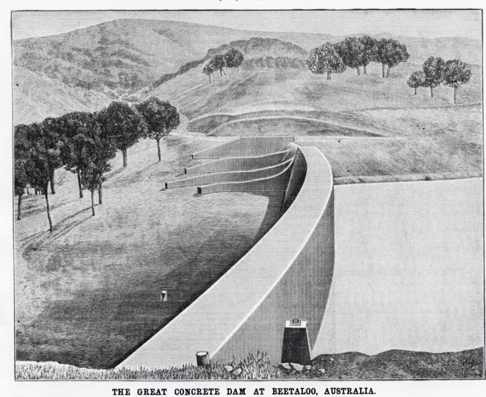
Above: from Scientific American, August 8 1891.

Bundaleer Scheme
The Bundaleer Reservoir, located near Spalding and south of Beetaloo, was built between 1898 and 1903 to supplement supplies from the Beetaloo Reservoir. Bundaleer is an earthen reservoir (capacity 6,370 megalitres), fed from the Bundaleer, Baderloo and Freshwater Creeks and the Broughton River, with mains connecting to the Beetaloo mains, and to towns and surrounding districts in the Mid North. The scheme includes 30 kilometres of concrete channels to divert surface waters into the reservoir, and at the time was considered a significant engineering achievement.
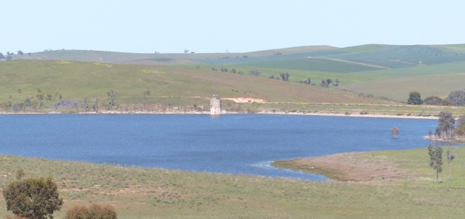
Above: Bundaleer Reservoir (2015). Earthen dam wall on the right.
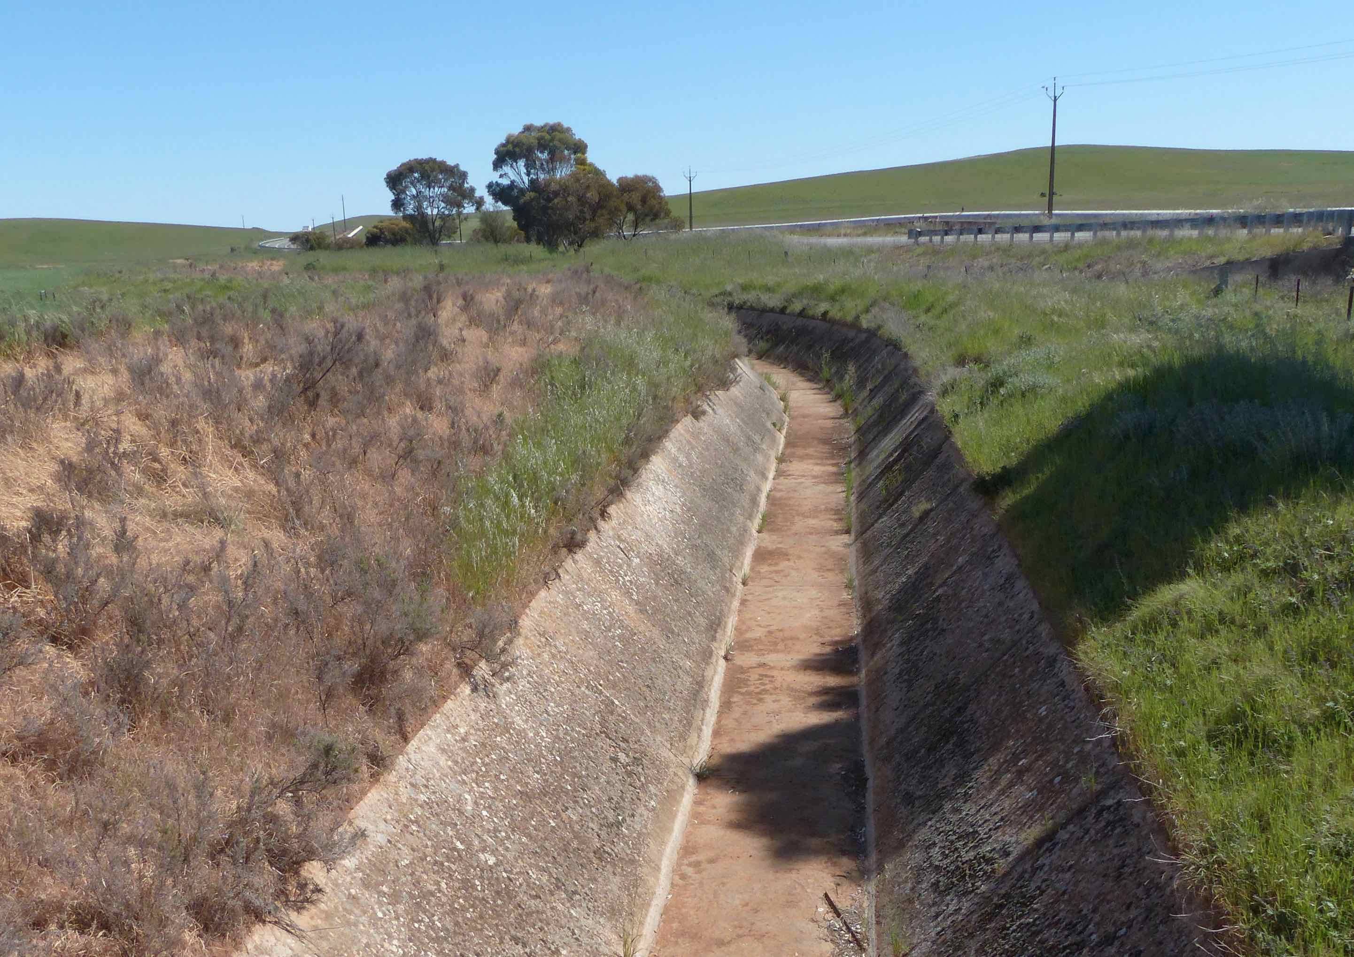
Above: Bundaleer Reservoir – concrete diversion channel (2015). Morgan-Whyalla pipeline in background.

Barossa (Gawler) Scheme
The Barossa Reservoir is in the Yettie Valley, in the northern Mt Lofty Ranges north west of Williamstown. The scheme, including the dam with a concrete wall, was built between 1899 and 1902 to supply water to Gawler and other northern country areas. Gawler at that time was an important industrial and manufacturing centre, and needed a reliable water supply. The reservoir (capacity 4,515 megalitres) was considered an engineering marvel, and with a wall height of 36 metres was at that time the highest in Australia. Its water comes through a two-kilometre tunnel from the South Para River.

Pekina
The Pekina Creek Irrigation Scheme (constructed 1906 – 1910) was one of the earliest irrigation schemes in South Australia, if not Australia. Its purpose was to irrigate forty blocks of ten acres each for growing lucerne and dairying on the Walloway Plain, five kilometres north east of Orroroo. To provide water a dam (capacity about 1,000 megalitres) was constructed on the Pekina Creek about two kilometres south west of Orroroo. For a more comprehensive history of the scheme see http://www.pir.sa.gov.au/__data/assets/word_doc/0011/285698/The_Pekina_Creek_Irrigation_Scheme.doc.

Yeldulknie Scheme
This water supply scheme on Eyre Peninsula, built around 1912, sourced water from concrete dams at Yeldulknie, Ullabidinie and Ulbana in the hills west of Cowell (total storage capacity perhaps 1,500 megalitres but the long term sustainable yield of the scheme may be less than 100 megalitres per year).

Warren Reservoir
The Warren Reservoir (4,790 megalitres) is in the northern Mt Lofty Ranges on the upper reaches of the South Para River south east of Williamstown. The scheme, with a concrete dam wall, was built between 1914 and 1916, to supply water to the Barossa and Mid-North.

Moorook and Loxton country water supply schemes
The opening up of the mallee land in the early 1900s south and east of the River Murray led to a demand for a reliable source of water, the groundwater in the region being saline. The Loxton and Moorook (pumping from Lowbank on the River Murray) schemes (constructed around 1916) supplied water by pipelines into these districts.

Tod River Scheme
Eyre Peninsula needed a water supply to meet the demand as the Peninsula rapidly developed following the extension of railways. The Tod River is the only stream on Eyre Peninsula providing reliable flows. Construction commenced in 1918, and was completed in 1922. An earth embankment dam, 27 kilometres north of Port Lincoln, held water supplied by concrete channels fed from weirs constructed across the Tod River and it's major tributary Pillaworta Creek. Pipeline construction continued for some years to the late 1920s, with further extension, replacement and enlargement in the 1970s. The capacity of the reservoir is 11,300 megalitres but due to rising salinity in the catchment following land clearing, the water quality deteriorated and Tod Reservoir is no longer used to supply water. Since 1960 groundwater resources from the Uley-Wanilla Basin, the Lincoln Basin, and the Uley South Basin progressively supplemented and then replaced Tod Reservoir water for supply to southern Eyre Peninsula.

Baroota Creek
The Baroota Dam (capacity 6,140 megalitres), in the southern Flinders Ranges, is situated on Beetaloo Creek, north-east of Port Germein and provided additional water for Port Pirie and other northern parts of the Beetaloo distribution system; completed in 1921. The dam was later interconnected with the Morgan-Whyalla Pipeline to allow local storage of water pumped from the River Murray. This storage is no longer required, allowing the reservoir today to supply irrigation water to local horticultural enterprises.

Aroona Dam
Aroona Dam is near Leigh Creek in the Northern Flinders Ranges. The Dam, with a capacity of about 7,500 megalitres, was constructed over 1952 – 57 to provide a water supply for the town of Leigh Creek and the coal mine developed at that time. However this supply was later abandoned in favour of artesian water treated in a reverse osmosis desalination plant.

Middle River (Kangaroo Island)
Prior to World War II Kangaroo Island and its largest town, Kingscote, relied mainly on farm dams, rainwater tanks and a small water supply scheme established in 1938. The lack of a major, reliable water supply became a major issue following the war, when the Soldier Settlement Scheme settled 170 new families on the Island. The population on Kangaroo Island more than doubled between 1948 and 1962. The Middle River Reservoir (capacity 540 megalitres) is a thin-walled, prestressed concrete structure constructed on Middle River, west of Kingscote.
The Middle River catchment became salinised after the 1970s, a result of groundwater rise following land clearing. The Department of Agriculture conducted investigations to understand the cause of rising salinity and the future risks to increase the utilization of the catchment for water. Due to the risks of salinisation of the catchment, additional water required for Kangaroo Island is supplied through a small desalination plant constructed (1999) at Penneshaw, east of Kingscote.
Middle River was the last dam to be constructed by the SA Government for water supply to country SA. By then most viable options for dam sites had been exploited. Although the total storage capacity was close to 40,000 megalitres the reliability of rainfall and low catchment yields meant that a much lower volume could be reliably harvested. In addition, some catchments had salinised, Tod being the main one, making these water resources unusable.

River Murray resources
The River Murray has been a very significant water resource for South Australia since settlement. Irrigation has been the largest user of water through both government and private schemes, while local towns have had a reliable source of water. See http://pir.sa.gov.au/aghistory/left_nav/natural_resources/water_resources_ag_dev/murray-darling_basin/critical_events_for_the_murray_darling_basin for some of the history of irrigation development along the River Murray in South Australia.
However, by the 1940s the State’s surface water resources were largely developed, with the exception of options for new dams in the higher rainfall Mount Lofty Ranges. Further regional growth now became dependent on wider utilization of River Murray water.
In 1914 agreement was reached between SA, NSW and Victoria, and the Commonwealth on sharing of River Murray waters between the States, and also on water conservation infrastructure and shared funding for river management. The River Murray Agreement of 1915 was a compromise between the competing interests of each State, but was vital to secure the water resource necessary for SA’s future. Even prior to the Agreement, work had started on engineering works required to control flow in the river including a system of locks and weirs commencing with Lock 1 at Blanchetown. Initially the river management focus for South Australia was to maintain sufficient depth of water in the river for navigation, thus enabling the riverboat trade so important then for the South Australian economy. Only later did irrigation water supply become the focus. Not until the 1940s after the construction of weirs and barrages did the River become a reliable water resource to supply both metropolitan Adelaide and country South Australia. Today the dependence of the state’s regional and farm economy on a water supply from the River Murray seems understated.
Until the river was fully locked and the Barrages at the mouth constructed (completed 1940), the River Murray, particularly in its lower reaches, was not sufficiently reliable or its water quality assured to justify the level of expenditure required for the pipelines and the pumping requirements necessary to access the water resource. Once the Barrages were in place the SA Government moved quickly to utilise River Murray water for supply to Adelaide and regional South Australia. Key dates and projects were:
- 1940 – approval for the Morgan – Whyalla pipeline (completed 1944) supplementing the reservoirs of the mid-north and extending supply of water to northern Spencer Gulf towns - prior to the new pipeline, Whyalla was supplied by a barge from Port Pirie. This pipeline allowed the development of the steelworks at Whyalla;
- 1949-1954 Mannum - Adelaide pipeline, which in addition to supplying water for metropolitan Adelaide, provided town and farm water supply to the northern Mt Lofty Ranges;
- 1962 – 1972 Tailem Bend – Keith pipeline, supplying water to towns and farms in the Upper South-East;
- 1963-1967 second Morgan – Whyalla pipeline, supplementing the first pipeline and also providing water to Woomera;
- 1972 Swan Reach – Stockwell pipeline, supplying water to the Barossa, Mid-North and Yorke Peninsula;
- 2007 Northern Eyre Peninsula – Morgan pipeline interconnection;
- 2009 Tailem Bend – Narrung Peninsula, supplying water into the Narrung Peninsula and adjacent areas when drought conditions resulted in the salinity of Lakes Alexandrina and Albert reaching levels too high for human or stock use;
- 2009 the Creeks Pipeline Company, with government assistance, developed a pipeline scheme to take water at Jervois on the River Murray, to Langhorne Creek and Currency Creek, to replace diversions from Lake Alexandrina which at that time had become too saline for the irrigation of horticultural crops.
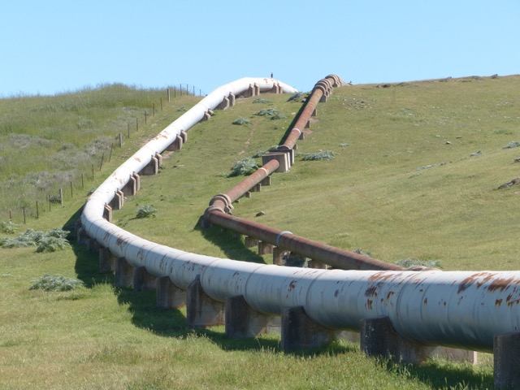
Above: Morgan – Whyalla pipelines – near Spalding (2015). First pipeline (1944) on right, second (1967) on left.
Some statistics
The first Morgan –Whyalla pipeline, constructed in the early 1940s, was designed to deliver around 4,000 megalitres per year to the northern areas of the State and around 5,500 megalitres to Whyalla (for the strategic steel industry located there, although this volume was never required). However, demand in the northern areas increased so the Bundaleer Reservoir was used to store River Murray water during winter and to subsequently provide for summer demand. By 1959 demand exceeded pipeline and pumping capacity.
The second Morgan – Whyalla pipeline, constructed in the mid-1960s, was designed to deliver around 7,000 megalitres per year to the northern areas of the State and around 2,000 megalitres to Whyalla, these volumes being in addition to those supplied by the original scheme. The increased demand in the northern areas included water for the new power station at Port Augusta (and the expanding town), a water supply for Woomera, expansion and industrialization of other northern towns, and increased agricultural requirements throughout the region served by the pipelines.

In 2007 the northern Eyre Peninsula pipeline, constructed as part of the Tod River Scheme and which supplies water by pipelines to much of Eyre Peninsula including to west of Ceduna, was interconnected to the Morgan-Whyalla pipeline to supplement water supply across northern Eyre Peninsula.
River Murray water was pipelined from Tailem Bend into the Narrung Peninsula and Meningie in 2009 when Lake Albert water became too saline for use, during the extended no flow period of the Millennium Drought. The adverse impacts on the dairy industry of high salinity and loss of access to water as water levels fell had become particularly severe. A private pipeline, constructed around the same time, takes water from near Tailem Bend to the Langhorne Creek and Currency Creek areas for irrigation supply for horticultural crops, replacing previous diversions from Lake Alexandrina and from groundwater.
The River Murray is arguably South Australia’s most important country water resource. Around 60,000 megalitres per year can be supplied to towns and farms across much of the State with most of the local water supplies interconnected into the pipeline network from the Murray. This is a highly reliable source of water with restrictions applying only under the most extreme drought conditions. In some cases, the local reservoirs are no longer used for water supply to towns and farms, although some in the southern Flinders Ranges are now utilized as irrigation storages. In all, there are around 17,000 km of pipeline supplying water to towns and farms across regional South Australia. Only the lower South East, the Southern Mallee, Kangaroo Island and the Far North (apart from Woomera) are not reached by Murray water.
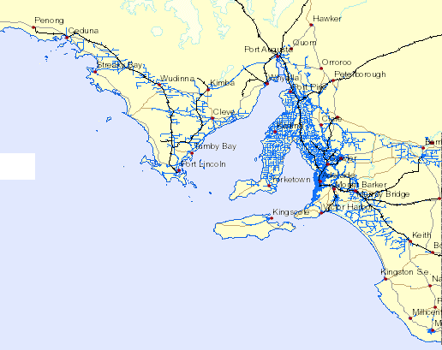
South Australia’s regional water pipeline network, connecting towns and farms to the River Murray and local water resources (circa 2010).

Other Water Supply Schemes

Willunga Basin Scheme

The Willunga Basin Pipeline is a reclaimed water scheme built in the late 1990s, utilising 5,800 megalitres of reclaimed water, and owned and operated by its water users. Irrigation water is sourced from the Christies Beach Sewage Water Treatment Plant and supplied by pipeline to vineyards and orchards in the McLaren Vale and Willunga area. Previously this water was discharged to St Vincent Gulf. The scheme has led to local economic growth, replacing and supplementing groundwater resources. There are current proposals to increase the capacity of the scheme.

Virginia Pipeline Scheme

Since 2000 Class A recycled water (sourced from the Bolivar Sewage Water Treatment Plant) has been used for irrigation of fresh vegetable plantings and other crops in the Virginia area, in part to supplement limited supplies of groundwater. The pipeline scheme provides farmers with around 20,000 megalitres per year of Class A recycled water, with opportunity for further increases. It is one of the largest recycled water reuse schemes in the world. The scheme is a public-private partnership between the Virginia Irrigation Association (representing market gardeners and other irrigators), SA Water and the owner and operator of the scheme. There is potential to double the volume of water supplied into the region and development work on this extension is currently occurring (2017).

Barossa Infrastructure Scheme
The Scheme provides for the use of River Murray water in the Barossa region. It is operated by Barossa Infrastructure Ltd (BIL) and supplies 5,000 to 7,000 megalitres per annum of River Murray water for supplementary irrigation in the Barossa Valley. The water is transferred by SA Water to Barossa Infrastructure via the Mannum Adelaide Pipeline and the Warren Reservoir. This scheme became feasible with tradeable water entitlements from the River Murray, and the potential to use underutilized SA Water pumping, storage and pipeline infrastructure. SA Water provides the connection to the Warren Reservoir, supplemented with water supplied via the Mannum Adelaide Pipeline and Warren Transfer Main, from the River Murray. BIL owns River Murray Water Access Entitlements either purchased or in the form of long-term leases.

Clare Scheme
The Scheme provides for the use of River Murray water in the Clare region. An off peak irrigation water supply utilizing unused winter capacity in the Morgan-Whyalla pipeline has been available from around 2004 but growers pay the state-wide water supply charge which is proving economically unviable. New proposals for a water supply arrangement similar to that in the Barossa are currently being developed.

Sources of information
Websites – SA Water; Flinders Ranges Research; The Creeks Pipeline Company; Barossa Infrastructure Limited; Willunga Basin Water; Trility (Virginia Pipeline); Department of Environment, Water and Natural Resources.
Hammerton, Marrianne (1986). Water South Australia. A History of the Engineering and Water Supply Department. ISBN 0 949268 75 5.
Yelland, Leith (2002). Pads, Tracks and Waters. South Australia’s pastoral stock routes. ISBN 0 7590 1327 6.
This paper was prepared by Phil Cole, June 2017.

