ENHANCED ABATTOIR SURVEILLANCE PROGRAM

Bruising
Bruising is caused by various types of external trauma that damages blood vessels causing bleeding at the site of injury. Bleeding from damaged blood vessels results in muscle discolouration and affected muscle must be trimmed from the carcase.

Condition summary
Document Title Here
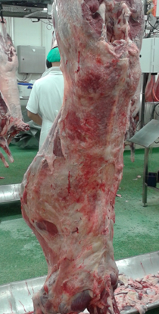
Bruising is due to bleeding into muscle and tissues and is caused by external trauma. Bruises can vary in size from mild and superficial, to large and severe involving whole limbs or carcase portions. Bruising is a condition of welfare importance at multiple points in the ante-mortem supply chain.
Bruising is a condition of welfare importance.

Damaged areas of the carcase must be trimmed which, depending on severity, results in reduced carcase weight.

Bruising can be avoided and minimised by good yard design, quiet stock handling and correct transport processes.

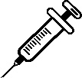

What impact does bruising have?
Bruised carcases will be trimmed and may result in carcases being downgraded from a high value chilled product to a low value frozen product. If bruising is extensive or deep, entire legs may be trimmed. Occasionally carcases may be condemned for bruising (e.g. in the instance of trampled stock).

Why is bruised meat trimmed at the processor?
Meat that is bruised is wasted as it is not suitable for use as food. Bruised meat decomposes and spoils rapidly as the increased blood in the meat is an ideal place for bacteria to grow. In addition, consumers will not buy bruised meat due to the lack of visual appeal.

What causes bruising?
Bruising may be a result of any one (or a combination) of the following:
- dog bites, even if the skin is not penetrated
- lifting sheep by their wool
- drafting gates being shut on animals
- injury from poorly designed yards, races, loading ramps and trucks
- trauma during handling such as shearing or, crutching
- injury during transport, including trampling
- use of sticks or other implements in the yard

How do I prevent bruising in my stock?
- Yard design
  - ensure handling facilities encourage easy movement of sheep.
  - check for sharp protrusions (e.g. wire, gate latches etc.) that sheep are likely to catch themselves on, and repair as appropriate.
- Handle stock calmly
  - exhausted or frightened animals bruise more readily.
- Dogs in yards
  - minimise the use of dogs and muzzle dogs if necessary. All dogs are muzzled at Thomas Food International lairage.
  - if sheep are not accustomed to being handled with dogs, and transporters use dogs for loading, they are more likely to bruise.
- Transport
  - avoid overloading or under loading trucks.
  - minimise transport distance and time where possible.
  - check trucks for any protrusions that sheep might catch themselves on and repair as appropriate.
- Consigning off-shears
  - stock consigned within two weeks of shearing (or other husbandry procedures) are at an increased risk of being bruised at the time of processing.
IMPORTANT POINTS: Approximately one in four South Australian producers consign bruised stock. Within affected lines approximately one in 10 carcases are bruised. Bruising can be avoided and minimised by good yard design, quiet stock handling and correct transport processes.

