HACCP PLAN
Transporting Meat and Meat Products

Business Name
PIRSA Accreditation Number: XX/XXXX

This is a HACCP template, developed by the Department of Primary Industries and Regions (PIRSA) for Transporting of Meat and Meat Products.
An Accredited Producer may identify additional steps or hazards upon undertaking their own hazard analysis and risk assessment of each hazard. If this occurs, the Accredited Meat Producer must discuss this with the PIRSA Food Standards team to ensure that this is reflected in this document and appropriately addressed.
It is the responsibility of the accredited producer to implement and maintain the HACCP plan as part of the approved Food Safety Arrangement.

Table of Contents
1 HACCP PROCESS 3
1.1 PRODUCT SPECIFICATION 4
1.2 FLOW CHART 5
1.3 CCP DECISION TREE 6
1.4 HAZARD ANALYSIS TABLE 7
1.5 HAZARD AUDIT TABLE 9
1.6 CCP WORK INSTRUCTIONS 10
1.7 CCP MONITORING FORMS 12
1.8 PROCESS VALIDATION 14

HACCP PROCESS

OUTCOME
To process food safely, producing safe food which complies with relevant legislation, regulations and standards.
HACCP
Process

This HACCP forms part of the Approved Food Safety Arrangement for the Accredited Meat Producer.
The HACCP team is responsible for maintaining this HACCP plan through analysing and improving procedures along with implementing effective controls to manage food safety risks. Each process undertaken by the business needs to be covered by a HACCP plan. This HACCP plan covers:
Transporting Meat and Meat Products for human consumption

The producer acknowledges following have been taken into consideration in the development of this HACCP plan;
- Primary Produce (Food Safety Schemes) Act 2004
- Primary Produce (Food Safety Schemes) (Meat) Regulations 2017
- AS 4696:2023: Australian Standard for Hygienic Production and Transportation of Meat for Human Consumption
- AS 4465:2005: Australian Standard for construction of premises and hygienic production of poultry meat for human consumption
- Meat and Livestock Australia - Guidelines for the Safe Manufacture of Smallgoods – 2nd edition 2015
- FSANZ Food Standards Code 4.2.2 and 4.2.3

For the activity of Transporting Meat (including Poultry) and Meat products for human consumption the producer must hold accreditation to carry on the business of producing meat including these processes.

PRODUCT SPECIFICATION

, The following constitutes a Product Specification for the purpose of the Food Safety Arrangement and obligations under the Act. The Specification detail the product characteristics as listed below and are considered when reviewing the HACCP plan.
General Category Product Specification (Example)
Product Category | Meat (including poultry) both carcass and carton formats
General Composition | Meat
Method of Preservation | Refrigeration – chilled at or below 5°C  Shelf stable products may be transported and stored under dry ambient conditions.
Packaging | Primary | Nil (carcass) or plastic liner
 | Secondary | Nil (carcass) or Plastic containers or Cartons
Storage Conditions | As defined by supplier requirements:  Keep refrigerated at or below 5°CSuitable for freezing (Frozen poultry to be stored at ≤-15°C)  Shelf stable – dry ambient conditions.
Distribution Method | Refrigerated vehicle at or below 5°C (to ensure individual product specifications are met)
Shelf Life | As defined by supplier requirements
Intended Use | Sensitive Customer | As defined by product label – applied by supplier
 | Customer Preparation | As defined by product label – applied by supplier

FLOW CHART

Objective | A step-by-step diagram of the flow of the stages of the operation/process with all inputs and outputs identified. Key steps in the process that are critical to food safety are referred to as Critical Control Points, (CCP). These are highlighted on the Flow Chart.

CCP DECISION TREE

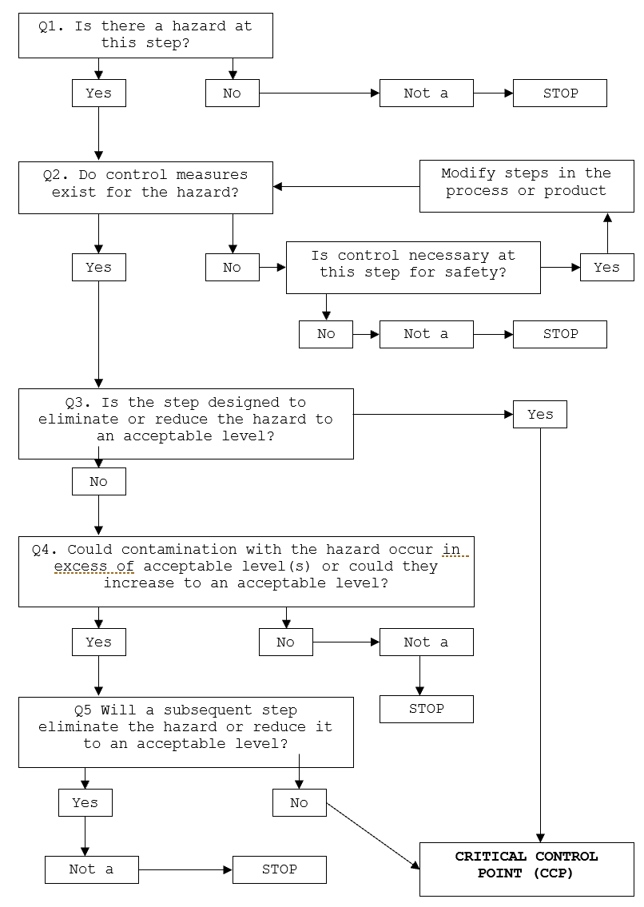

HAZARD ANALYSIS TABLE
Hazard Types: B – Biological; C – Chemical; P – Physical
Objective | A documented review of each step identified in the flow chart and with the importance of each step in the safety of the finished product rated to identify Critical Control Points (CCP).

Process Step |  | Hazard | Cause | Q1 | Q2 | Q3 | Q4 | Q5 | Preventative measures for hazard control | CCP | CP | GMP | Support Program
Applicable at each step and to all stages of process | Hygiene and sanitation | B - Microbiological cross contamination due to unclean surfaces/equipment | Poor cleaning and sanitation process | Y | Y | N | Y | Y | Hygiene and sanitation procedure  Pre-op monitoring
 |  | C – Chemical residue | Chemical residues at unsafe levels | Y | Y | N | Y | Y | Use of approved chemicals at correct dilutions  Training Program
 | Personnel Hygiene | B - Microbiological cross contamination due to unhygienic handling procedures | Poor personal hygiene | Y | Y | N | Y | Y | GMP procedures  Hygiene monitoring  Training program
 |  | P – foreign objects | Poor GMP procedures | Y | Y | N | Y | Y | Program of works  Pre-op monitoring

Process Step | Hazard | Cause | Q1 | Q2 | Q3 | Q4 | Q5 | Preventative measures for hazard control | CCP | CP | GMP | Support Program
- Loading | C – Chemical contamination | Cleaning chemical residue in vehicle. Chemicals transported in vehicle | Y | Y | N | Y | Y | Cleaning as per procedure  Inspection by driver of vehicle – clean prior to loading.  Meat and meat products are not loaded into the vehicle if the vehicle is not in a clean compliant condition.
 | P – Foreign objects | E.g., Pallet splinters | Y | Y | N | Y | Y | Inspection by driver of vehicle – clean prior to loading.  Inspection of Carton condition at point of loading.  Damaged or contaminated product shall not be loaded.
- Transport | B – Growth of microbiological pathogens above unsafe levels. | Product not stored under appropriate temperature control. | Y | Y | Y | - | - | Product maintained less than or equal to 5°C under active refrigeration. | CCP
 | P – contamination | Foreign objects | Y | Y | N | Y | Y | Compliant vehicle construction
- Unloading | B – Growth of microbiological pathogens above unsafe levels. | Product not stored under appropriate temperature control. | Y | Y | Y | - | - | Product maintained less than or equal to 5°C under active refrigeration. | CCP

HAZARD AUDIT TABLE
Objective | Documented controls to be implemented and measured and recorded to demonstrate compliance to process to make safe food.

Step | Hazard | Critical Limit | Monitoring | Corrective Action | Records
Transport  &  Unloading  CCP 1 | B – Growth of microbiological pathogens above unsafe levels. | Active refrigeration in place to maintain temperature of meat at less than or equal to 5°C. | What: Vehicle set temperature and actual air | Assess temperature of meat. If greater than 5°C, move product to alternate refrigerated vehicle if available. Note: If frozen product is thawed, product is not to be re-frozen. Suitable to be sold as chilled.  Adjust vehicle temperature setting to achieve less than or equal to 5°C product temperature.  Advise the receiver of the meat or meat products to arrange refrigeration without delay.  Repair or replace refrigeration unit. | Vehicle Temperature Log  Calibration record
 |  |  | How: Visual check of Calibrated refrigeration gauge or thermometer
 |  |  | When: At point of loading and unloading
 |  |  | Who: Operator

CCP WORK INSTRUCTIONS
Objective | At steps that are critical for the safety of the finished product, checks on the process are completed to confirm the process has met the critical limits and the results recorded. If the check finds the product has not met the critical limit of the process, actions need to be taken to make the product safe. These steps need to be documented in a work instruction.

- CCP 1 – Transport & Unloading

WORK INSTRUCTION | Transporting & Unloading
Objective | Suppress growth of microbiological pathogens in Meat and meat products; they are not contaminated nor their wholesomeness jeopardised.
Procedure | Cartons, portion and carcass meats are be transported in the meat carrying compartment of the vehicle. Exposed meat and meat products are not in contact with surfaces that may cause contamination. This includes unwrapped carcase and carcase parts which are to be carried in closed containers as to not contaminate other meat and meat products.  The compartment operates at an air temperature to maintain meat temperatures in accordance with the Australian Standard:  - Temperature of carcase meat at less than or equal to 7°C.  - Temperature of poultry carcases, portioned or carton meats at less than or equal to 5°C.  - Shelf-stable meat products can be transported and stored under dry ambient conditions which will not adversely affect the microbiological safety of the product.  - Frozen products to remain frozen during transport. Frozen Poultry to remain ≤ -15°C. Note: If frozen product is thawed, product is not to be re-frozen. Suitable to be sold as chilled.  Product to be stored off the ground and spaced for adequate refrigerated air circulation, with all cooked and raw meats stored separately and that no cross contamination occurs.  A product traceability system is in place from end to end of the supply chain (i.e., supplier to customer) to prevent inadvertent substitution of product.  Any product returned are segregated and evaluated for wholesomeness at time of return, with product deemed unwholesome defaced and discarded.  Record the set temperature of the vehicle when loading the vehicle.  Monitor the air temperature of the meat carrying compartment during transportation. Adjustment to the thermostat may be required to maintain required air temperature.  Monitor air temperature of meat compartment upon arrival at destination for compliance with Australian Standard.
Frequency | At point of Unloading
Records | Vehicle Temperature Log
Corrective Action | Assess temperature of meat. If greater than specifications above, move product to alternate refrigerated vehicle if available.  Note: If frozen product is thawed, product is not to be re-frozen. Suitable to be sold as chilled.  Adjust vehicle temperature setting to achieve less than 5°C product temperature.  Service and repair vehicle.  If the Transporter becomes aware of conditions which may have compromised the wholesomeness during transport, they will advise the proprietor of the meat business that receives the meat or meat products without delay.
Responsibility | The operator is responsible for monitoring, documenting and maintaining temperature of cold storage areas.

CCP MONITORING FORMS

- Vehicle Temperature Log (CCP1)
Date | Meat Compartment Clean & Pest Free  ( / ) | Set Temperature  (°C) | Compartment Temperature at  Unloading  (°C) |  |  | Comments / Corrective Action | Signature
12/1/24 |  | 2 | 2 | 3 | 3.5 | Swept Floor | SS

PROCESS VALIDATION
Objective | Confirm the process followed will control the hazards identified, making the product safe for consumption.

Verification & Validation | Transporting & Unloading
Objective | Theoretical validation – AS4696:2023 Section 15  Provide evidence sufficient active refrigeration is in place to maintain temperature of meat at less than or equal to 5°C.
Verification | Refer to work instruction for monitoring records and frequency to confirm validated process has been followed to achieve hazard control.  Calibration of thermometer probes required at this step:  - 3 monthly – internal calibration (as per Food Safety Arrangement); or  - annually – external calibration.

