ENHANCED ABATTOIR SURVEILLANCE PROGRAM

Knotty gut and pimply gut
Knotty gut, also known as pimply gut, is caused by the nodule worm parasite, Oesophagostomum columbianum which lives in the intestine of sheep. In South Australia it is known to occur in higher rainfall and irrigated regions however it is uncommon. It is more frequent in NSW and Queensland, and most cases detected in SA are found in sheep sourced from interstate. It can cause severe disease if heavy infestations are detected, particularly in weaners. It also impacts offal cost recovery at processors.

Condition summary
Knotty gut is a condition resulting from the larval stage of a parasite that forms nodules in the intestinal lining. Nodules vary in size from small gritty lesions in the small intestines to large abscess-like lesions in the large intestine. If infection is severe, nodules may also be found in other organs, such as the lung, liver and kidneys. The adult parasite causes disease due to its feeding which damages the colon causing ulcers and bleeding.
On farm impacts include reduced growth rates and weight loss, which can cause significant production losses, and death may also occur.
The intestines (runners) are condemned, as they cannot be used for sausage casings and suture material.
Nodule worm is easily treated with broad spectrum drenches, however once sheep have developed nodules in the walls of the intestine they do not fully recover.
Document Title Here
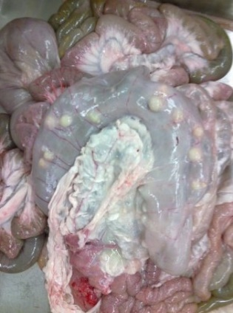

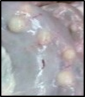

Large intestine with hard white nodules (inset, enlarged) due to nodule worm parasite.
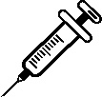

How do sheep get knotty gut?
The parasite prefers a summer rainfall climate as nodule worm eggs and larvae are sensitive to cold weather and to drying out. The adult worm lives in the large intestine of sheep and eggs are passed in faeces to contaminate pasture. In warm wet conditions larvae hatch and mature on pasture before being ingested by sheep. The larvae burrow into the intestinal lining causing nodules to form. The larvae then leave the nodules which remain as scars and enter the intestine and travel to the large intestine where they develops into adults, and eggs are produced around 42 days after ingestion of the larvae.

What might be seen on farm?
Nodule worm causes disease both in larval and adult form. Inflammation in the gut can cause considerable pain due to the damage done by the nodules as well as adult worms feeding. Sheep, particularly weaners, show ill-thrift, often standing with a characteristic hunched back, may have a stiff gait and lose condition, become weak and scour intermittently. Diarrhoea can contain mucous and blood, and anorexia, anaemia (pale gums) and death may occur.
The larval stage of the nodule worm causes the most damage to the gut. Therefore sheep may show signs of clinical disease before the larvae have matured to adults, that is, before they are passing large numbers of eggs.

How do I prevent knotty gut?
- Give quarantine drenches to all new stock entering your property.
- Protect young and susceptible animals – weaners and pre-lambing ewes.
- Monitor worm egg counts regularly and drench strategically.
Some handy tips include:
- Use grazing management to create low worm-risk paddocks:
  - Avoid heavily contaminated paddocks.
  - Reduce contamination of paddocks – e.g. making hay or silage.
  - Allow time for eggs/larvae to die – e.g. pasture spelling.
- Breed and feed for worm resistant sheep.
- Monitor worm burdens regularly using worm egg counts (“Worm Test”) at recommended times for your region/climate zone (visit wormboss.com.au).
- Use drenches tested to be most effective on your property and multi-active combinations where possible (see “DrenchCheck”).
- Keep stock off pasture for three days following drenching by holding in yards or a small holding paddock, until all eggs present have passed from the gut. Keep this paddock free of sheep, goats or alpacas for at least 3 months (summer) or 6 months (cooler months).
- Strategic drenching at recommended times for your region/climate zone and then move onto safe pastures (visit wormboss.com.au) and follow up with worm egg counts 14 days after the drench to check effectiveness (“DrenchCheck”).
- Test for drench resistance every 2-3 years unless indicated earlier, using the Worm Egg Count Reduction Test (WERCT, or “DrenchTest”).
- Manage drench resistance – use a fully effective drench or combination of drenches for the strategic (summer) drenches. Where possible, use a combination of two or more groups, use short-acting treatments, and rotate among all effective drench groups for each mob (and each paddock where possible).
- For detailed information on recommended times to drench and on making drenching decisions, based on worm egg counts, visit wormboss.com.au. This information is specific for state and area and, in the case of the Drench Decision Guide, your property.
IMPORTANT POINTS: Knotty gut may cause serious production losses on farm, and affects offal cost recovery at processors. Strategic drenching by administering a quarantine drench to all stock coming on property, providing low worm-risk pastures for the most susceptible sheep and monitoring worm egg counts regularly will result in healthy sheep without unnecessary drenching. The damage to the intestines by larvae is permanent, so an effective drenching program may take some years to see reduced detection levels and reduced offal condemnation at processors.

