Illegal slaughter, processing and sale of meat
  - All meat or meat products processed in South Australia must come from a business accredited by the Department of Primary Industries and Regions.

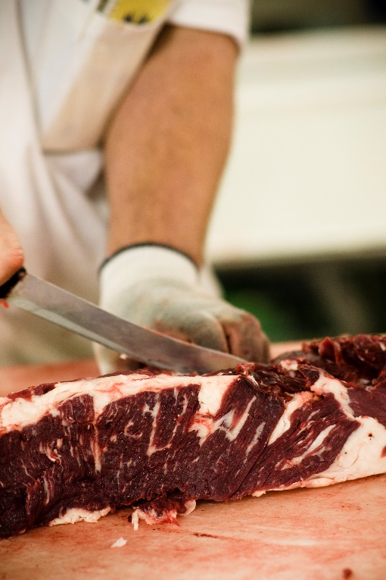
What you need to know
Unless you are accredited by the Department of Industries and Regions, you cannot kill or further process animals or birds where the meat is:
- sold, or intended for sale
- used, or intended for use, as food for paying guests
- taken away, or intended to be taken away, from the premises.
If you operate illegally, you can be fined up to $20,000 under the Primary Produce (Food Safety Schemes) Act 2004 and the Primary Produce (Food Safety Schemes) (Meat Industry) Regulations 2017.
Primary producers may kill stock on their own property to provide meat for themselves, their families and employees living on the property. However, it is illegal for meat to leave the property.

Food safety
If meat is handled under unhygienic conditions, it cause severe food poisoning, even if it appears normal.
For your safety, make sure your meat is branded or labelled, processed by an accredited operator and bought from a recognised retail butcher.
Branding signifies that the meat has been inspected and is safe to eat.

