Southern Zone Rock Lobster Fishers
This guide assists Licence holders and registered masters to access and complete their reporting of Catch and Disposal Records via eCatch, including;

- SARDI (Deckhand)
- CDR (Deckhand)
- Landing Scales

- Trip Reports
- Dashboard and Managing Errors
- Non-Trip Reports
- Non-Trip Reports

Please note: Required fields are marked with *

Where to report your catch?
You can report your catch via eCatch at https://mypirsa.pir.sa.gov.au or 1800 eCatch (1800 322 824) or the Deckhand application.
If you are unable to use Deckhand, you must complete your reporting prior to departing the main vessel by logging onto eCatch web portal or by calling 1800 eCatch (1800 322 824).
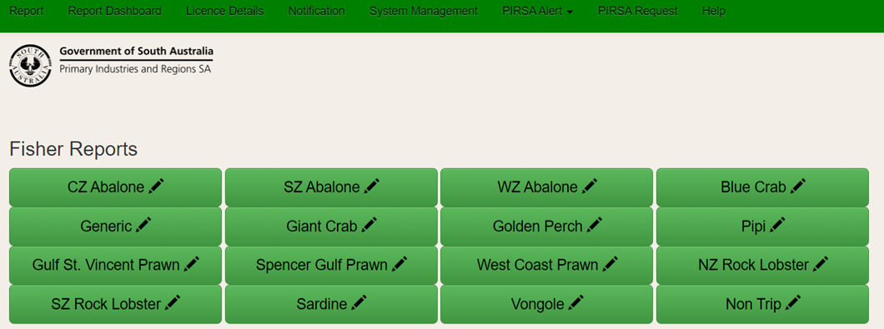
To complete your reporting via the eCatch portal you can access these reports by selecting the ‘Report’ menu button and then the ‘SZ Rock Lobster’ buttons both circled below.

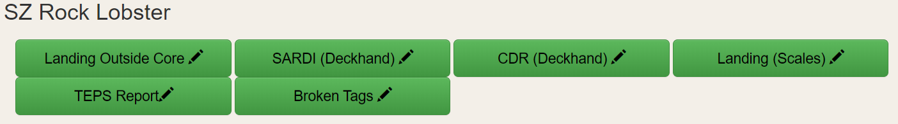
Selecting the ‘SZ Rock Lobster’ button then presents the six report types indicated below.

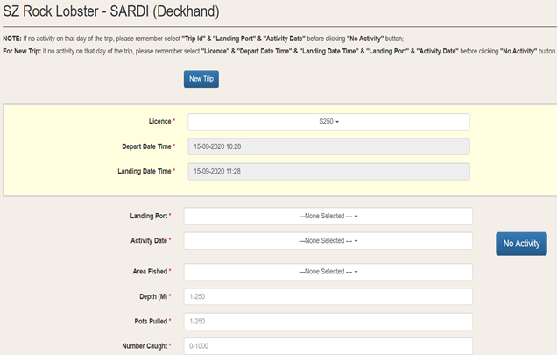
SARDI (Deckhand)
- One SARDI report per day of trip.
- Select ‘New Trip’
- Required fields are marked with *
- Click ‘Add By Catch’ for each new species of by-catch.

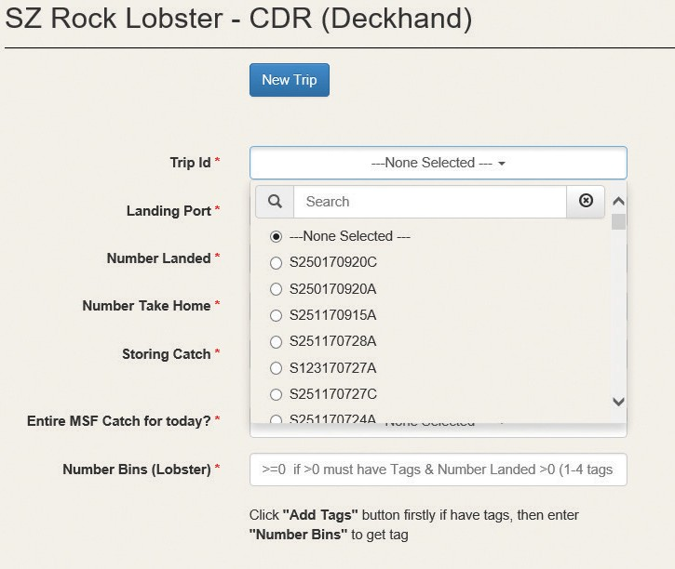
CDR (Deckhand)
- One CDR to be entered per trip.
- Do not select ‘New Trip’, select the existing trip ID from the drop down box
- Required fields are marked with *
- Click the ‘Add Tags’ button to add a range, click again to add multiple tags

Landing (Scales)
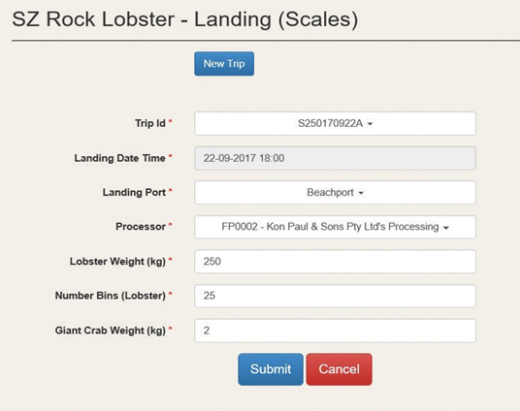
This report captures data relevant to the transaction of your catch. If you are unable to use the scales, you must complete your reporting before departing the scales by logging on to eCatch or by calling 1800 eCatch (1800 322 824).

- If this is not the first eCatch report for the day, find your existing trip ID. If this is the first eCatch report for the day, select ‘New Trip’.
- To consign to multiple processors, allocate the first partial consignment to a processor by changing the number of bins and then follow the prompts to assign to the next processor.

Trip Reports

Landing Outside of Core Hours
If you are landing your catch outside the core hours of 08:30 and 17:00 hours, you must complete a ‘Landing Outside Core’ report. You are required to report at least one hour before removing the Rock Lobster from the main vessel.

TEPS Report
This report captures data relevant to the Commonwealth legislative requirement to report interaction with threatened, endangered and/or protected species.
Select the ‘TEPS Report’ tab, find your existing trip and follow the fields.

Broken Tags
This report records when broken tags have been replaced.
Select the ‘Broken Tags’ tab, find your existing trip and follow the fields.

Dashboard and Managing Errors
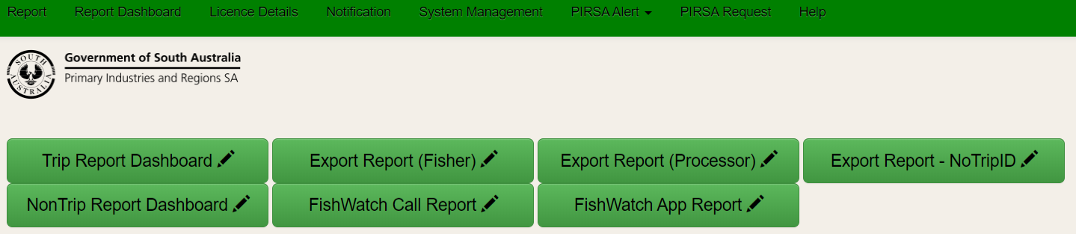
The ‘Report Dashboard’ enables you to access the ‘Trip Report Dashboard’ (both circled below) to view reports and correct errors.
Errors in your dashboard will show ‘Pending’. Select ‘Show Details’ to view the error. Find the activity with the error and click on ‘Edit’. All errors need to be reconciled by you through this dashboard.
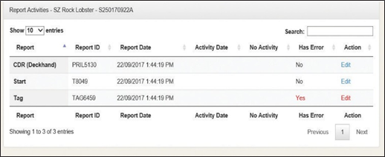
- eCatch will provide additional information regarding the error
- Ensure all fields indicated with an * are completed prior to clicking ‘Submit’. An error message will be displayed if fields are missed.

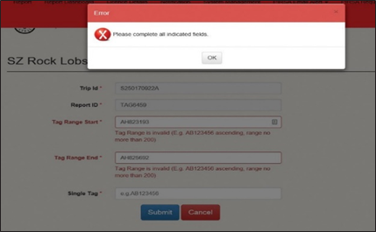
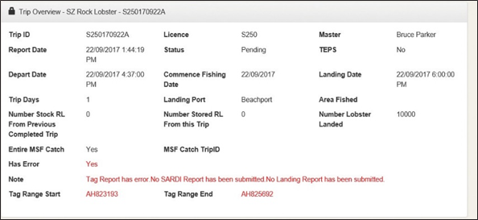
Non-Trip Reports
The following Non-Trip Reports can be made via eCatch.
- Bait net
- Deregistering vessel for Recreational fishing
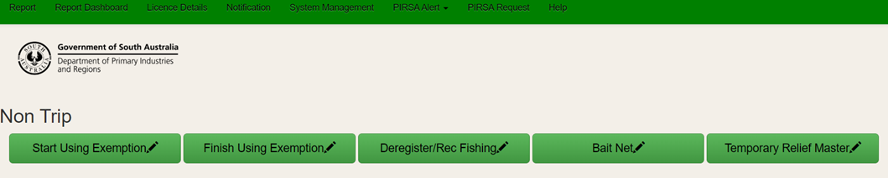
To access these reports select ‘Report’, then select ‘NonTrip’ both circled below.

More information
For more information about myPIRSA or eCatch, please contact your local PIRSA Fisheries Officer or Fishwatch via 1800 eCatch (1800 322 824).

