ENHANCED ABATTOIR SURVEILLANCE PROGRAM

Hydatid tapeworm (Echinococcus granulosus)
Hydatid cysts are the cystic stage of the dog tapeworm Echinococcus granulosus. This parasite normally infects livestock and dogs, however it can also infect people and can cause very serious illness. Hydatids are extremely rare in South Australia. Areas of infection in other states are often associated with circulation in wildlife and poor control in farm dogs, and not being able to effectively control infection in wild dogs and to a lesser extent foxes.
Condition summary
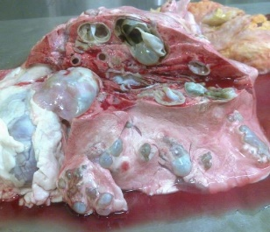
Hydatid cysts are fluid filled sacs usually found in the liver and lungs. They sometimes become very large in sheep and other animals. Cysts can also be found in the brain, kidneys, spleen or heart. In South Australia suspected hydatids are most commonly confirmed by the laboratory to be congenital liver cysts and not hydatids.
Hydatids do not affect sheep health or production on farm. The economic consequences of hydatid infection in livestock are considered to be negligible.
If a suspected hydatid cyst is detected at the processor, affected organs (commonly liver and lungs) are condemned, and samples are also sent to the laboratory for testing.
There is no treatment for hydatids in sheep. Control involves monthly worming of dogs with a tape wormer, preventing carcase scavenging and avoiding feeding of raw meat/offal to dogs. Effective control of hydatid tapeworms in dogs will also control sheep measles which is a common cause of carcase condemnation hence economic loss.

Hydatid cysts in sheep lung (Image provided by Tom Collyer)

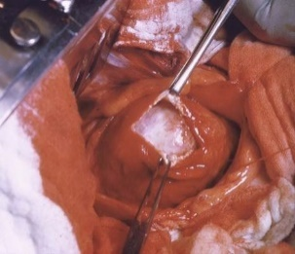

Hydatid cyst being surgically removed from human lung (Image provided by Tom Collyer)

Why should I be concerned?
Although rare, hydatid disease is a serious human health concern that is potentially fatal, with children being more vulnerable to infection.
People become infested by the accidental ingestion of eggs passed by adult hydatid tapeworms in dogs. Human infection most commonly occurs when infested dogs are handled due to the sticky eggs being present on the dog’s coat.
Children are more commonly affected due to their close association with dogs and inability to manage good hand hygiene. People do not become infected by eating sheep meat or offal contaminated with hydatid cysts. Symptoms can occur a long time after infection, sometimes months or years later.

How do sheep get tapeworm cysts?
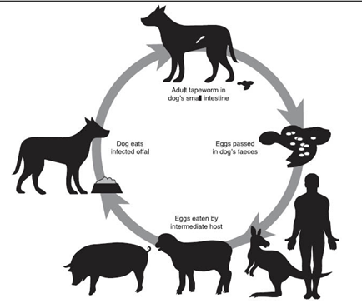
Dogs are infested when they eat raw offal or meat containing tapeworm cysts from infected sheep or other animals. The adult tapeworms are found in the intestines of dogs, including foxes and dingoes, and infective eggs are passed onto pasture in dog faeces. Eggs can be spread by insects, wind and water, and are also very sticky.
© State of Western Australia (Department of Primary Industries and Regional Development, WA)
Sheep are infected by ingesting tapeworm eggs from dog faeces on contaminated pastures. The eggs hatch and the larvae migrate through the body to form fluid filled cysts usually in liver and lungs. Eggs can survive on pasture for months. Other animals such as kangaroos, wallabies, wombats and pigs, as well as humans can also be infected (“intermediate hosts”).

How do I prevent hydatids?
- Worm your dogs monthly with a tape wormer containing the active ingredient praziquantel.
- Don’t allow dogs to eat raw sheep or goat meat or offal.
- Practice good hand washing hygiene to protect humans against infections.

Some handy tips include:
- Ensure all dogs coming on property have been appropriately wormed in the past month, including dogs belonging to shearers, livestock transporters, retired working dogs and pets.
- Don’t allow dogs to eat raw sheep, goat or kangaroo meat or offal. Ensure meat is thoroughly cooked or frozen for two weeks at -10°C.
- Stop dogs from scavenging or roaming, and when not working, tie up dogs or keep in a run.
- Clean up and dispose of dead sheep quickly and effectively by burning or burying.
- Prevent dogs from toileting in vegetable gardens and near children’s play areas.
- Wash hands after handling dogs, before eating and smoking, as tapeworm eggs are very sticky, and don’t let dogs lick faces, especially those of children.
IMPORTANT POINTS: Hydatids are parasite cysts in sheep, caused by ingestion of eggs from the dog hydatid tapeworm, Echinococcus granulosus. It can cause serious and sometimes fatal disease in people, with children being especially vulnerable. Regular monthly tape worming and not feeding offal to dogs can control the disease. Controlling hydatids will also help to control sheep measles, caused by a tapeworm with a similar lifecycle.

