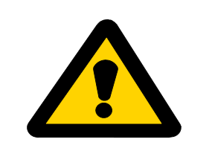
NOTIFICATION OF POISON BAITING PROGRAM
Dear neighbour
This is to inform you that my poison baiting program for the control of pest animals is about to commence on my property.
Poisons pose an extreme risk to your livestock and domestic dogs. Please take steps (e.g. restraint or muzzling) to make sure your dogs does not have access to the baits or affected animals.
I will leave baits for wild dogs in place until they are taken or decompose – I do not need to collect them.
All baits remain toxic for at least 12 months, even after rain. I will make every effort to remove all untaken rabbit baits, but some may be moved by animals but not eaten, and these may remain on the ground.
I will not lay baits within 5 metres of my property boundary, nor within 150 m of your dwelling.
I will erect signs warning of the poison baits at the property entrance to, and around my property boundary.

Property where baits will be: ______________________________________________________________________________________________________________________________________________________________________________
Dates of poison baiting program: _______________________________________________
Untaken baits will be collected by: ______________________________________________

(circle applicable bait situation)
Toxin: 1080 Pindone PAPP
Target Animal: Rabbit Fox Wild Dog
Bait Type: Grain Capsule
Situation: Property CPE

Please advise all other people on your property about this baiting program and the risk to dogs.
Contact the baiter: Contact the LSA Board office:
Name: __________________________________ Name: _________________________________
Phone number: ___________________________ Phone number: __________________________

