Jamestown District Office

The town of Jamestown was surveyed in 1871and is located 200 km north of Adelaide. It remains a major service centre for northern agricultural cropping areas and the North East pastoral region.
Jamestown has been at the heart of agricultural development in these regions from the 1880s.
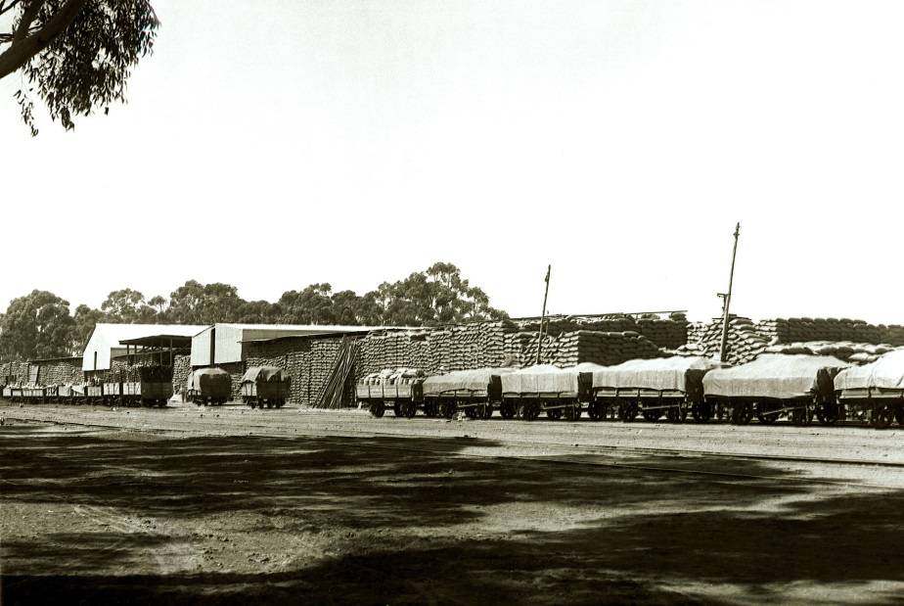
Jamestown grain stacks -1910
Image PRG 280/1/1/17/86
State Library of SA

In 1928, the Department of Agriculture established the Upper North District to better service farming industries and appointed Mr E.L. Orchard from Roseworthy Agricultural College as the first District Instructor.
Mr E.L. Orchard, stock inspectors Mr S.A.C. Curtis (pre 1928), T.D. Bilson (1928-1947), dairy adviser J.O. Hatter (1928 – 1946) and other staff that followed, worked initially from home and then from rented office space. In 1960, the Department of Agriculture purchased premises in Irvine St which remains the current Jamestown office location. It developed as the local centre for engaging with the farming community and delivering State government, Commonwealth government, and industry funded programs as circumstances changed.
Jamestown office building in Irvine St built in 1960.

Numerous young officers located initially at the Jamestown office went on to hold important Department of Agriculture management roles later in their careers.
Innovative new agricultural industry programs were pioneered at Jamestown and later introduced to other districts in South Australia. Some of these major innovative programs included introduction of soil conservation methods, adoption of whole farm management and budgeting techniques, development of the nitrogen and phosphorous calculators and improving sheep genetics for the wool industry. Details of many of these programs are provided in this article.
Jamestown has also been an operational base for many programs delivered in the northern pastoral regions of the state. These include revegetation programs, locust and grasshopper control programs, Brucellosis and Bovine Tuberculosis Eradication programs (BTEC), and operation of the Oodlawirra fruit fly roadblock.
Since 1928 the staff at Jamestown became part of, and learned much from the rural community. They have helped the regional farming community change and adapt in the face of droughts, depressions and recessions, commodity price changes, changing markets, and changing government policies. Jamestown staff have played a key role integrating new technologies and efficiencies into farming and pastoral businesses that make up a thriving rural community.

The Early Years
South Australia has had a strong reliance on agriculture, to feed the people and generate export income, since the first days of establishment of the colony. Land was progressively cleared predominately to expand wheat growing, as the main source of State income. The Journal of Agriculture was the main vehicle for agricultural extension articles and the Agricultural Bureau branches, made up of local farmer groups, its target. The branches provided the point of contact between the practicing agriculturalist and expert officers. The Bureau branches were considered to be part of the Department of Agriculture; as its outposts and conduit for change in regional areas.
Mr Orchard’s role at Jamestown was to support branches of the Agricultural Bureau by addressing meetings on topics of their choosing or matters relative to the season, visiting farms, and being part of regional district tours for branch members. Considerable attention was also given to the smooth working of the Bureau organisation and regional conferences.
Wheat crop and fallow competitions conducted under the auspices of the Department of Agriculture were viewed as having a marked effect in raising the standard of farming operations in many districts. Mr Orchard played a key role judging the crop and fallow competitions within his region.
Other early District Instructors or District Agricultural Advisers who followed Mr E.L. Orchard were W.C. Johnston (mid 1940s), Peter Angove, Jack D. McAuliffe (1950s) and Bruce G. Hall (1960s).

Diversification - Surviving the Great Depression and 1930s Drought
World overproduction of wheat and release of large volumes of stored grain onto world markets in the late 1920s resulted in plummeting grain prices. During this period, world wheat prices were 50% below the cost of production. Thus many farmers could not afford to buy superphosphate to maintain productivity.
Drought during the late 1920s and early 1930s put government drought relief programs under the spotlight, and by 1931 were already creating major strains on Government funds. Opinion was emerging that wheat farming had extended too far north into less than 7.5” annual rainfall regions. This thinking was consolidated by 1938, the seventh unproductive wheat season in a row.
Low prices and depressed wheat market outlooks required a focus on increased efficiency, documentation of best farming practices per region, and a need for improved skills and education of farmers.
Farmers were diversifying into a series of sidelines like milk, eggs, butter and lambs to provide for their families and enable their businesses to survive. The Department also encouraged production of fat lambs and pork for export.
Due to the almost subsistence nature of many farms, pigs, poultry and dairying were incorporated on most mixed farms. This was to utilise “waste products” and supply a steady income and food source throughout the year. Poultry were fed lower quality grain with the resultant eggs used domestically and surplus sent to Adelaide by train for local consumption or pulping for export.
Most farms milked a few dairy cows to provide milk, cream and butter. Surplus milk was separated into cream and throughout the agricultural areas, dairy factories sprang up to make butter for local and export use. Pigs were added to the enterprise mix to utilise surplus grain and the skim milk.
Cream was produced on wheat growing farms and was collected and carried to a processing point for manufacture, unfortunately with deterioration over the summer months. Cream quality was occasionally an issue in butter making.
The dairy industry was well serviced by advisory officers. J Hatter was the District Dairy Adviser from the early 30s.

Soil Erosion and Conservation in the 1940s
Clearing land for cropping and a continual fallow and wheat cropping rotation had exposed land to water and wind erosion. Overstocking had also decreased ground cover. Pastoral lands too, had been exposed to wind erosion through overstocking and rabbits.
There was a need to readjust agriculture and pastoral practices to be more sustainable and reduce soil erosion.
The Soil Conservation Act was passed in 1939 giving the Minister of Agriculture wide powers to control erosion on agricultural lands. Soil erosion problems in the pastoral zone were being handled by the Pastoral Board by getting voluntary cooperation from lessees to close parts of their runs.
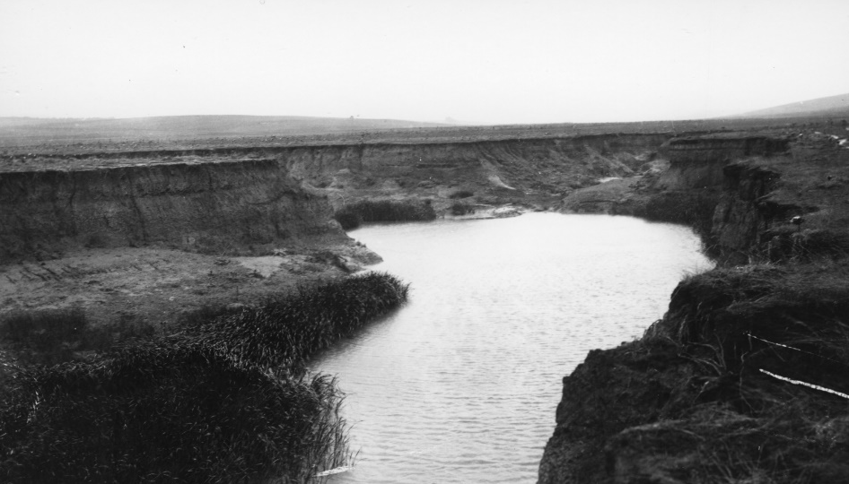
Serious gully erosion on the Hutt River, north of Jamestown, 1938
Source: PIRSA image 105533

Heavy January rains in 1941 led to catastrophic soil erosion in the Jamestown and other areas of the State. In response, the Department launched a major soil conservation program in the Mid North, providing technical assistance and increasing awareness of erosion issues through field days.
The Soils Division of the Council for Scientific and Industry Research (later CSIRO) began a detailed survey of soils and erosion in County Victoria, the first attempt in Australia to map and classify erosion on a large area, but the scope was reduced due to World War 2pressure on resources.
The Jamestown Department of Agriculture staff conducted a farm survey on cropping history and farming methods in the Hundred of Belalie to evaluate the effect of management practices on soil erosion. This complemented the County Victoria program, giving a picture of the impact various farming decisions had on soil conservation.
A key turning point for the region resulted from the disastrous 1944 drought, considered to be a one in one hundred climatic event. The drought resulted in badly drifting land, decreased stock numbers, and reaffirmed that wheat growing in marginal lands was risky and pastoral stocking rates were too high. The Soil Conservation Branch and Pastoral Board began the process of setting permanent livestock carrying capacities on pastoral properties to allow regeneration of degraded land.
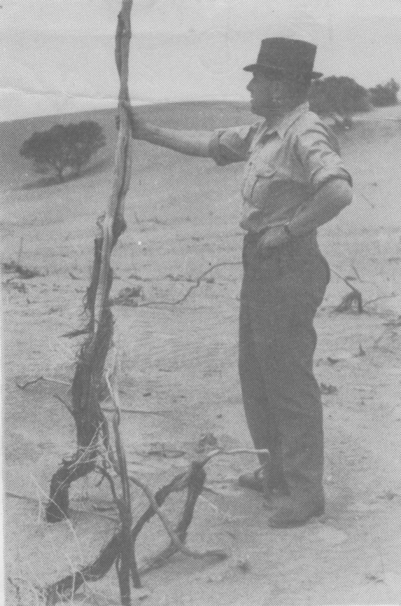
The first Soil Conservator of Soils, R.I. Herriot inspecting degraded farmland in 1940.
Source: PIRSA image 105680

The first Soil Conservator, R.I. Herriot realised farmer ownership of the problem was a critical success factor and examined the concept of Soil Conservation Boards as used in the USA. This led to the introduction of soils legislation and formal conservation programs.

Supporting World War 2 Efforts
With the outbreak of World War 2, the Commonwealth Government purchased the nation’s wheat crop, and the British Government purchased Australia’s export meat production.
The Commonwealth Government also funded drought relief to retain farmers on the land, feed starving livestock, and subsidise the planting of crops.
Few dairy farmers were wealthy and their income from milk and cream was spasmodic. Largely because of the need to organise industries during the Second World War, governments began to regulate such matters as pricing, health and safety. Dairy and factory hygiene was regarded as extremely important by governments.
Modelled on United Kingdom committees, 15 District War Agricultural committees were established in 1943. They functioned throughout the State to safeguard rural interests and develop production according to the requirements set by the Commonwealth Production Goal Committee.
There were two chaired by Jamestown based officers; the Upper North Committee based at Jamestown (E.L. Orchard) and the Western District Committee based at Crystal Brook (J.O. Hatter). The committees were required to investigate manpower requirements, survey labour availability, the pooling of this labour, managing the purchase of agricultural machinery, windmills, fencing and water piping and the control of ammunition for pest control.
The shortage of manpower increased the use of tractors, especially after introduction of the Lend Lease Program in 1942.

Post War Years
The District War Committees were disbanded in 1946. Jamestown staff then focused on post war work in the region such as assessing submissions and providing assistance with rural training schemes, assisting the Repatriation Commissioner and the Commonwealth War Service Land Settlement Scheme.
Following World War 2, tractors replaced horses, pastures were improved, fallowing reduced, and rotations widened; which helped reduce soil erosion.
The Commonwealth Government made money available to the States to expand advisory services and stimulate food production. The Department actively expanded technical staff numbers as a result, including at Jamestown. Mr A.T. Hooper replaced Mr J.O. Hatter as Dairy District Adviser in 1946.
The dairy advisers across the State aimed at improving husbandry methods through advice given at farm visits, Bureau meetings, field days and herd judging competitions. They also reported on farm demonstrations under the Dairy Industry Efficiency grant arrangements and did survey work on district developments and trends in dairying and diseases such as mastitis.
There was a drive to encourage dairy farmers to keep more detailed records of production and management methods, which served as a basis for discussion, analysing trends and pin pointing the most desirable husbandry practices, particularly on low and average production farms.
Dairying was a significant industry in the Mid North region, supplying dairy factories at Laura (milk, ice-cream), Whyalla (bottled milk), Clare (carton milk) and Saddleworth(cheese) and several regional cream depots.
These regulations were even more important after the war, as the population of urban areas grew rapidly through immigration and a rising birth rate, and people demanded fresh milk daily.

Their success and a strong global demand for dairy produce led to the construction of several new dairy factories in South Australia during the 1950s. By this time a range of products, including powdered milk, were sought for export and local consumption.

Extension to farmers in 1946 was still predominately through the Agricultural Bureau system, which now had 8,780 members state wide.

1950 to Regionalisation in 1979
In the early 1950s markets changed and Australia was now in open competition for the British market. Buyers were looking for quality not quantity and there was a need to increase efficiency to produce the quality product demanded.
The complexity of modern agricultural science meant it was necessary for technical officers to specialise. The Division of Extension Services and Information was formed to direct and coordinate extension and information services across the state.
- Soil Conservation
By 1952, three Soil Conservation Boards were operating; in the Murray Mallee, Murray Plains and Upper Eyre regions. The Yorke Peninsula Soil Board was approved, and there was another application to establish the West Broughton Board.
The Soil Conservation Branch recruited 3 soils officers to Jamestown in 1953 namely Geoff Robinson, Peter Barrow and Arthur Tideman.
Contour banking, trialled initially at Blackwood Experimental Orchard, and contour furrowing trial projects began under the guidance of the soils officers at Jamestown, as did planning for siting of dams. Across the State, the Department did the planning and provided for a small fee, graders to implement contouring projects.
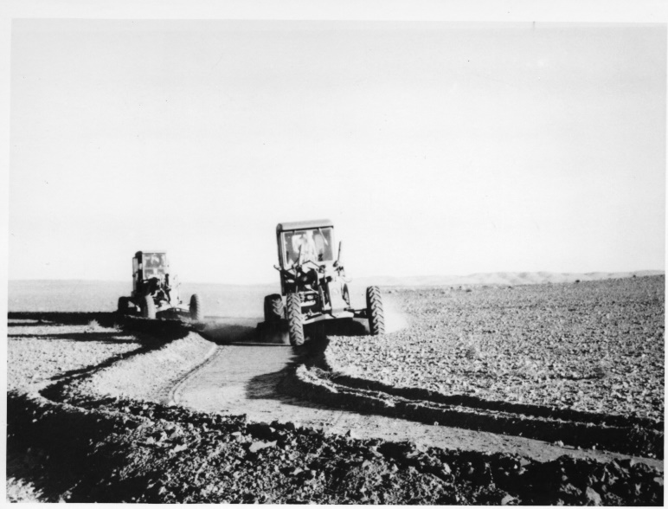
Constructing contour banks with road graders in 1960s.
Source: PIRSA image 105572

The Soil Conservation Branch started intensive soil schools for farmers through the Agricultural Bureau branch network including the Mid North region and in 1957 was promoting land use based on whole farm plans. Pasture establishment and renovation trials on highland country were carried out.
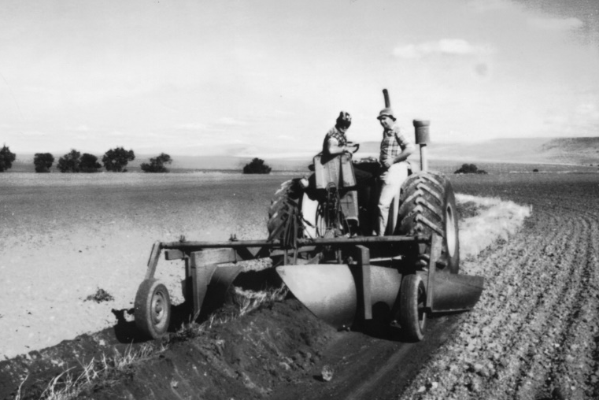
Constructing contour banks with a Booleroo plough in 1960s.
Source: PIRSA image 105563

Departmental soils officers based at Jamestown were secretaries to the West Broughton Soil Conservation Board from 1953 and supported the Board with delivery of on ground works. Secretaries to the West Broughton Board during this period were Peter Barrow (1953-1956), Bill Matheson (1957–1965), Gavin Young (1965–1979).
In 1975 the Australian Government made funds available for approved soil conservation projects. They partly funded the Board’s Pisant Creek Scheme and later the Koolunga, Redhill and Narridy Creek projects by offering subsidies for earthworks and fencing.
The West Broughton Soil Board reported that 25% of class 3 land was contour banked in 1964, and had grown to 60% by 1976.
- Pastoral lands
Pastoral management was predominantly the realm of the Pastoral Board.
The Willochra Plains area centred around Hammond (between Quorn, Wilmington, Orroroo and Carrieton) was settled from 1875 for grain growing. It is low rainfall country outside of Goyder’s Line. Above average rainfall during the 1880s encouraged grain growing, but reversion to normal rainfall patterns saw many farms abandoned and significant erosion problems. Surveys in the 1950s followed by programs of rehabilitation and conservation measures addressed drift problems in this area. Much of this country has now reverted to pastoral use.
In 1956 it was decided to investigate means of re- establishing native vegetation cover on scalded land in the Northern Marginal lands of South Australia (Peterborough to Hawker) using contour furrows.
Trial sites were set up at Dawson (Merngenia Station), Ucolta and Hammond using collected native seed. A variety of perennial species were planted in 1956, 1959 and 1960, fenced from stock and monitored until the early 1970s.
The outcomes were that species needed to be suited to the soil type, sown in winter into freshly cultivated furrows or pits and be protected from livestock for revegetation to be successful.
- Animal Health Services and Livestock Advisers
Animal Health services were initially provided by Stock Inspectors at livestock markets checking for lice and weed seed contamination, certification of interstate stock movements (mainly stud Merino sheep), and investigation of regional animal health cases that arose. In addition to the Mid North district Stock Inspectors serviced the North East Pastoral and Upper North regions.
More specialist Animal Health officers were recruited from 1960toinvestigateanimal disease occurrences, assist farmers with stock health issues, and were responsible for implementing the State’s Brucellosis and Bovine Tuberculosis Eradication programs in the Upper North and North Eastern Pastoral regions in the late 1970s. The Jamestown based Veterinary Officer in the late 1970s was Dr John McCosker.
Livestock Officers had an animal industry development role. Peter Carr (1971-74) was transferred to Jamestown as the first Livestock Officer with a mandate to bring population genetics to the merino stud industry and to drive improvements to the SA sheep industry. He was followed by Peter Barber who developed flock modelling and sheep production calculators.
- Whole Farm Management
In 1956 the Department of Agriculture identified that to improve the uptake of technical advice, there was a need to take account of farm management considerations like cost/benefit analysis, financial capability, and farmer capacity to implement change.
The decision to establish a “whole farm approach” within the advisory services required greater support from agricultural economists. Suitably skilled staff were recruited and based in Adelaide.
Whole Farm Management involved collecting and analysing financial and production data, then using group meetings to compare results, and identify the key drivers for a profitable business. This process enabled specialist technical information to be applied; taking account of the complete structure of the farm, its location, soils, pattern of production, capital investment and the personal preferences of the farmer and his family.
Further information can be obtained from the article “Economics and the development of farm business management in the SA Department of Agriculture 1955-70” by Venton Cook by linking to: www.pir.sa.gov.au/aghistory/left_nav/department_of_agriculture_programs/economics_and_marketing
A pilot Whole Farm Management program was started in 1958 with advisory officers based at Jamestown, led by Jack McAuliffe. Initially 29 farmers were cooperating with extension staff. In 1959, this concept was expanded to include 26 farmers from Mt Gambier plus another 40 across the state.
The number of whole farm groups grew rapidly between1965 and 1968, with 25 groups involving 400 farmers formed. These included specialist groups in dairy, poultry, and wheat/sheep.
The program was aimed at improving the skills of extension officers and became the main focus for extension officer training.
In the 1970s, wheat overproduction resulted in the introduction of production quotas and controls. Dairy farmers were also experiencing difficult times. Farmers were looking to diversify into a range of new crops. This crisis demanded greater emphasis on farm management techniques.
In the late 1970s, new sheep production calculators were developed by John Pauley, Agricultural Economist Adelaide, and Peter Barber, Livestock Adviser Jamestown. These used gross margins, linear programming, and sensitivity analysis, to enable modelling of flock comparisons and flock build up scenarios.
- Dairy Industry Development
A5-year Commonwealth grant to encourage dairy efficiency and production expired in June 1953 and was extended for a further 5 years with a focus on improving the efficiency and quality of the supply chain and factory output. There was a major drive to improve cheese quality.
Wilf Bowen replaced A.T. Hooper as the Dairy Adviser based at Jamestown. Between 1956 and 1968he had an interest in utilising the farm management service concept in the dairy industry. A farm management survey of dairy farms of the River Murray reclaimed swamps was the trigger for the Mid North broadacre program.
For further information, see: “History of Dairy Industry in the Mid North” by Geoff Norman and Wilf Bowen by linking to: www.pir.sa.gov.au/aghistory/livestock/dairy
- Crop Agronomy Services
Field officers continued to assist with and promote the adoption of crop diversity and the integration of a pasture phase in the rotation (ley farming).
Gavin Young was seconded to a SA Government negotiated an international project in Libya to introduce the ley farming system.
Further information about development of South Australia’s wheat industry can be accessed at: www.pir.sa.gov.au/aghistory/cereals_and_grains
- Vertebrate Pest Control Authority
In 1977 the Vertebrate Pest Control Authority (VPCA) became part of the Department of Agriculture and Agricultural Adviser, Dale Manson was based at Jamestown that year as part of a new state-wide network to oversee programs focused on dingos, rabbits and foxes.
- Clerical Support
Office expansion at Jamestown required the appointment of a typist Margaret Gleeson to run the office (1955-60). Subsequent clerical officers during this period were Joyce Jacka (1960-1970), Karen Pfitzner, Monica Redden and Sharon Hagger (1979).

1979 to 1998: RegionalisationtoRural Solutions
Regionalisation of Department of Agriculture services in 1977resulted in the creation of Central Region in 1979 and subsequent appointment of Gavin Young as the Senior District Officer at Jamestown. He was responsible for programs across all disciplines that were run from the Jamestown office. Phillip Warren replaced Young on his retirement in 1986. In 1990 Warren had a wider role as Acting Regional District Officer over the three offices servicing the Upper North, Mid North and Yorke Peninsula.
Regionalisation and now regional management gave more flexibility to address regional issues alongside State and National agendas.
- Collaboration: soils, agronomy, livestock and farm management
From articles in Stock Crop and Country it was clear that all disciplines were complementing each other. In the early 1980s to the late 1990s the main focus was responding to a situation where negative economic drivers such as falling commodity prices, the collapse of the reserve price for wool, droughts, and changing market demands were putting immense continual pressure on farm viability; forcing change.
- Agronomy
Farmers increased the intensity of cropping and over time included new crops such as grain legumes and canola, all with new regional issues, including the real risk of increased soil erosion. Farmers also needed to increase efficiency in the cost price squeeze they were facing.
They consequently needed and therefore supported obtaining local trial results on pasture and crop varieties, fertilizer requirements, the benefits of liming or adding gypsum to soils, and options to meet changing market specifications like being paid for high wheat protein, or large lean lambs. So that more intense crop rotations could be sustainable, farmers had to consider and integrate where appropriate, new decision making aids. These included soil testing for soil fertility and organic matter levels, and soil and plant tissue tests for making fertiliser application decisions.
Practices like stubble retention, minimum tillage, direct drilling and spraying out grasses in pasture to control cereal diseases in the following year were adopted. This in turn impacted on grazing management decisions as crops now had weed free stubbles, and with improved harvesters leaving less spilt grain, the grazing time on stubbles was dramatically reduced.
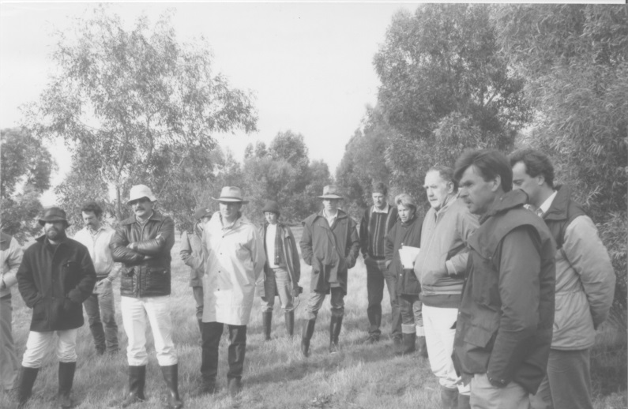
Farmers and agronomists attending a soil salinity workshop at a trial site near Jamestown in 1970s.
Source: PIRSA image 105743

A range of strategies from agistment to spring lambing and feedlotting were considered as ways of reducing the impact of this new feed shortage. With crop intensification came less pasture availability over winter and spring which required increased supplementary feeding, or later lambing or feedlotting over the break. A common strategy was to simply reduce the numbers of livestock held on farm.
New pasture legumes were regularly trialled on farm trial sites as part of the need to efficiently produce animals to increasingly strict market requirements. The techniques to manage pasture seed set and assessing dry matter levels in pastures to guide stock carrying capacity were investigated and promoted.
Programs increasingly involved the farming community and focused on existing Agricultural Bureau branches.
- Vertebrate Pest Control Authority
When Dale Manson took up the position of Livestock Adviser at Jamestown in January 1981, his former VPCA Agricultural Adviser role was transferred from Jamestown to the Kadina District Office.
- Soils and Landcare
The Northern Marginal Lands project aimed to decrease the risk of soil erosion and rehabilitate degraded areas. The Conservation Farming on Red Brown Earths project aimed at investigating and integrating new farming practices. Specific project officers were appointed.
The Narridy Creek Group Catchment Scheme project aimed to develop cooperative plans with farmers to control water erosion and runoff.
Richard Payne developed the Phosphorous and Nitrogen Calculators which were used across South Australia and interstate and was the catalyst for a major change in thinking on fertiliser decision making. It was incorporated into cereal production advice.
The Nitrogen Calculator turned the scientific theory of nitrogen flows into a practical tool for working out how much nitrogen should be used. For most it meant a quantum leap in the amount of fertiliser applied and gave an accompanying increase in production and potential yields. He also developed the organic matter calculator.
Soils staff still supported the West Broughton Soil Conservation Board as secretary (Gavin Young (1979-1984), Chris Auricht (1985), Mary-Anne Young (1986-1996) and with on ground works associated with contour banking. In 1997 the West Broughton Board contracted its own secretary and subsequently trained local people to survey contour banks instead of the Departmental Soils Officers, who were charging for services.
The National Landcare program and the Decade of Landcare commenced in 1989. Landcare Officers, Jean Turner (1990-1995) and Trudie Stanley (1995-1998) were stationed at Jamestown to promote the program and support local Landcare groups during this period.
For a review of Landcare see www.pir.sa.gov.au/aghistory/left_nav/natural_resources/landcare_and_volunteers
- Livestock
Following the resignation of Peter Barber as Livestock Adviser late in 1980, Dale Manson was appointed to the position in January the next year. A key activity now was the process of empowering producers to utilise comparative measurement tools through participation in wether trials, beef carcase competitions and prime lamb assessments.
When Dale Manson transferred to the Murray Bridge Livestock Adviser position in 1983, Albert Singh was appointed as Livestock Adviser with a primary focus on sheep production economics, management, reproduction, nutrition, and particularly Merino sheep breeding.
He was state coordinator for Woolplan, the National program aimed at using objective measurement to improve ram selection on studs to better produce rams that met future market demands.
The Government Veterinary Officer based at Jamestown, Chris Taylor, was relocated to Clare in 1989 when it became the management centre for the Clare, Jamestown, Nuriootpa and Kadina offices. The Stock Inspector role was provided from 1994-2001 by Mike Stanley from Clare with a “hot desk” available at the Jamestown office.
A sheep feedlot near Jamestown in the 1980s.

- Farm Management
Farm management economics became increasingly important.
Sheep production groups were operating into the mid 1980s across the state run by livestock officers, including the Laura production group coordinated by Albert Singh with members of the Laura Agricultural Bureau.
Philip Warren was farm management adviser (1990-93) and subsequently had the roles of soil economist reflecting the importance of managing the soil resource (1993-94), then senior economist (1994-95) and senior analyst (1996-97). Throughout he provided outlook information, and enterprise gross margin analysis.
These roles reflected the importance of farm management and the increasing use of farm computers and farm business programs in farm management decision making. He also provided counselling and assessment of financial positions which helped people make hard decisions about their future and leaving farming.
- Rangelands projects
Technical Officer (Pastoral) Peter Butler’s projects in the North East Pastoral and Flinders Ranges area involved trialling techniques and providing advice in revegetation options for pastoral lands including seed collection and direct seeding. The Dawson Paratoo project to reduce erosion risks and revegetate degraded lands followed under the guidance of Trevor Dooley. Jenny Bourne was based at Jamestown as the district planning officer for the Pastoral Soil Conservation Boards.
- Clerical Support
Sharon Hagger and then Deirdre Joss continued to provide full office management and phone services, took responsibility for producing Stock Crop and Country and took on other duties as required such as collections officer for Fisheries related fees, and supporting Locust control programs.
Sharon Hagger returned (1990-1996) as the Soils/Landcare projects clerical officer with funding from federal projects.

Rural Solutions
In 1998 the Primary Industries and Resources SA (PIRSA) extension and office staff were put into a new organisation, PIRSA Rural Solutions, a business unit within PIRSA, and titles of staff were changed to consultants to reflect a fee for service agenda. Management was again centralised.
In this purchaser/provider model, PIRSA’s Divisions had access to the finance allocated to the agency from the state and potential industry and Commonwealth Government partners. The Divisions commissioned Rural Solutions staff or private consultants to deliver programs on their behalf.
PIRSA Rural Solutions was renamed Rural Solutions SA with a charter to return a profit above full costs. This driver led to expansion into new markets, and bidding by its consultants for interstate and international projects.
Delivery for developing regional groups and other State Government Departments may or may not have involved Rural Solutions consultants. Staff from Jamestown, as elsewhere, because of their State profile and experience, were often contracted to deliver anywhere in the state, interstate or overseas.
Following is a summary of major programs delivered in the Mid North agricultural zone and North East Pastoral Zone by PIRSA Rural Solutions and Rural Solutions SA consultants.
- Industry focus
There was a shift to facilitation through action learning groups and supporting industries rather than helping individual farmers who were encouraged to use stock agents, private consultants and product providers.
Specific targeted Statewide programs were developed. For example, the livestock program was three-fold; promoting large lean lamb, improving pasture utilisation and productivity, and increasing the rate of genetic gain.
Cost recovery and external funding was sought to drive all programs.
Livestock articles from their core programs, managed by staff elsewhere, began appearing in Stock Crop and Country reflecting a tightened state government agenda.
Forward contracting of wool, livestock and grain by producers, in response to market signals, drove focused programs.
- Agronomy
One such market driven program was as the State program to increase production of high quality wheat.
This commenced with the TOPCROP program and establishment of TOPCROP groups aiming to monitor progress and overcome cropping limitations. Michael Wurst was the state TOPCROP Information Development Consultant.
Low protein production areas were identified and information packs of technologies to produce greater than 10% protein wheat, together with workshops and forming farmer groups commenced in 1999. In 2001 the target was 13% protein.
The Upper North Low Rainfall Farming Systems project (UNFS), funded by the Grain Research and Development Corporation (GRDC) began in 2001 to increase awareness and adoption of new farming practices, and by 2010 was focussing on the integration of precision farming.
This long running project was instigated by a group of growers who initially wanted to analyse the viability of farming in the Upper North. This farming system project identified the important risk issues faced by Upper North growers associated with adopting best practice in low rainfall cropping areas. Improving farm profitability was seen as a way of encouraging the younger generation to return to the family farm, and in turn strengthening local communities.

Six UNFS groups were established and paddock scale trials and demonstrations were set up on farms to validate research or technology such as matching fertiliser requirements to crop yield potential, and integrating feed lotting and no-till technologies.
Risk areas evaluated were:
- comparing a range of rotations with varying levels of cropping intensity on whole farm profitability;
- comparing the impact on herbicide resistance of a range of cropping intensities;
- comparing the profitability of sowing the same area against varying the area sown and crop type, based on predicted yield using a range of pre-sowing indicators;
- comparing the profitability of using a range of grain marketing strategies in a highly variable production system.
With livestock key programs were, comparing the profitability of various grazing systems such as continuous stocking, drought feed lotting, production feed lotting and cell grazing for both sheep and cattle, and comparing the profitability of using a range of wool marketing strategies.
Farm business communication strategies to maintain and improve a strong business and family structure included Risk Management Business Plans funded by PIRSA, and taxation management were also addressed.
Over the life of the project, many growers adopted a range of new technologies and better practices ranging from low cost technologies such as new varieties to more complex high cost systems such as cell grazing and no-till farming.
The 2002 to 2010 drought however coincided with the project, which restricted the rate of adoption of findings.
The group became recognised nationally by funders as an important group in tackling the issues facing low rainfall cropping areas across Southern Australia and has been part of a number of GRDC funded collaboration projects across Australia and a focus for international visitors.
The farm groups were able to lever funding from Farmbiz, the National Landcare Program and the Commonwealth Enviro-fund to support the project outcomes.
More detail is provided on the GRDC website http://finalreports.grdc.com.au/CFS00002#sthash.xmVg9vWI.dpuf
- Livestock
The Statewide Better Breeding program (funded by the International Wool Secretariat) aimed at empowering commercial woolgrowers to make change in genetics by better understanding the importance of the ram, and ram source choice, in achieving a profit.
The program ran workshops across the state and had over 70 on farm ram evaluation trials on commercial woolgrower properties, with results and topical articles published in a regular newsletter. A number of woolgrowers changed bloodlines and began asking about the breeding objectives of ram suppliers and asking for appropriate objective measurement to be provided on sale rams.
Pasture Pic, a photo standard book to estimate pasture dry matter levels and ground cover was developed with the Appila and Bundaleer Pasture group. It was used to calculate grazing days to leave enough cover to prevent soil erosion. It was marketed nationally and internationally through the Kondinin group.
After a 10-year gap, a Livestock Consultant (Daniel Schuppan) was again based at Jamestown. He serviced the Mid and Upper North and the Eyre Peninsula, delivering projects addressing sheep production economics, management, reproduction and he particularly focused on pastures and nutrition.
- Soils
Intensification of production systems could result in exposing soil to erosion. From the late 1990s, Federal Government funding had become more important and increasingly drove the agenda with an increased emphasis on farmer participation, program ownership and involvement.
Programs focused on the integration of conservation farming technology. This often included a project officer and clerical support based at Jamestown. Similarly, Industry, through grower levies also funded projects.
For more detailed information about the history of soil conservation activities in South Australia, link to: www.pir.sa.gov.au/aghistory/left_nav/natural_resources/soil_conservation
- Farm Management
Whole farm viability analysis was a prerequisite for farmers to receive drought relief funding from the Commonwealth funded Central North East Farm Assistance and Exceptional Circumstances programs. Staff at Jamestown prepared farm viability analysis reports for farmers. A Rural Financial Counsellor was stationed at Jamestown for some of the Exceptional Circumstances period.

Staff locally delivered the Landcare funded, Property Management Planning Program, aimed to strategically plan and then holistically manage the farms natural resources, people, finances and the environment. They also promoted and utilised the nationally funded Farmbiz program which led to the development and delivery of training programs to improve business management.
- Natural Resource Management
The Landcare, Natural Resource Management and biodiversity agendas were strongly supported with dedicated officers in regional offices encouraging farmers and community groups to become involved.
National Heritage Trust projects focussed on native vegetation, protection of diversity in the Tarcowie region and trials associated with grazing and cropping of native grasslands.
Other projects were promoting the benefit of shelter belts in conjunction with the West Broughton Soil Conservation Board and improving the health of the Broughton River.
Soils legislation was upgraded in 2004 to the Natural Resources Management Act. This new legislation was based on regional planning for a range of natural resources, not just soils, and the Soil and Pastoral Boards were absorbed into the State’s Natural Resources Management Boards, funded by taxpayer levies.
- Clerical Support
Now regionally managed, business support services at the office were provided to Rural Solutions consultants.

Communication with the Farming Community
The network of Agricultural Bureau branches across South Australia was the backbone for communication with the farming community. The branches provided a major point of contact between farmers and expert officers.
Communication with farmers was supported by the monthly Journal of Agriculture magazine (1889 to 1976) which was distributed to Agricultural Bureau members.
With the demise of the Journal of Agriculture in 1976, Jamestown Office staff saw the need to produce their own extension publication. In 1982, the Jamestown Office staff began producing “Stock Crop and Country”, which was mailed quarterly to all registered landowners in the District. It was produced for 30 years, finishing with edition 118 in 2012.

International projects
Michael Wurst (Senior Consultant Field Crops) delivered as part of Rural Solutions SA international programs in India and Eritrea. He and other staff members (Mary-Anne Young and Charlton Jeisman) were part of the team that delivered in Australia training to Iraqi agriculturalists for AusAID, as part of a substantial training program won by Rural Solutions SA following the Gulf War.

Emergency Management Response
Jamestown staff regularly were involved in response and recovery associated with local fires and flood and fire responses across the State.

Locust and Grasshopper Plagues
Periodically South Australia’s agricultural areas experience invading plagues of local grasshoppers or Australian Plague Locusts that migrate from the channel country in Queensland through north west New South Wales and northern South Australia. The Department of Agriculture/PIRSA normally mount control programs across the state’s pastoral and agriculture districts to minimise the impact on SA’s agriculture and horticulture industries.
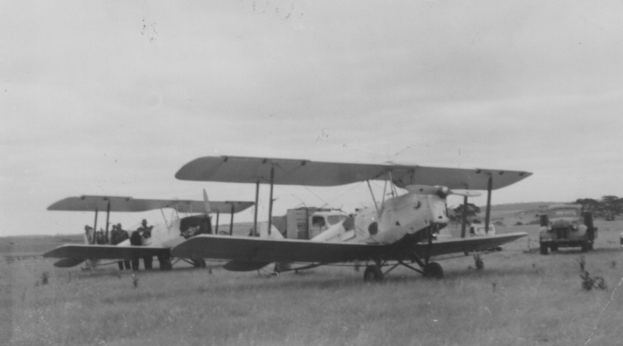
Tiger moth aircraft used for aerial spraying of locust plagues north of Jamestown in the 1950s and 1960s
Source: PIRSA image 105179

Aerial spraying operations for locusts in the 1980s.

Jamestown staff have played a key role in these control programs. The initial major locust control program was carried out in 1955 under the supervision of Jack McAuliffe. From 1980, Graham Barry, Chris Flower, Albert Singh, and Phil Warren were Officers in Charge of various control campaigns. Jamestown staff have played key roles in field surveying, operating aerial control bases, and giving field team support. The programs were State and Commonwealth funded, the biggest responses having two bases operating concurrently with substantial aerial spraying capability.
Historic reports about locust and grasshopper control campaigns can be accessed at: www.pir.sa.gov.au/aghistory/left_nav/department_of_agriculture_programs/pest_and_disease_programs/crop_protection

Oodlawirra Fruit Fly Road Block
From 1957, the Department of Agriculture commenced establishing a network of roadblocks to prevent the movement of fruit fly infested fruit into South Australia’s horticulture districts. Four fruit fly roadblocks were established at Yamba, Pinnaroo, Cockburn and Ceduna.
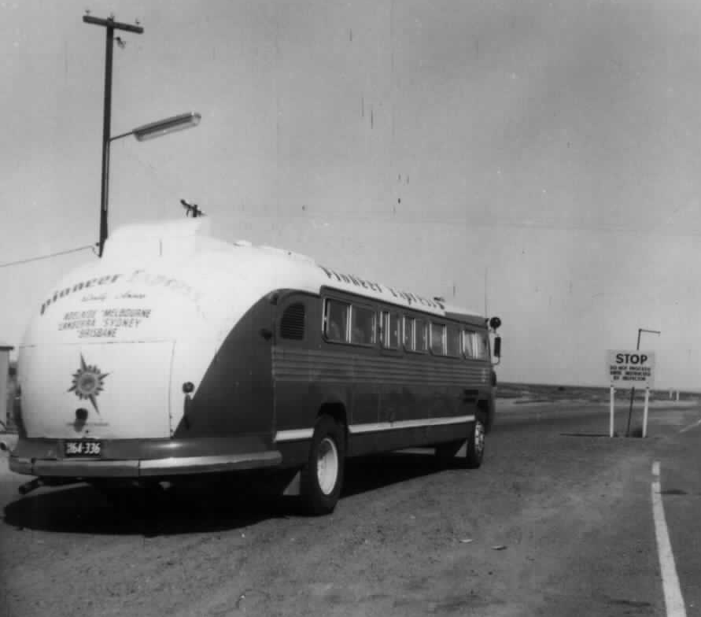
The original fruit fly inspection roadblock at Cockburn in 1964.
Source: PIRSA image 103282

The fruit fly roadblock on the Barrier Highway was initially set up at Cockburn in 1960 and operated there until May 1980. This road block was then relocated to new facilities at Oodlawirra in December 1980, and has operated at that location since. The Senior Roadblock inspector had access to clerical services at Jamestown.
In addition to assisting with the management of fruit fly risks this roadblock contributes to minimising a wide range of plant and animal biosecurity risks.

Mining Officers
In 2001 with Department restructures, mining became part of PIRSA. Compliance Officers were relocated to Jamestown from Peterborough.

Recent years
The move to larger acreages and larger cropping machinery for farms to be profitable, combined with Satellite Global Positioning System assisted farming, has resulted in a trend to remove many contour banks. This has only been possible through the adoption by farmers of practices to maintain ground cover and protect land from water erosion over the last 40 years.
The location of Rural Solutions staff became less of an issue as they worked on projects in other regions, interstate and internationally. Improving communication technologies like email, video conferencing and mobile phones enabled greater flexibility.
In response to budget pressures, Rural Solutions SA downsized significantly between 2011 and 2013, requiring rationalisation of offices. Consideration was given to closing the Jamestown office in 2014. In 2016 the office remains open but with public access restricted. Two long serving consultants, Mary-Anne Young (soils) and Michael Wurst (field crops) remain alongside two minerals officers.
Mary-Anne Young continues delivering soil related projects to a range of stakeholders within and outside the region, mentoring staff across the State and lead PIRSA’s recovery program to the 2016 Pinery fire.
Field Crop Consultant, Michael Wurst also delivers projects across South Australia but is now working mainly on PIRSA projects.
The wheel has gone full circle. But in between, staff like the community they interacted with and felt a part of, have been resilient in responding to a multitude of ever changing drivers, resulting in a great contribution to the agricultural development of South Australia.

Further Information
Department of Agriculture Organisation – Brief History to 1980 by V. Lohmeyer
French, R.J & Potter, J.S, 1975, Observations on the Re-establishment of Native Shrubs in Northern Marginal Lands of South Australia (PDF 754.6 KB), Agricultural Record, Volume 2, Department of Agriculture, South Australia, Adelaide.
Blackburn, G and Baker, RM (1952). Survey of soils, land use and soil erosion in the northern marginal lands, SA. CSIRO Soils and Land Use Series, No 6.

Jamestown Staff Over the Years
Following is a comprehensive list of staff by area of expertise located at the Jamestown office derived from staff records and recollections. Wherever possible, years of service have been listed. The contribution of all to the success of the office and its regional programs has been significant with a number of staff moving to State leadership roles within the Department of Agriculture.
Senior District Officers
Gavin Young (1979–1986)
Philip Warren (1986–1989)
Philip Warren, Acting Regional Officer (1989–1990)

Agronomists (includes District Instructors, District Agricultural Advisers and field crop consultants)
E.L. Orchard (1928–1946)
W.C. Johnston (1946-?)
Peter Angove (1948-1952)
Jack McAuliffe (1953–1959)
Bruce Hall (1960s)
Peter Mowatt (1970-1976)
Allan Hincks (1976–1983)
Peter Smith (1983–1990) and 1991
Rod Lynch 1990
Tony Craddock (1992–1993)
Michael Wurst 1993 – present (2016)
Sarah Warner, Field Crops Consultant (1999-2001)
Malcolm Johnson, Field Crop Consultant (Upper North Farming Systems) (2002–2004)
Ali Cooper, Field Crop Consultant (Upper North Farming Systems) (2004–2007)
Charlton Jeisman, Field Crop Consultant (2007–2012)
Barry Mudge, Sustainable Agricultural Systems Consultant (2009-?)
Josh Telfer (2009–2010)

Weeds
Gavin Young (1954-?)
Campbell Phillips
Neville Gilbertson
Ian Williams

Vertebrate Pest Control Authority
Dale Manson (1977-1980)

Soils & Natural Resources
Peter Barrow (1953-1956)
Arthur Tideman (1953–1956)
John Potter (1958–1962)
Geoff Robinson (1953-1956)
Bill Matheson (1956–1965)
Gavin Young (1965–1984)
Harold Blesing, Field Assistant
Peter King (late 1960s)
Bob Hagerstrom (1960–1962)
Neville Gilbertson
Peter Pearce (late1970s)
Garry McPhie (early 1970s)
Don McCarthy, Technical Officer Soils (?–1983)
Chris Auricht, Technical Officer Soils (?–1985)
Chris Flower, Field Assistant Soils (?–1985); OIC 1984 Locust program
Peter Butler, Technical Officer Soils (Pastoral) (1983–1985)
Glenn Gale, Technical Officer Soils; OIC Narridy Creek Group Catchment Scheme; Project Officer District Planning (1985–1991)
Mary-Anne Young, Technical Officer Soils – Senior Land Management Consultant (1984–present (2016))
Fairlie Bartholomaeus, Technical Officer Soils; Hawker Parachilna Group Conservation Project (1985–1987)
Trevor Dooley, Technical Officer Soils (1985–1989)
David Heinjus, Technical Officer Soils (1988)
Bruce Kennewell, Soils Officer (1989–1995)
Jean Turner, Soils Officer (1989–1990)
Richard Payne, Technical Officer Soils (1989–1996)
Trudi Bock, Project Officer: Conservation Farming on Red Brown Earths (1990–1991)
Jenny Bourne, District Planning Officer – Pastoral Soil Conservation Boards (1993–1995)
Lisa Ognanovic, Land Management Consultant (1999–2000), (2001–2002)
Catherine Miles, Land Management Consultant (2000–2003)
Melanie Rees, Land Management Consultant (2003–2006)
Melinda Hunt, Trainee Soils and Land Management consultant (2007–2009)

Federal Government Program facilitators
Jean Turner, Landcare Officer (1990–1995)
Trudie Stanley, Landcare Officer (1995–1999)
Naomi White, Landcare Officer (1999–2000)
Michael Head, Landcare Officer (2000–2003)
David Sloper, NRM Officer (2004–2006)
Mick Higgins, NRM Officer (2006)
Kimberley Heynen, NRM Officer (2006–2007)

Dairy
J. O. Hatter (1928–1946)
A.T. Hooper (1946–1955)
Wilf Bowen (1956–1968)

Stock Inspectors
S.A.C. Curtis (?–1928)
T. D. Bilson (1928–1947)
Keith Sinclair (1947–1960)
Justin Lynch (1960–1962)
Paul Heap (1965–1970)
Graham Barry (1984–1994): OIC 1984 locust program
Michael Stanley (late 1970s, then hot desk at Jamestown (1994-2001)

Animal Health Advisers
George Rankin (1964-?)
Red Hodge (1969–1975)
Warwick Hack (1976–1981)
Jeff Stringer (1981–1983)

District Veterinary Officers
Dr John McCosker (late 1970s)
Dr Chris Taylor (1981–1989)

Livestock Officers
Peter Carr (1971-1974)
Peter Barber (late 1970s-1980)
Dale Manson (1981–1983)
Albert Singh (1983–1999)
Daniel Schuppan (2009-2012)

Farm Management
Phillip Warren, Farm Management Officer (1990–1993; Soils Economist (1993–1994); Senior Economist (1994–1996); Senior Analyst (1996–1997)
Paul McInerney, Rural Financial Counsellor (2006-2008)

Fruit Fly Roadblock (Oodlawirra)
Neville Duncan, Senior Roadblock Inspector (1982–2001)

Minerals
Peter Talbot, Mining Compliance Officer Jan 2002 – present (2016)
Deane Carbine, Mining Compliance Jan 2002 –present (2016)
Steven Silvester, Mining Compliance Officer (2005–2009)
Glen Orr, Mining Compliance Officer (2012-?)

Clerical Administration and business support
Margaret Gleeson (1955–1960)
Joyce Jacka (1960–1970)
Monica Redden (1971–1979)
Sharon Hagger (1979-1985)
Deidre Joss (1985–2007)
Sharon Hagger, Soils/Landcare projects Clerical Officer (1990–1996)
Donna Kelly (2007–?)

Acknowledgements
This article was prepared by Albert Singh with assistance from Barry Philp, Wilf Bowen, Arthur Tideman, and Don Plowman. Joyce Jacka, Sharon Hagger, Phil Warren, Mark Seeliger, Dale Manson and Glenn Gale provided valuable information and comments on various versions. Thanks to all for being involved.

Published in November 2017

