ENHANCED ABATTOIR SURVEILLANCE PROGRAM

Dog bites
Dog bites are detected on inspection at the processor when wounds to the skin, resembling bite marks are found. Damage and bruising to underlying tissue is also present and unless fresh, wounds may also be infected. Bite wounds are most commonly found on the back legs.

Condition summary
Document Title Here
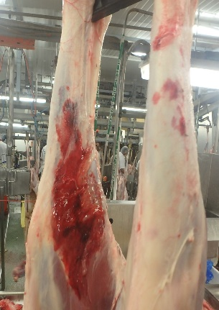
Dog bites are the result of unmuzzled or incorrectly muzzled dogs having access to sheep, either in paddocks, yards or during transport processes. Dogs are required to be effectively muzzled in stock holding facilities at the processor, and all dogs are muzzled at Thomas Foods International. Dog bites are most common on the hind quarters, but can also occur on the face or along the back.

Dog bites are a condition of welfare importance.

Bruised areas on carcases are trimmed to remove any unwholesome tissue, and in severe cases the affected part of the limb is removed. If bruising or bites are extensive or deep, entire legs may be trimmed. In rare cases where bite wounds are infected, a carcase may be condemned if the animal is showing signs of fever or septicaemia.

Prevention involves management of farm dogs, including muzzling, dog training, and utilising low stress stock handling practices avoiding the use of dogs where possible.

Dog bite puncture wounds on the hind leg of a carcase

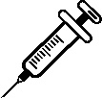

What might be seen on farm?
Dog bites and attacks on farm may result in direct death from trauma or deaths due to fly strike and secondary infections. Reduced growth rates may result from sheep being sore from trauma and less able to graze effectively or if wounds become infected.

How do I prevent dog bites?
- Farm dog management.
- Reduce reliance on dogs where possible.
- Dingo and wild dog control.

Some handy tips include:
- Muzzle biting dogs or all dogs to ensure that sly biters are muzzled. This should include dogs that belong to contractors or transporters.
- Improve dog training and management as necessary.
- Do not allow farm dogs to wander and attack in packs. Restrain dogs when they are not muzzled and not working especially at night or when unsupervised.
- Reduce reliance on dogs through good yard design which encourages easy movement of sheep and employ low stress stock handling practices.
What can I do if there are dingoes or wild dogs involved?
- If it is suspected dog bites are a result of dingoes or wild dogs see: pir.sa.gov.au/wilddogs
or contact the State Wild Dog Coordinator at PIRSA on (08) 8429 2398.
- For the Landscape Board (formerly NRM region) contact for your region and information on dingo control in your area including access to baits see details at: statewide.landscape.sa.gov.au/
IMPORTANT POINTS: Dog bites are both a significant welfare issue and a cause of wastage at the processor and on farm. Dog bites can be prevented if all dogs around sheep are effectively muzzled.

