ENHANCED ABATTOIR SURVEILLANCE PROGRAM

Sarcocystis
Sarcocystis (sarco) is a single-celled parasite, spread by cats, which forms small white cysts in muscles in sheep. These cysts must be trimmed from affected carcases. The disease exists throughout southern Australia but is more common in Tasmania and Kangaroo Island in South Australia.

Condition summary
Sarco lesions are found in the muscle of sheep at the processor. These small white cysts resemble grains of rice and commonly affect the oesophagus, tongue, diaphragm and skeletal (carcase) muscle.
Sarco does not affect sheep health or production on farm.

Light to moderate infections result in trimming of the affected muscle. This results in a reduced carcass/dressed weight. Although rare, heavily infected carcasses may be condemned.
There is no treatment for sarco in sheep. Prevention is based on preventing cats becoming infected and contaminating pasture. This includes controlling feral cat populations.

Document Title Here
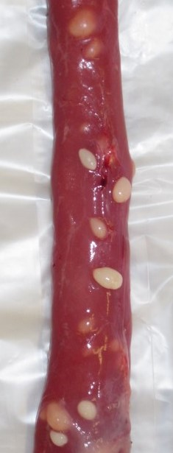

White sarco cysts on the oesophagus

What impact does this have?
Light to moderately infected animals are trimmed or boned out, which happens post grading, after the carcase is weighed. Therefore most costs are borne by the processor due to the extra labour involved and downgrading of the carcase value. Due to these added costs some processors may therefore choose not to buy sheep from high risk areas. Economic cost to the sheep industry is not well known.

How do sheep get Sarco cysts?
Sarco is a single-celled organism with a sheep-cat life cycle. It requires both hosts in order to complete its complicated life cycle:
- An ‘intermediate (sheep) host’
- Sheep ingest sarco spores (“sporocysts”) when feeding on contaminated pasture or hay/grain.
- Spores move from the gut to small blood vessels where they multiple and move into muscle tissue.
- Within the muscle tissue spores develop into cysts which are seen as small firm white lumps or cysts.
- Cysts can take up to four years to develop to full size but are visible approximately nine months after infection.
- A ‘definitive (cat) host’
- Cats are infected when they feed on infected sheep meat, often through scavenging carcasses.
- Ingested sarco cysts develop in the cat to produce tiny spores.
- These microscopic spores are passed in cat faeces contaminating pasture and/or stockfeed.
- Unlike with Toxoplasma, a gut parasite also found in cats that can cause abortion in sheep, cats don’t develop immunity to Sarcocystis and can become reinfected repeatedly throughout their lives.

How do I prevent Sarco?
Some tips include:
- Keep livestock feed secure from access by cats.
- Do not feed domestic cats (and dogs) uncooked meat or offal and do not allow them to scavenge carcasses.
- Bury or burn carcasses immediately or dispose of in a secure pit.
- Control feral cat populations.
There is no treatment for cysts in sheep or infection in cats. Prevention involves breaking the life cycle of the parasite by stopping cats eating infected sheep carcases and preventing infected cat faeces from contaminating pasture.
Cats are territorial, so completely eliminating domestic cats may allow feral cats with uncontrolled breeding to establish themselves in the same area. This may also lead to bigger problems with respect to another disease carried by young cats called Toxoplasmosis, which has a similar lifecycle to sarco, and can cause abortion in ewes.
Sporocysts, the infective stage of the sarco parasites in sheep, are present in cat faeces and can survive 6-8 months in the environment. Recent research on Kangaroo Island suggests that low soil pH and high clay content are risk factors for sarco by potentially influencing survival of sporocysts in the environment.
The effectiveness of agricultural lime to reduce survival of sarco in soils has not yet been tested but has been suggested to potentially reduce incidence of infection.

