ENHANCED ABATTOIR SURVEILLANCE PROGRAM

Cirrhosis and jaundice
Damage to the liver may result in cirrhosis and jaundice. Jaundice may also be a result of excessive breakdown of red blood cells. Common causes include fungus and mould toxins, prolonged and repeated exposure to toxic plants and weeds, copper toxicity and bacterial infection with Mycoplasma ovis which is found in the red blood cells.

Condition summary
Document Title Here
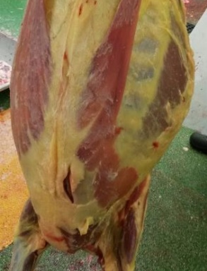
Liver damage and/or liver overload may result in:
- Jaundice: yellowing of body tissues such as gums, conjunctiva, and whites of the eyes, organs, fat and skin.
- Cirrhosis: when severely damaged liver cells are replaced by scar tissue.
Significant reductions in growth rate, weight loss, jaundice and deaths may result. Photosensitisation may also be seen. Supplementary feeding and holding stock until recovery may add significant costs on farm.
Carcases with severe jaundice are condemned and livers with cirrhosis are condemned.

Remove animals from toxin source, provide good quality hay and limited amounts of grain during recovery, ensure good hygiene during marking, mulesing and shearing, and minimise stress.

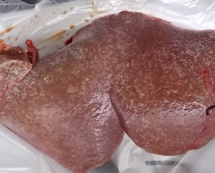
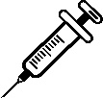
A jaundiced carcase (top) & liver cirrhosis with scarring (bottom).

What impact does this have?
Jaundice is uncommon in flocks, however it is one of the more common causes of carcase condemnation. Cirrhosis however is more common, indicating chronic liver damage which has the potential to impact growth rates and cause weight loss in stock on farm. Animals recovering from liver damage may do poorly for months afterwards and may be more susceptible to further toxic liver damage. However the liver also has significant regenerative capacity so the presence of cirrhosis at the processor may not be directly indicative of the degree of long term production losses on farm. Cirrhosis also impacts offal recovery at the processor.

How do sheep get cirrhosis and jaundice?
- Various toxins can cause liver damage and subsequently cirrhosis, the most common are associated with toxic plants and weeds including Potato weed (heliotropes), Salvation Jane, Lesser loosestrife, Caltrop and Panic grasses. Mycotoxins are produced by a fungus (Diaporthe toxica) and occur with feeding lupins (lupinosis) and spoiled or mouldy feed (aflatoxicosis).
- Jaundice is seen with Mycoplasma ovis infection (formerly Eperythrozoon ovis), a bacteria affecting red blood cells. The disease is often spread through the transfer of infected blood on contaminated equipment during management practices such as marking and shearing. Not all infected sheep will show signs of disease, but may suddenly show signs when under stress, such as during transport, and can act as carriers and spread disease to susceptible sheep.
- Jaundice may also be seen with copper toxicity, which has several causes including, excessive supplements, administration of copper, dietary imbalances such as low molybdenum and sulphate, or with certain liver-damaging plant and fungal toxins. When sheep are stressed, e.g. due to poor nutrition, yarding, transport or bad weather, copper levels in the liver reach a critical point and copper is suddenly released into the blood stream causing a massive breakdown of red blood cells, then jaundice and often death.

What might be seen on farm?
Depending on the cause, a rapid onset or a slow progression pattern of illness may be observed.
- Death may occur following stressful events such as yarding or transport or as a result of being susceptible to other diseases, such as pregnancy toxaemia, ammonia (urea) or copper toxicity and Mycoplasma ovis.
- Sheep will separate from the mob and show signs of depression, may show a sudden onset of pale gums, lethargy and jaundice 1-2 days before death. Most deaths occur within 3-5 days.
- Reduced growth rate, loss of condition, weakness, ill-thrift, disorientation, and a stiff gait with a hunched back and death may be seen over weeks or even years following ingestion of toxic plants and weeds, including feeding lupins or grazing on lupin stubble due to chronic liver damage.
- Photosensitisation (inflammation of the non-wool areas) may also occur as a result of liver damage, and is common when grazing green pasture. Sheep will develop red, swollen and crusty lesions especially on the face and ears.
How do I prevent cirrhosis and jaundice?
- Weed management and preventing stock from having access to toxic weeds.
- Check sheep daily when grazing lupin stubble and remove sheep if heavy dew or rain occurs.
- Avoid grazing sheep that have a history of liver damage that may be more susceptible to lupinosis.
- Avoid feedstuffs and mineral supplements with extra copper and treatments for copper deficiency unless deficiencies are confirmed.
- Handle and manage animals in ways that minimise stress.
- Ensure good hygiene during marking, mulesing and shearing.
IMPORTANT POINTS: Liver damage seen as cirrhosis and jaundice occur most commonly due to grazing toxic weeds such as Potato weed, Salvation Jane and Caltrop, and lupins or lupin stubble infected with a specific fungal toxin. Clinical signs can range from sudden death to chronic
ill-thrift together with jaundice and/or photosensitisation, and are usually associated with stressful events. The resulting liver damage is cumulative over the life of the animal, hence animals which recover should be culled at the earliest opportunity.

