ENHANCED ABATTOIR SURVEILLANCE PROGRAM

Tapeworm cysts in sheep: sheep measles and bladder worm
Both sheep measles (ovis) and bladder worm are moderately common conditions which are caused by the larval stage of two different dog tapeworms. On farm losses are rare, however sheep measles can result in losses to both producer and processor. Carcase condemnation may occur with sheep measles.

Condition summary
Cysts found in sheep are the larval stage of dog tapeworm parasites.
- Sheep measles cysts are small, firm, white/cream found in the muscle, including the heart.
- Bladder worm cysts are fluid filled sacs (‘bladders’) in the liver, but are also seen as scarred remnants of cysts, or tracts in the liver from migrating larvae.
Sheep measles has no effect on sheep health on farm. The same is usually true for bladder worm although migrating bladder worm larvae can occasionally trigger black disease in unvaccinated sheep.
Carcasses are trimmed from the muscle and are condemned for sheep measles if >5 cysts are detected in the carcass muscle. Bladder worm cysts are trimmed or the liver is condemned.
There is no treatment for sheep measles or bladder worm. Control involves monthly worming of dogs with a tapewormer containing praziquantel, avoiding feeding of raw meat/offal to dogs and preventing carcass scavenging.
Document Title Here
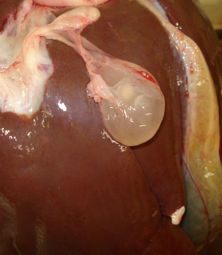

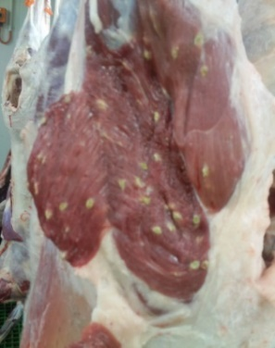

Top: Bladder worm cysticercus in a liver (sac; image provided by Tom Collyer), and remnant/scarred Bladder worm cysts in a liver (top inset) and Sheep Measles cysts in a carcase (bottom)

What impact does this have?
Sheep measles cysts must be trimmed from the muscle. This results in either reduced carcase weight or in severe cases carcase condemnation if five or more cysts are detected in the carcase muscle. Bladder worm cysts in the liver are trimmed from the liver or the liver is condemned.

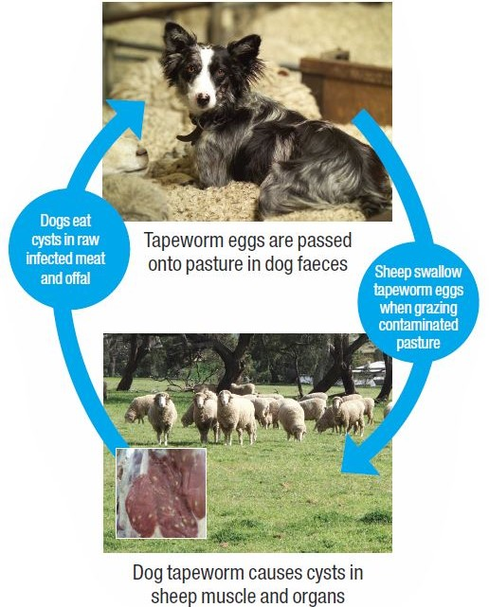
How do sheep get tapeworm cysts?
The adult stage of this parasite is found in the intestines of dogs, with infective eggs being passed onto pasture in dog faeces. Dogs are infected when they eat raw offal/meat containing tapeworm cysts from infected sheep.
Once a sheep is infected, the intermediate (or larval) stage is found in cysts in the muscle or liver of sheep which are present for life. Sheep are infected by ingesting tapeworm eggs from dog faeces on contaminated pastures. Once ingested the eggs hatch and the larvae migrate through the body to form cysts. Eggs survive on pasture for months.
What might be seen on farm?
Sheep measles cause no harm to sheep so no signs of ill health will be seen on farm. Cysts may be seen in muscle or offal (especially the heart) of home butchered sheep. Bladder worm rarely causes disease on farm but can occasionally cause death by triggering Black disease.
Black disease is a clostridial (bacterial) disease triggered by bladder worm larvae migrating through the liver, and correct vaccination can be protective.

How do I prevent sheep measles and bladder worm?
- Worm your dogs monthly with a tapewormer containing the active ingredient praziquantel.
- Don’t allow dogs to eat raw sheep or goat meat or offal.
- Burn or bury carcasses promptly to prevent scavenging.

Some handy tips include:
- Dose dog worming according to weight and round the dose up to the nearest tablet or half tablet.
- Ensure any dogs coming on the property have been appropriately wormed in the past month, including dogs belonging to shearers, livestock transporters/other contractors, friends or family who visit, and retired working dogs and pets. Untreated dogs entering properties has been associated with very high rates of sheep measles.
- Raw sheep or goat meat/offal should not be fed to dogs. Instead ensure meat is thoroughly cooked or frozen for two weeks at -10°C.
- Carry out home killing of sheep/goats in a dog proof enclosure.
- Stop dogs from scavenging or roaming, and when not working, tie up dogs or keep in a run.
- Clean up and dispose of dead sheep quickly and effectively by burning or burying.
- Excellent additional information on sheep measles can be found at sheepmeasles.co.nz
IMPORTANT POINTS: After initiating prevention strategies, it is common to see sheep measles or bladder worm on processor reports for some time. This is because scarred remnants of cysts are present for life. Control is achieved with time and persistence and although 100% eradication may not be possible, prevention measures will ensure the problem and associated economic impacts are minimized.
Note: foxes are not believed to play a major role in the sheep measles life cycle – there is no significant difference in levels of the disease seen in mutton sourced from fox free Kangaroo Island compared to the mainland.

