ENHANCED ABATTOIR SURVEILLANCE PROGRAM

Cheesy gland / Caseous Lymphadenitis (CLA)
Caseous lymphadenitis (CLA) is caused by a bacteria which causes chronic infections and abscesses in lymph nodes of the body and internal organs, especially the lungs. Infection is acquired predominantly through skin injuries. It is most common in mutton and impacts productivity on farm as well as carcase trim and wastage. Up to 50% of South Australian producers consign affected sheep to processors.

Condition summary
Caseous lymphadenitis is a common contagious and chronic disease found in sheep caused by the bacterium Corynebacterium pseudotuberculosis. It is characterised by formation of abscesses in lymph nodes and internal organs. The condition gets its name due to the resemblance the dried out pus has to cheese.
Reduced wool production – up to 7% clean fleece weight in the year of infection.
Weight loss – chronic infection can cause ill-thrift, emaciation and poor reproductive performance.
Wool contamination – from ruptured abscesses or abscesses cut open at shearing.
Trimming – abscesses are trimmed. This can result in a reduced carcass/ dressed weight.
Carcass condemnations – if infection is generalised and has resulted in whole carcass emaciation.
There is no treatment for infected sheep. Vaccination is the most important tool in preventing CLA. It will not cure affected sheep but is very effective at protecting unaffected sheep.
Document Title Here
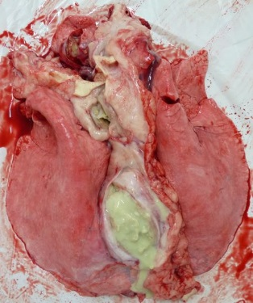

Cheesy gland abscess in lungs

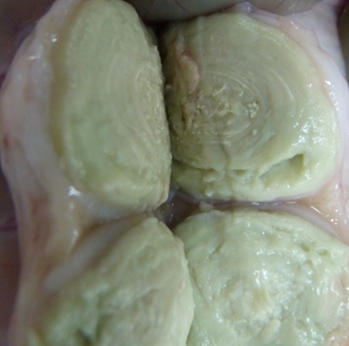
Cheesy gland lymph node abscess cut open
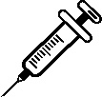

What might be seen on farm?
Initial CLA infection often goes unnoticed however sheep may show fever and loss of appetite, and then ill-thrift associated with internal organ abscesses. Abscesses may be seen if they rupture or are cut at shearing and can be felt if superficial, i.e. are in an external location. Common locations of superficial abscesses in sheep are the crease between the shoulder and neck, the flank fold and the groin.

How do sheep get Cheesy gland/CLA?
- CLA is most commonly transmitted at shearing, when infected animals with lung lesions cough bacteria on to the skin of freshly shorn sheep, with bacteria entering the body through shearing cuts.
- Bacteria can penetrate intact skin so keeping sheep confined together after shearing for off shears lice treatment or other reasons increases the chance of infection.
- Abscesses that are cut open by shearing or rupture for other reasons are also a source of infection.

How do I prevent Cheesy gland/CLA?
- Vaccination is the most important tool in preventing CLA. It will not cure affected sheep but is very effective at protecting unaffected sheep.
- Avoid or minimise contact with infected sheep by controlling management practices which reduces the spread of disease.

Some handy tips include:
- CLA is included in 3-in-1 and 6-in-1 vaccines.
- In order to be effective this vaccine must be given as an initial course of two injections and then an annual booster, ideally 1-6 months before shearing.
- Give lambs their first dose at marking and their second dose four to six weeks later (at weaning).
- The most effective time to give sheep an annual booster is four to six weeks before shearing (as shearing poses the greatest risk for infection).
- Release animals as soon as possible to minimise the time spent in close contact with other sheep.
- Minimise the time sheep are kept undercover post shearing as the bacteria will survive much longer when protected from sunlight and wind.
- Shear in age groups, starting with the youngest sheep first.
- Clean and disinfect contaminated equipment, yards and sheds properly.
- Do not dip off shears. Allow shearing wounds to heal before dipping (between two and four weeks), ensure dip fluid is clean (don’t reuse or top up fluid); and again treat the youngest sheep first.
- Segregate and cull any animals with obvious or open abscesses to prevent the spread of the disease. Dip these sheep last as they will contaminate the dipping fluid and infect other sheep, or cull them immediately.
IMPORTANT POINTS: There is no treatment for infected sheep. Prevention is the key to managing CLA. Most new infections occur at the first or second adult shearing, so it may take a number of years of vaccinating against CLA before a change is seen.

