THE RIVER MURRAY MILLENNIUM DROUGHT 2002 -2010

Prepared by Greg Cock
January 2023

From 2002 much of Australia entered in a period of low rainfall that became known as the ‘Millennium Drought’ which lasted until early 2010. In South Australia, lowest on record rainfalls in 2006 triggered impacts and responses of a full blown ‘exceptional circumstance’ drought across the State. Particularly for River Murray water-dependent industries, communities, and environments.
The State and Federal Governments delivered wide ranging support programs which were recorded in a Primary Industries and Regions report called ‘State Drought Response – 2006-2011’.
Set out here are extracts from that report pertaining to the River Murray ‘Corridor’. It summarises the:
- drought conditions, where flows in the River Murray were at an historical lows,
- impacts on water availability and allocations, with severe restrictions put in place for irrigators,
- impacts on industry, communities, and the environment, where irrigated crops were devastated, communities were under severe stress and environmental assets were seriously at risk,
- SA Government response program to offset and mitigate the economic, social and environmental impacts, and the
- learnings from the response program for the future which showed that with a combination of resilience shown by industry and the community, structural adjustments made by industry, and the highly successful support provided by governments, the region was well placed to recover despite the harsh circumstances.
Prior to the Millennium Drought, with the construction of the Hume and Dartmouth Dams and the series of weirs in the River Murray to regulate flows, there was a general understanding that the supplies of water from the river were ‘drought proofed’, until the Millennium Drought. Up until this time the amount of water on licenses was greater than required, and any shortfall could generally be managed.
In the 1980s and 1990s there were improvements to the efficiency of water use. Prime amongst these was the almost total change from furrow/flood irrigation to more efficient sprinkler and drip irrigation, management of salinity, a shift from irrigators ‘taking’ water according to a supplier’s roster to water on order, and the tradeabilty of water, all of which gave greater flexibility in water management. A compounding factor from the tradeabilty of water was the sale of previously unused allocation for use on new and expanded plantings.
The last drought of the magnitude of the ‘millennium drought’ was not within the memory of most irrigators. Irrigators were not expecting the shortfall of water that unfolded during the 2000s and certainly were not experienced in managing the situation.
Drought Conditions
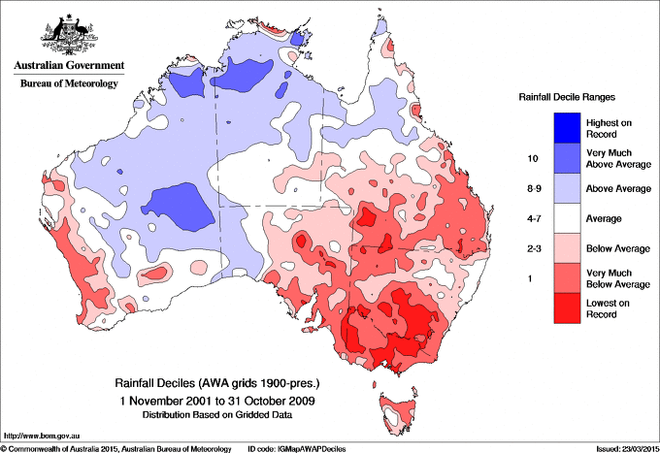
From late 1996 to mid-2010, much of southern Australia (except parts of central Western Australia) experienced a prolonged period of dry conditions, known as the Millennium Drought.
The drought conditions were particularly severe in the more densely populated southeast and southwest of the continent, and severely affected the Murray-Darling Basin and virtually all of the southern cropping zones.
Australian rainfall deciles for 2001-2009

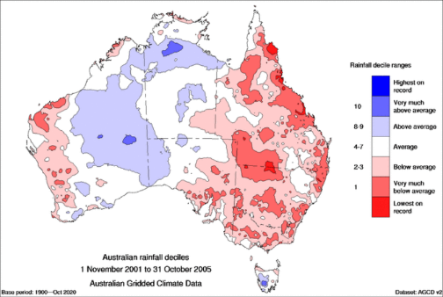
This picture is broken down to phases of the drought.

2001 to 2005: El Niño strong drought conditions

Australian rainfall deciles for Nov 2001 to Oct 2005

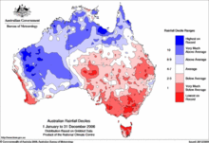

Then in 2006 extremely dry conditions set in, notably on the Murray Darling Basin

Australian rainfall deciles for 2006
At the end of 2007 the Bureau of Meteorology estimated that south-eastern Australia had missed the equivalent of a full year's rain in the previous 11 years.
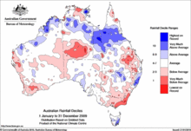
2008 and 2009 saw continuing hot and dry conditions in south-eastern Australia, with occasional heavy rainfall failing to break the continuing drought. The effects of the drought were exacerbated by Australia's (then) second-hottest year on record in 2009, with record-breaking heatwaves in January, February and the second half of the year
Australian rainfall deciles for 2009
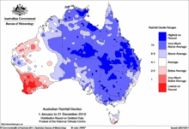
In 2010 and 2011: La Niña finally broke the drought.

Australian rainfall deciles for 2010

The declaration of drought for the ‘drought proofed’ River Murray Corridor was truly the result of an exceptional circumstance. The Murray-Darling Basin Commission (MDBC) reported in July 2006 that the River Murray system was entering its sixth consecutive year of drought.

River Murray Flows
Over the five years from July 2001 to June 2006, average inflows to the River Murray system were 4,800 GL/yr, which was about 40% of the long-term average of 11,200 GL/yr. In
- 2006 from January to July, large areas of the Basin (MDB) were experiencing record low rainfall, and rainfall over the Basin in October 2006 was the lowest on record, providing only 70 GL inflow to the River Murray system; compared to previous lowest of 135 GL in 1914.
- 2007 inflows of 30 GL in January 2007 were an historic record low (for any month), and overall, the 12-month period ending January 2007 was the driest experienced in the Basin in 115 years of historical inflow records.
- 2008, by August system remained in severe drought. Inflows during August were around 270 GL compared to the long-term average of 1,550 GL, and inflows from June to August 2008 were only 665 GL, compared to 1,025 GL for the same time in the previous year, and the long-term average of 3,340 GL.
- 2009 extreme drought conditions continued across the Basin, the volumes in upstream storages were 14% capacity compared to the long-term average of about 53% capacity, and below Lock 1, water levels remained low and salinity levels remained high due to reduced flows into SA.
- 2010 heavy rainfall from late September 2010 to January 2011 generated a number of significant inflow events across the Basin, these rainfall events allowed storages to recover, ensuring high water availability to all states for 2011-12.
The diagram below illustrates the River Murray System inflows from June to May during the period 2006-07 to 2010-11, the long-term average inflow and the average inflow over the previous 10 years.
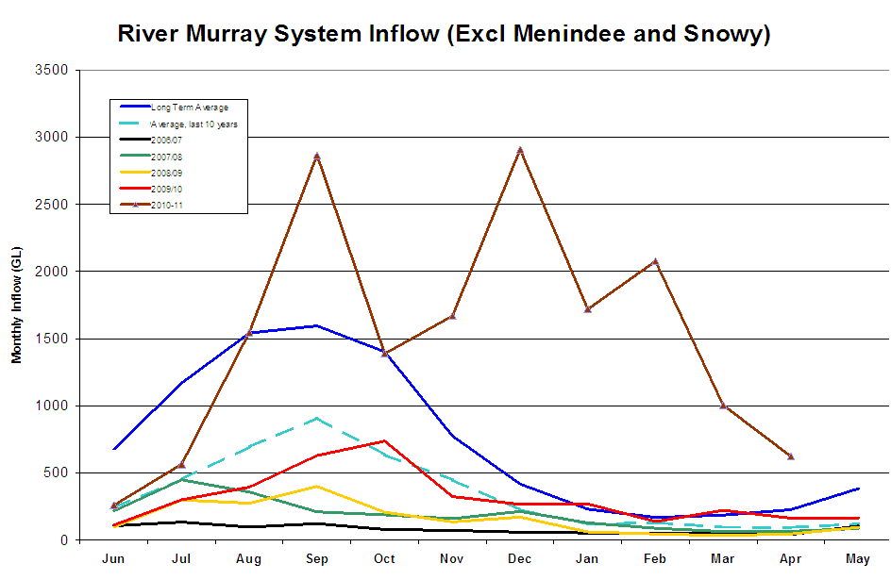

Murray flow to South Australia from 2005/06 to the end of April 2011.
Period (June – May) | Inflow (GL) | % Long Term Average
2010/11 to end April | 13,640 | 284%
2009/10 | 3,210 | 36%
2008/09 | 1,880 | 21%
2007/08 | 2,230 | 25%
2006/07 | 970 | 11%
2005/06 | 6,380 | 72%
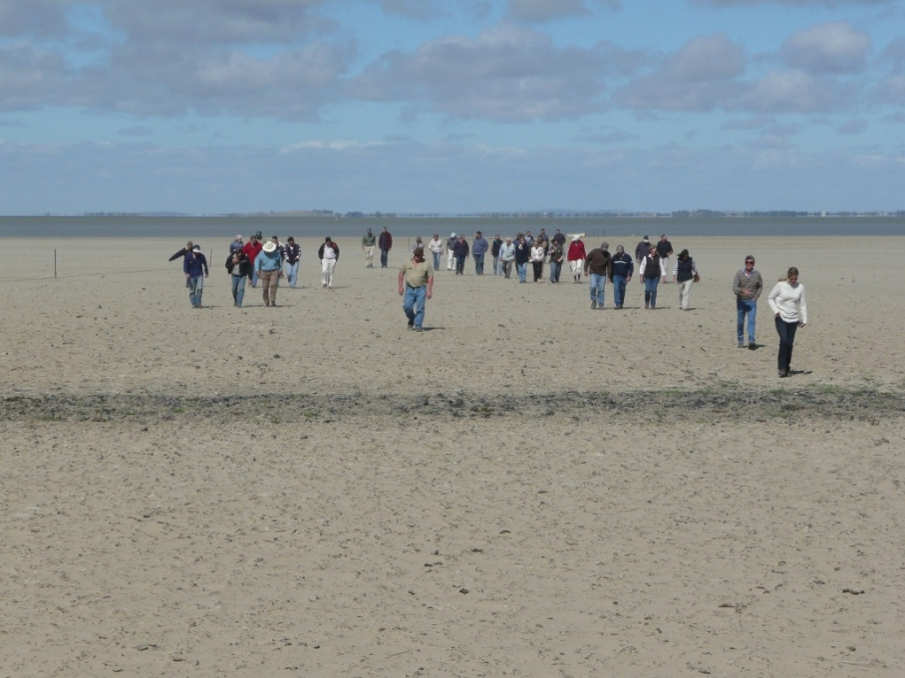
At the peak of the drought:

- flows across the South Australian border fell to just 960 GL per year,
- Lakes Alexandrina and Albert virtually dried up.

Lake Alexandrina at Clayton in late 2007
Access to Allocations
With ongoing low inflows to the Murray-Darling system during 2007-08 to 2009-10, South Australia negotiated Special Water Sharing Arrangements with Victoria, New South Wales and the Commonwealth Government. Temporary River Murray carryover arrangements were introduced in 2007-08 to allow water users to manage their annual inter-seasonal risks.
Irrigators started 08-09 and 09-2010 with the lowest starting allocation on record – just 2 % and by November 2008, South Australian allocations reached just 18% and stayed at that level for the remainder of 2008-09, almost half of the previous lowest allocation of 32% in 2007-08.
Announced SA River Murray water allocations during 2003-2004 to 2010-2011.
Irrigation Season | % of Licensed Allocation
 | Commencement Allocation | Final Allocation
2010 - 2011 | 21 | 67
2009 - 2010 | 2 | 62
2008 - 2009 | 2 | 18
2007 - 2008 | 4 | 32
2006 - 2007 | 80 | 60
2005 - 2006 | 70 | 100
2004 - 2005 | 70 | 95
2003 - 2004 | 65 | 95

That for the years 07 /08, 08 / 09 and 09/10 allocations at the start of the irrigation year were at just 2-4%, with no understanding or guarantee of what increases may be announced had serious consequences for the decision making and resilience of irrigators to manage.
With this: irrigators were forced to manage with what they could. At the time, a burgeoning water trading market came into play and for those with the financial resources and risk appetite, were able to purchase ‘temporary’ water from the market to keep crops alive at wildly fluctuating costs and expensive outlays. For many not able to enter the market, government provided financial assistance to eligible businesses to purchase water to keep perennial crops alive through the 'Critical Water Allocation’ scheme: describe later.

Impacts on Industry, Communities, and the Environment
Irrigation Industry
For the irrigation industry there was just not enough water and in places water could not be accessed to enable irrigation of existing plantings, with impacts which lead to significant restructuring of industry, in the case of dairying in the Lower Murray, almost total decimation.
In the Riverland:
- producers ceased irrigation of most annual crops.
- Drought ‘survival’ strategies to keep perennial plantings alive, through severe pruning and maintenance irrigation regimes was implemented.
- Old and unprofitable varieties of vines and tree fruits, especially juicing citrus varieties were taken out of production. The extent of the ‘abandonment’ of plantings was assessed by a series of aerial surveys, reporting that permanent irrigated agriculture decreased by 23% or 12,436 ha between July 2007 and January 2009 with most of this loss occurring in pastures,
- horticulture losses were intermittently dispersed throughout the Riverland.
The aerial survey conducted in February 2009 reported the change in irrigated area from 1 July 2007 to January 2009 for the following:
- 1,820ha or 6.6% of a total vine area of 24,400ha recorded no irrigation since July 2007. This comprises 760ha of vines observed as not irrigated in 2008 and a further 1,060ha observed as not irrigated in 2009.
- 1,100ha or 13.7% of citrus no longer irrigated since July 2007. Near equal amounts of the industries two main varieties (Navels 445ha and Valencia 405ha) are not irrigated. The reduction in citrus area observed in 2008 was 716ha compared with a further 387ha in January 2009.
- 418ha or 27% of the stone fruits crop area not irrigated since July 2007. 234 ha was recorded as not irrigated in 2008 and 184 ha in 2009.
- 98ha or 12.7% of pome fruit area recorded with no irrigation since July 2007, with pears showing the largest net reduction in area.
- 51ha or 1.2% of the total nut crop area of 4250ha is not irrigated since July 2007. There has been 320ha of older almond plantings removed since 1 July 2007. New or replacement almond plantings of 269ha occurred during January 2008 and January 2009.
In the Lower Murray access to water was severely restricted.
- Low water levels and high salinity made extraction of water difficult, if not impossible for Lake Albert. Around 60 dairy producers were unable to irrigate and most ceased production. It took many years for the salinity levels to become useable. The dairy industry mostly did not return.
- In Langhorne Creek - the Creeks Pipeline allowed water that would have been drawn from Lake Alexandrina to be provided by the pipeline from Wellington. Major crop losses were avoided.
- In the Lower Murray levy bank slumping caused major management problems to the reclaimed swamp areas and in some areas as water levels fell, acid sulphate soils developed.
- Pasture crop losses on the reclaimed swamps along the Lower Murray were extensive and no irrigation was occurring from Lake Albert.
River Murray Communities
- High levels of stress across communities, both locally and more generally were experienced by the social service agencies, schools.
- There were concerns for the potential levels of suicidal behaviour amongst drought affected communities. Evaluation surveys by Country Health SA reported that ‘anxiety, stress, mental health (depression) was VERY or QUITE SIGNIFICANT for 69% of respondents and that 75% found that their community was severely affected by the drought. The drought impact on their region’s community was identified as severe through to extreme.
An intelligence gathering project identified the need to:
- Assist people in accessing the range of State and Commonwealth assistance programs,
- Intervene early to avoid far reaching and devastating consequences of high levels of community, family and individual mental health stresses, including the risks of suicides, and
- Have measures in place to maintain the social fabric of communities, including a focus on
- the retention of young people
- maintenance of skills in the workforce
- pathways for transitioning employment between industries, and
- morale and resources in schools that provide a centre piece of communities, and
- capacity and capability of sporting clubs

River Murray Environment
Environmental impacts while widespread across the Basin and the SA corridor, the concerns were largely focussed on the Lower Murray.
The extended period of drought caused significant detrimental impacts to the Lower Lakes and Coorong. Due to record low flow to South Australia, water levels in Lakes Alexandrina and Albert fell to unprecedented lows, disconnecting the two lakes. During 2009, the water level in Lake Alexandrina dropped to their lowest point in a thousand years, from pool level of +0.75 metre AHD to -1.0 metre AHD, and in Lake Albert -0.5 metre, resulting in the exposure of acid sulphate soils. More than 20,000 hectares of acid sulphate soils were exposed on the Lakes, resulting in potentially disastrous acidification of lake waters, putting water quality and biodiversity assets, notable fish stocks and turtle populations at risk. In addition, salinity was at record levels, damaging ecosystems and threatening supplies for people and livestock
- Due to the low levels in the river, slumping of the banks below Lock 1 became a serious safety and environmental risk and measures were put in place to understand and mitigate the risk to the community and infrastructure
- The dredging of the Murray Mouth, which began in 2002 to keep it ‘open’ was ramped up in 2006 with addition of dredging capacity.
- Lakes Alexandrina and Albert reached with the water level in Lake Alexandrina plunging to 1.1 metres below sea level in April 2009,
Aboriginal communities suffered the exposure of ancient burial grounds
Upstream of the Lower Lakes, the drought caused a number of problems including the cracking and slumping of riverbanks and irrigation levee banks, drying of wetlands, and the stranding of irrigation infrastructure.

Regional Economy
PIRSA undertook 3 studies at the time of the drought to understand the economic position of the primary production sector. They were
- the Economic and Social Impacts of Key Industries on the Riverland to assess the impact of a range of forces on the regional economy (coincidentally0 leading into the drought,
- a series of annual ‘Food Score Card(s)’, to assess the overall value of industry to the state, and
- a monitoring study of key indicators of the regional economy during the drought.
The three studies were done for different purposes, different scales and measured different parameters and thus made it difficult to get a consistent picture of the economic impact of the drought. The following summarises a precis of these reports at Attachment 2.
- The study of the Economic and Social Impacts of Key Industries on the Riverland started prior to the drought and reported existing economic problems and predicted significant additional impacts (“a crisis”) due to the drought. Salient points from the report were that
- “oversupply and other competitive forces had resulted in a decline in incomes within the Riverland associated with activity in the wine grape and citrus industries from the peak of $306 Million (sustaining an estimated 5700 full time equivalents (FTEs) of employment in 2001/2) to an estimated $240 Million (3700 FTEs in 2004/5)”, and
- [Then] in (2006/07), there was an estimated decline in activity, compared to 2004/05 of 1130 FTE less jobs of which 810 were in the grape and citrus sectors with the balance of 320 jobs from other areas of the economy and a $73 M reduction to the Gross Regional Product $73M ($54 Million in the grape and citrus sectors) and Reduced yields and therefore incomes due to the drought and resultant 60% of water allocations.
- The report predicted “higher figures would result if the drought extended beyond this year taking lost incomes potentially up to $700 million and lost employment up to 12,005 person years.”
Notwithstanding the significant downturn and hardship felt by most in the Riverland from the residual impacts of the drought, the true extent is unclear.

- The Food Score Cards were conducted at a state level and to translate the results to a regional level are indicative only. Some results where industry sectors are concentrated in the River Murray Corridor and/or the impacts of the low flows and water allocations are likely to have been most felt give some indication of the impact of the drought.
For example, from 2007 to 2009 there was a state-wide drop in the value of the dairy industry of 8 %, much of likely to be from the impact of the drought in the lower Murray. Over the same period an 11 % drop in the value of vegetables and an 8% decline for the citrus industry was largely ascribed to the drought and a dramatic reduction (21%) for the grape and wine industry, much it from River Murray irrigation areas impacted by the drought
- The regional economy monitoring project analysed data on key indicators on a regular basis over the 2006 -2010 period, including unemployment, new motor vehicles sales, dwelling approvals, residential, primary production and commercial property sales, and uptake of Rural Financial Counselling services. The data showed that while there were significant impacts is parts of the economy, the region showed remarkable resilience. The data showed a mixed impact of the drought, where:
- unemployment rose and stayed higher than usual.
- new motor vehicle sales, as a primary means for indicating the strength of consumer spending and confidence, showed signs of a strong economy,
- new dwelling approvals as a means to track longer-term sentiments, showed that the lower Murray ‘held up’ but a decline in ‘sentiment’ in the Riverland,
- property sales as an indicator of underlying changes in the regional economies, showed that:
  - residential property sales showed a significant and sustained decline,
  - primary production property sales trended downwards, and the declining trend continued, with the index about one third of its value in 2009 cf. 2006, but
  - there was significant increase in the average value of sales, and
- the numbers utilising the Rural Financial Counselling Services fluctuated over the drought periods but went from 150 in April 2007 to height of 380 by late 2007.

The State Government Response

As a precursor to the following outline of the response, it is acknowledged here that the Murray Basin Plan which evolved post the Millennium Drought was in large part created in response to drought.
During the Millennium Drought, the Australian Government committed to an intergovernmental agreement with the Basin states and the ACT so that the Basin would be managed as a whole, acknowledging that the Basin is a connected system. The result was the Basin Plan, which was created to help improve the health of the river system for the benefit of its users and the environment.
Over the years, the combination of natural droughts and the increasing use of water for agriculture, manufacturing and communities has harmed the health of Basin waterways. A combination of changes in rainfall patterns and increasing temperatures has resulted in more evaporation. This adds to the intensity and impacts of both floods and droughts. Managing water resources through the Basin Plan to improve the health of the river system was increasingly important.
In the short term the Australian and South Australian Governments launched significant programs of response and recovery support across the state. The scope and impacts of the state’s program were compiled in a report, the ‘State Drought Response 2006-2011’ at the cessation of the drought and the program.
The following sets out the major elements of that Response Program.
The entire suite of some 40 strategic programs across the state, reported on in the ‘State Drought Response 2006-2011’ Report are at Attachment 1. The following focusses on those most pertinent to the River Murray
The Program focussed on the key areas of:
- Governance arrangements
- Intelligence gathering and Communications
- Industry Support
- Community and Health and Well-Being Support
Governance and Consultative arrangements with irrigators.
As the drought set in, the government established a raft of arrangements to inform the development of the range of industry and community support programs. There were overarching arrangements because the whole state was in drought, but some specific to the irrigation communities along the River Murray.
At a state-wide level:
- a Committee of Cabinet was formed,
- Ministers of Agriculture and Water resources, respectively McEwen and Maywald were designated responsibility to oversee the program
- former Premier the Hon. Dean Brown was appointed as Ministers Special Advisor on Drought
- under the leadership of PIRSA a ‘High Level Task Force” of Chief Executives from across the range of relevant agencies was formed
- under the leadership of the Department of Water Land and Biodiversity’s Water Security Advisory Group of Chief Executives from across the range of relevant agencies was formed, and
- a Drought Response Team of Directors from the range of relevant agencies was formed

Focussing on the River Murray, structures were established with the support of PIRSA and DEW to inform and oversee the Program, including:
- a PIRSA River Murray Response Group,
- SA River Murray Corridor Drought Management Committee,
- Drought Task Force,
- The Riverland Horticulture Reference Forum.
Intelligence and Communications.
A communications strategy was developed, including regular reports on conditions and program activities to inform program delivery and key stakeholders on conditions, impacts, delivery of programs and outcomes of those programs through a program of Drought Intelligence Reports.
This included establishment of a Drought Hot line and Website to inform and support the community with up-to date information.
Industry and Business Support.
Supporting was provided to regional groups to prepare applications for government support programs, including for the Commonwealth Governments
- Exceptional Circumstances Declarations and the subsequent availability of Interest Rate Subsidies for eligible businesses, and
- ‘Exit Grants’ to eligible businesses to exit the industry and forego their ability to irrigate their land for 5 years.
Support for irrigators to apply for the State Government’s support for irrigators to purchase temporary water through the Critical Water Allocation program to keep plantings alive. 1,375 businesses applied and 61 GL was underwritten by the scheme
A program for assisting producers with strategic planning for recovery from the impacts of the drought called ‘Planning for Recovery.
Mentoring for dealing with financial and well-being pressures, through additional Rural Financial Counsellors and a network of Family and Business Mentors.
A research program into drought management for production systems through a program called Enhancing the Resilience of Permanent Horticulture which led to the development of an ‘Irrigators Toolkit’ of strategies to manage droughts and build resilience into production systems.
A Farmer Peer Support Network was set up to support people to provide mentoring and networking support with their rural communities.
Concern for local business struggling to retain apprentices lead to an Apprenticeship Retention Scheme to assist was implemented and business capability through support for skills development and apprenticeships projects,

Community and Health and Well Being Support.
- Two ‘Drought Coordinators’ were put in place to be a point of contact for the community to navigate the ranges of support programs.
- A network of Rural Community Counsellors was put in place to provide ‘around the kitchen table support to individuals and families struggling with well-being and mental health issues.
- Two Drought Relief Centres were established (Berri and Murray Bridge) to provide a one-stop shop accessibility to the range of support programs.
- A network of Family and Business Mentors was established from community members to lend an ear and referrals to critical support services for those struggling with well-being and/or business pressures.
- A Regional Communities Drought Fund provided support through dedicated regional facilitators of support and specifically with sports programs and community events,
- A Young Farmers Peer Support Network was established to develop leadership capacity with rural communities.
- A Mental Health Education program provided support to teachers confronted with additional stresses experienced by students at school.
- An ‘Additional Psychiatric Services’ program provided proactive and preventative clinical interventions to deal with the stresses related to the impacts of the drought
- Community Support Grants were available for local government development projects.
- Financial support to families struggling to pay school fees was provided through a program of Farm Family Education Expenses.
- Arrangements were put in place for alleviating financial burdens from a range of public fees and charges through a program of Concessions and Anti-Poverty Services for a number of agencies
Learnings from the Response Programs for Future Approaches
- 4,200 people supported by Country Health SA Community Counsellors
- 733 men assisted in the Peer Support Program
These programs informed policy direction by demonstrating, over more than the past decade, that key components of a support program were a focus on:
- regional empowerment to ensure ownership of proffered support,
- targeted and responsive support for industry and community needs by Government,
- government support for the complete continuum as per Emergency Management Principles of response, recovery and preparedness,
- importance of development of capacity and capabilities of individuals and communities,
- regional employment skills and knowledge,
While recovery and preparedness take time, Government support must have an end date. The development, resilience and sustainability in industry, individual growers and communities was of strategic importance.
Reflecting upon those experiences and learnings, in 2006 the State Drought Response Program set out to:
- deliver a Whole of Government coordinated approach
- be informed by leaders of regional communities
- be evidenced based according to assessed needs
- take a considered and phased approach that responded to changing needs.
It should provide:
- informed and appropriate support to businesses, families and communities, and
- have a focus on a transition to recovery.

Attachment 1: The Suite of Projects of the State Drought Response Program

The following summarises all of the projects (by name) which were run through Program many and most had direct impacts upon the ‘River Murray Corridor’.
- Short Term Initiatives PIRSA
To ensure that a number of separate work activities of importance to the SA DRT were managed so that what was being done, by whom and against what timescales was recorded, understood, tracked and reported through to completion.
- Integrating Drought Communications: PIRSA
To coordinate and integrate Government agency communications in response to drought and to:
- provide strategic communication responses to the drought related to identified needs, and
- develop and implement a cross agency framework that would provide for an integrated response to media questions and queries on complex drought issues that crossed over agency or portfolios.
- Drought Intelligence Reports PIRSA
To provide up-to-date information throughout the course of the drought, on a region-by-region basis, that would assist decision makers to determine Government’s approach to the drought was appropriate.
- Coordination of Drought Management Workshops: PIRSA
To manage the coordination and delivery of 100 workshops for rural businesses and families affected by the drought of 2006 from the initial management of the drought towards recovery.
- Drought Technical Support PIRSA
To oversee the management of funded drought response measures, including communication through Drought Response Team, Premier’s High Level Drought Taskforce and Regional Drought Task Forces through the Drought Coordinators and to maintain technical integrity of the DRT Program, enable a capacity to monitor regional situations and engagement between the Drought Team and communities, particularly in the River Corridor.
- Exceptional Circumstance Application Preparation PIRSA
To assist South Australian regions in the preparation of Exceptional Circumstances (EC) applications that would be endorsed and supported by the Australian Government. Poor seasonal conditions had been experienced across extended areas of South Australian over the previous 5 years resulting in the need to seek additional support available under EC.

- Drought Response for Schools
Department for Education & Children’s Services
To develop educational support strategies to assist educational communities affected by drought. Aimed at government education sites in drought affected areas throughout South Australia. Information sharing extended to non-government sites in some circumstances. Fee rebates involved non-agency bodies bearing the costs for the good of students from drought affected areas.
- Managing the Pressures of Farming: Country Health SA
To build the capacity of farming communities to take care of their mental health and to mitigate factors that contribute to poor mental health. Drought conditions and prolonged stress being experienced by many farmers in farming communities prompted the urgent need to focus attention on Promotion, Prevention and Early Intervention for Mental Health in those communities.
- Farm Debt Mediation PIRSA
To provide financial support via a State Government funded grant, to engage an independent accredited mediator to assist primary producers in negotiations with financiers relating to ongoing financial support and improved farm viability. This assistance measure provided the farm sector with satisfaction in the knowledge that this support was available where other strategies did not meet their needs.
- Community Support Grants: PIRSA
To fund activities that supported rural communities to maintain or improve the wellbeing spirit and resilience of their community. Individual grants of up to $5,000 were available for not-for-profit organisations to stage activities specifically to assist communities in coping with the drought.
- Drought Forums: PIRSA
Forums were held to seek information on drought related issues and gather responses from regional leaders from a range of sectors including business, financial, industry, social and natural resource management. The forums were aimed to disseminate information and establish clear links between the Government and relevant peak groups.
- Additional Rural Financial Counsellors:
Rural Financial Counselling Service SA
To provide additional funds to the Rural Financial Counselling Service (RFCSSA) to enable their network of qualified rural financial counsellors to meet the increased demand from rural communities for financial advice.
- Critical Water Allocation Scheme: PIRSA
Through the Critical Water Allocation Scheme (CWA) provided support to irrigators of permanent plantings who wanted to remain in the industry and who could demonstrate the long-term viability of their business. This occurred by underwriting critical water supplies needed to ensure the survival of permanent plantings through this time of drought and low water allocation.
- Characteristics of Persistently Profitable businesses: PIRSA
Case Studies to inform policy and program development under a reformed national approach through a better understanding of the key characteristics of farm businesses that maintain their financial positions over the long term and particularly during adverse periods
- Strategic Planning and Communication Workshops PIRSA
The Rural Financial Counselling Service of SA, in collaboration with PIRSA, coordinated the delivery of specialist strategic planning workshops for drought affected businesses and families with a focus on business continuance and succession, from the initial management of the drought towards recovery.
- Irrigated Industry Support Program: PIRSA
A Grants program to assist eligible irrigators to purchase ‘emergency’ water to maintain plantings with severely restricted allocations and financial stress aimed at protecting South Australia’s multi-million-dollar horticultural industry by ensuring the survival of its long-term viable plantings. Each increase in water allocation throughout the irrigation season reduced the number of approved grants that would ultimately be eligible for payment.
- Generic Counselling for People in Drought Affected Communities:
Country Health SA
For the recruitment of suitably qualified generic counsellors to provide generic counselling and outreach support to people in farming communities in rural and outback South Australia.
The Counsellors were positioned to support those rural clients utilising the Drought Hotline (based at the Rural and Remote Mental Health Service) and in rural areas whose farming communities were most affected by the drought. The counsellors also provided mental health literacy education to communities utilising resources developed by the Managing the Pressures of Farming Task Group.
- Drought Hotline & Website: PIRSA
The Government required a co-ordinated, integrated, timely and accessible interface with the community to communicate its drought response measures. The Drought Hotline was commissioned to provide a single point government contact for the community through a free call call-centre and support referral service. The hotline was managed by Centrelink.
The Drought Conditions and Exceptional Circumstances (EC) sections of the PIRSA website were developed to provide technical information and support for individuals, businesses and communities affected by the drought, and the available assistance for eligible farmers in EC declared regions.

- Planning for Recovery PIRSA
To support farm businesses, accessing an Exceptional Circumstances Interest Rate Subsidy, to develop and implement high quality business plans, which would in turn deliver significantly improved economic, production, family and natural resource management outcomes in the short and long-term. Farm business were then able to access an implementation grant to help them to reduce the decline in the condition of their core farm assets and provide a stronger platform from which recovery can be accelerated.
- Concessions & Ant-Poverty Services: Department of Treasury and Finance
To provide energy concessions, water and council rate remissions, Emergency Services Levy remissions and remissions on pastoral and perpetual lease costs for farm families verified as receiving Exceptional Circumstances Relief Payment (ECRP) or Farm Help payments from Centrelink.
To provide financial assistance for to school fees to drought affected farmers and associated businesses.
- Drought Business Management for Irrigators: PIRSA
To provide irrigators with basic skills and information to assist them to better manage the physical and financial resources of their business while River Murray water allocations are restricted. To develop and deliver a package of information products and run a series of skilling events tailored to the needs of specific irrigation industries to equip irrigators with critical information they needed to make sound management and business decisions in the 2007-08 irrigation season. Information addressed mental health, irrigation management, business management and financial support. Key highlights were:
- Drought information toolkit- “Irrigators Toolkit”; CD produced and distributed, information loaded onto PIRSA web site, Industry and community event support; Drought hot-line referrals; 1-on-1 advice/information; Riverland Horticulture Reference Forum support and Discussion groups
- Managing ‘Top Up’ Water Licence Applications: DWLBC
To process increased numbers of water licence applications for transfer of water in a timely fashion. The project dealt with the processing of increased numbers of water licence transfers as a direct result of the drought and the Government decision to not charge licence holders for transfers that merely ‘topped up’ their existing allocations.
- Rural Community Counsellors: Country Health SA
To provide generic counselling and outreach support to people in drought affected farming communities in rural and outback SA and including those affected by low River Murray flows, as well as Recovery Management Support for rural communities emerging from the Drought.
Rural Community Counsellors were strategically placed to support those farmers/ farming and growing communities most affected by the current drought.
- Farmers Peer Support: Country Health SA
To establish peer networks to support men and women in rural communities. The initiative engaged, trained and supported key individual men and women who were willing to assume supportive and mentoring roles, and establish sustainable support networks in drought affected areas.
- Mental Health Education through Schools: Country Health SA
To assist primary and secondary school teachers to improve mental health awareness, and support responsiveness of schools, school communities and parents for the benefit of rural children. Through the application of a Mental Health Educator, over 12 months, primary and secondary school teachers were given training to improve the preventative mental health capacity of their schools.
- Additional Psychiatric Services: Country Health SA
To provide for increased access to psychiatric services and proactive and preventative clinical interventions to those in drought affected communities. The ongoing drought conditions and prolonged stress being experienced by many rural communities/ farmers prompted the urgent need to focus attention on the increased provision of psychiatric services.
- Drought Apprenticeship Retention Scheme: DEFEEST
To provide support to rural towns and communities during the drought by helping businesses retain apprentices. A retainment allowance $1,500 (2 instalments of $750) was made to the employer for each apprentice/trainee retained. The program assisted employers to continue to retain their apprentices/trainees.
- Farm Family Educational Expenses:
Department of Education and Children’s Services (DECS)
To provide support to families faced with additional educational expenses and to promote student participation in extra-curricular activities and events. Grants of $150 were provided to all Drought School Card recipients attending government schools in the drought affected areas to assist with additional educational expenses such as camps, excursions, sporting excursions, and entry to competitions.
- Moratorium on School Bus Routes:
Department of Education and Children’s Services (DECS)
To extend a moratorium on the removal of school bus services in drought affected areas. The moratorium relieved parents from the burden of finding alternative transport arrangements during the period in which families were coping with the drought.

- Enhancing Resilience of Permanent Horticulture in SA:
SA Research and Development Institute (SARDI)
To monitor, capture and evaluate outlier crop performance data associated with the extended drought and its recovery. The data to be valuable in developing improved climate risk and drought management regimes for future events predicted to become more common with the ‘climate shift’.
- Drought Tolerance Traits for Wheat & Lucerne: SARDI
To address research and strategy development into reducing the impact of drought on River Murray horticulture and grain crops. Focus of the measure was to research and develop strategies that minimised the impact of drought on permanent horticulture and develop ways to improve the performance of low rainfall pastures and cropping systems.
- Young Farmers Peer Support Network: Country Health SA and PIRSA
To help young farmers provide leadership in their communities and industries and in turn help address leadership succession concerns facing many rural communities.
- Labour Market Transition:
Department of Further Education, Employment, Science and Technology
To re-skill producers and workers from drought affected farms in Exceptional Circumstances Areas of South Australia and Production Horticulture enterprises in the River Murray Corridor. By providing Heavy Vehicle and Machinery Operator Certification, we will be able to increase employment opportunities for these people in mining, forestry or general transport industries.
- 742 persons received training
- 993 registrations of interest
- Drought Coordinators: PIRSA
The Drought Coordinator’s (incl. in River Murray Corridor) role involved:
- Supporting their respective Regional Drought Task Forces by providing a conduit between the regions and Government for drought related matters;
- Providing high level executive support to the Regional Drought Taskforces;
- Facilitating collaborative partnerships in the development and delivery of programs,
- Promoting and distributing information about support services that are available to drought affected producers, small businesses and communities,
- Provision of accurate, timely and strategically important regional information to the State Government and the Premier’s Special Adviser on Drought, for consideration in the ongoing development and management of drought response strategies; and
- Identifying opportunities and strategies to streamline the delivery of programs.

- Accelerating ECIRS processing Delivery Agency: PIRSA
To accelerate the processing of Exceptional Circumstances Interest Rate Subsidy (ECIRS) applications by engaging additional staff to reduce application levels to a manageable level, and secure additional premises to promote efficiency of processing and accommodate the extra staff.
- Regional Communities Drought Fund PIRSA
Established a $400,000 Regional Communities Drought Fund, available to all Councils within the declared Exceptional Circumstances areas of South Australia, and the Outback Areas Community Development Trust, for projects that supported their communities. Through the fund, regional communities were financially assisted to undertake projects designed to:
- Protect or improve economic and social infrastructure,
- Protect or improve environmental assets; and
- Develop or enhance community capacity through education and training.
- Computers & Training for Drought Affected Primary Producers
PIRSA FarmBis SA
To give primary producers an ex-government computer (through the Smart State Initiative, Computer Recycling Scheme administered by Department of Administrative and Information Services (DAIS)) in combination with a package of four hours of training through TAFE SA at regional centres. The training was to encourage primary producers to up-skill and utilise computers as part of their business tool kit. Training was to introduce record keeping, budgets, business management and how to manage businesses more effectively.
- State Drought Relief Technical Support: PIRSA
To oversee the management of funded drought response measures, including communication through Drought Response Team, Premier’s High Level Drought Taskforce and Regional Drought Task Forces through the Drought Coordinators.
- State Drought Relief Centres: PIRSA
To provide a number of drought response centres or hubs where producers could access services with a focus on supporting decision-making in their businesses.
The project recognised that the state had established the elements of an ongoing capacity to provide a drought response through a one-stop-shop centre, regional coordinators and Regional Taskforces.
- Family and Business Mentors: PIRSA
The Family and Business (FaB) Mentor program was introduced in recognition of intelligence from the regions that there was an increasing number of farmers, who due to the stresses of the impacts of drought, were becoming increasingly indecisive about measures they needed to adopt to secure their future.

- School Card: Department of Education and Children’s Services
To provide financial assistance to drought affected farmers and associated businesses, in relation to school fees. School Card support was provided to families whose income had been significantly and directly affected by the drought.
The initiative was aimed at all families that resided in Exceptional Circumstances declared areas who had experienced a significant change in financial circumstances due to the drought. The intention was to assist families with the cost of school fees at Government schools.
Attachment 2: Precis of Economic Studies
Economic and Social Impacts of Key Industries on the Riverland
Undertaken prior to the onset of the low River Murray flows in 2006 , the study indicated that the oversupply and other competitive forces had resulted in a decline in incomes within the Riverland associated with activity in the wine grape and citrus industries from the peak of $306 Million (sustaining an estimated 5700 full time equivalents (FTE's) of employment in 2001/2) to an estimated $240 Million (3700 FTE’s in 2004/5). The cumulative lost income (Gross Regional Product) to the region over the 2002/5 period was estimated at $185 Million. From a state perspective the loss over the four years in terms of Gross State Product was estimated at close to $250 million and a decline of underlying employment from 5,700 FTE's in 2001/02 to 4,400 in 2004/051.
[Then] in the Riverland in (2006/07), there was an estimated decline in activity, compared to 2004/05 of;-
  - 1130 FTE less jobs of which 810 will be in the grape and citrus sectors with the balance of 320 jobs from other areas of the economy.
  - Gross Regional Product $73M less ($54 Million in the grape and citrus sectors)
  - Reduced yields and therefore incomes due to the drought and resultant 60% of water allocations.
In the State, the projections indicated that the economic impact to the State, over the period 2006 – 2010, will have the effect of the same drivers prevailing, and will bring about an impact as follows:-
  - Lost incomes to South Australia of $410 million (pa)
  - Lost employment opportunities of 6,900 person years.
The Report stated that:
“Higher figures would result if the drought extends beyond this year (2005), taking lost incomes potentially up to $700 million and lost employment up to 12,005 person years.”
In the Riverland Region there would be lost incomes of $300 - 400 million (pa) over 2006 – 2010, even with a median rain fall or better in 2006. If, there were to be a further year of drought and water restrictions on irrigators water allocations, then lost incomes would escalate to the order of $550 million. There would be lost employment opportunities of 5 000 – 7 000 person years in the event of reasonable rain fall this year and beyond, escalating to in excess of 10 000 person years if the drought were to continue into 2007/08.
This would represent an annual average of almost 10% decline in regional incomes and employment opportunities over the base level of activity in the economy (2004/05) and a very significant foregone economic opportunity and significant social and economic cost. This is a significant problem from an individual and community context.
The economic modelling undertaken by PKF, supports the concerns expressed in the region about the apparent economic crisis.
Furthermore, what the study found was that the many social issues evident in the region were primarily the resultant effects of the economic downturn, evidenced specifically at the grower level.
Strategies in the short term are required to equip the region to deal with the social issues as identified by UniSA as the effects of the downturn. Action needs to be directed at the community’s capacity and resourcing of mental and general health services linking the delivery of services and management of social issues with community attitudes and willingness to change.
At the causal level, the viability and profitability of growers and their respective industries is paramount in the short term, with sustainability and adaptability being key drivers for the long term. These factors need to become the building blocks around which short term and longer-term strategies are built, due to the dependence of the region on these industries.
Strategies are required to assist growers’ capacity to cope in a changing business paradigm with rapidly increasing exposure, to global economies and commodity marketing systems. Initiatives aimed at supporting their capacity to operate in this environment, targeting, their access to finance (to allow scale and the further uptake of technology); access to market information and analysis, as well as access to new markets and marketing systems for their product, are all paramount.
At the regional and State level, strategies are required that target the issue of regional diversification, new industry attraction, health service capacity and a communications campaign that targets intrastate and interstate markets heralding the opportunities the region offers.
As an issue that cuts across both wine grapes and citrus industries, the region’s attractiveness and the State’s competitiveness in export markets is the very real lack of realistic exit strategies. Existing programs fail to deliver the pace required (for restructure) or take a managed approach, in terms of allowing long standing operators the ability to retire while still sustaining land values in traditional irrigated areas.

The Food Score Card
The following table sets out the Scorecard for industries for 07/08 and 08/09 at the ‘height’ of the drought.
 | Value $ million |  | Value
 | 2007/ 08 | 2008/09 | % Change
Field Crops | 1,253 | 952 | - 24 %
Livestock | 893 | 1,057 | 18 %
Dairy | 273 | 251 | - 8 %
Horticulture | 517 | 536 | 4 %
potatoes | 133 | 131 | - 1 %
Apples and Pears | 46 | 48 | 4 %
Almonds | 59 | 61 | 4 %
Vegetables | 33 | 30 | - 11 %
Citrus | 56 | 51 | - 8 %
The data shows the dramatic drop in value for field crops undoubtedly due to the ‘dryland’ drought but also from dairy, likely due to the dramatic decrease in production from the Lower Murray and from vegetables and citrus, much of it from irrigated production off the River Murray.
At a more specific scale, the 07/08/09 Score Card at the height of the drought, for the grape and wine industry where much of the production in focussed on the River Murray shows the dramatic decline in value, with significant impacts (- 21%) of the drought evident.
Key Performance Indicators | Value ($m) | Change over Year ($m) | % Change over year
Production | 487 | 278 | - 36 %
Processing | 1,926 | - 567 | - 22 %
Exports OS | 1,576 | - 279 | - 15 %
Exports Interstate | 60 | - 253 | - 81 %
Consumption | 517 | - 39 | - 7 %
Gross Wine Revenue | 2,153 | -561 | - 21 %
The River Murray Economies
The regional economy monitoring project analysed date on a regular basis over the 2006 -2010 period of the River Murray Drought for a number of key indicators:
- the labour market (Centrelink data showing the number receiving unemployment benefits: Newstart and Youth Allowance) and estimates of unemployment and the labour force.
- new motor vehicles sales
- property sales, residential, primary production and commercial, and
- Rural Financial Counselling services

In April 2010, a previous report suggested a significant recovery might be underway during the last quarter of 2009. The first four months of 2010 failed to provide further evidence of improving conditions.
- While the number of Centrelink recipients continued to decline, unemployment peaked in late 2009 at the highest level since at least 2003;
- Labour force participation is declining and there has been no net job growth;
- New motor vehicle sales declined, reversing the strong growth of 2009;
- The number of new private dwelling approvals remained low, mostly in the Riverland.
- Property sales have continued declining.
- Residential property sales remained subdued (despite an increase in average value);
- Primary property sales continued to decline, especially Riverland’s with very low levels;
- Commercial property sales were again volatile; and,
- RFCS client numbers grew in early 2010 (before declining in April).
While there was an apparent decline in conditions, given a longer-term perspective, the performance of these economies has been strong and it is likely that will continue to have considerable momentum.

The Labour Market
Information regarding the labour market came from 2 sources: Centrelink data showing the number of clients receiving unemployment benefits (Newstart and Youth Allowance) and estimates of unemployment and the labour force.
  - the unemployment rate peaked in the upper and lower Murray in December 2009; and
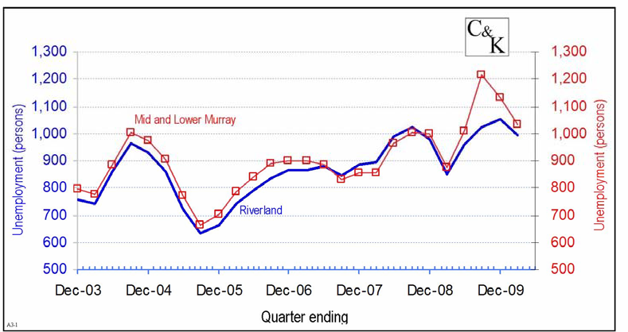
  - the declines in the estimated labour force, supported the view of no net jobs growth in either region; the unemployment rates remained high relative to other periods since 2003.

New Motor Vehicle Sales
The data for new motor vehicle sales were the primary means for indicating the strength of consumer spending and confidence. In a report from December 2009, these data were showed signs of a strong economy. However, in the last quarter of 2009:
  - Sales declined, especially in the Riverland and in the month of April 2010 were the lowest for 12 months: and were near the low of the time series to December 2006.
However, the trend data were still well above the base month of November 2007.
Murray Bridge MV Registrations
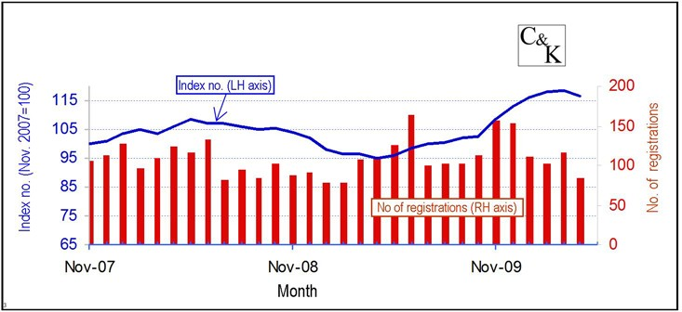
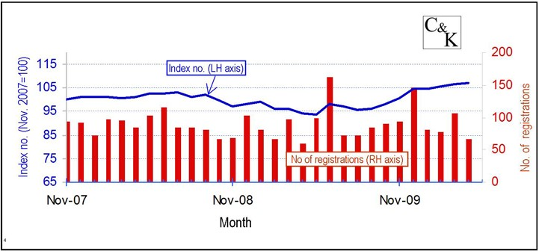
Berri MV Registration;

New Dwelling Approvals
New dwelling approvals were the means by which to track the longer-term sentiments of local residents. The data also usefully indicated expectations of activity in the building industry over the medium term future. The data showed:
  - A small decline in the number of approvals in both the lower Murray and Riverland;
  - A moderation in the rate of decline (dramatic in the last quarter of 2009);
  - The very low value of approvals in the Riverland continued (and so remains 25% less than at June 2006).

Lower Murray New Private Dwelling Approvals; 12 month moving average
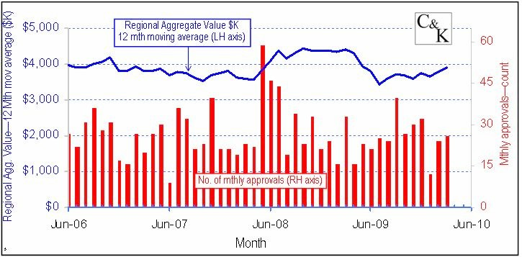
Riverland New Private Dwelling Approvals

Property Sales
Property sales provided some indication of underlying changes in the regional economies. However, the data showed numbers of sales and their total value are highly variable and can be difficult to interpret e.g. does few sales mean good or poor conditions?
Despite the difficulties in interpretation, overall, as a sum of sales for all sectors, the property market continued the declines that were so evident in the last quarter of 2009. The value of sales has also remained commensurately low.
Looking more closely at individual sectors and given that residential property sales is by far the largest category:

Residential property
The number of sales continued at very subdued levels and the value of sales was also low. The result was largely due to the very low sales levels in the Riverland. By contrast, the current rate of sales in the Lower Murray was not unusually low.

A point of note was that the average value of sales had been increasing. The trend was upward, and showed the highest average price since January 2006.
Upper and Lower Murray Residential Property Sales
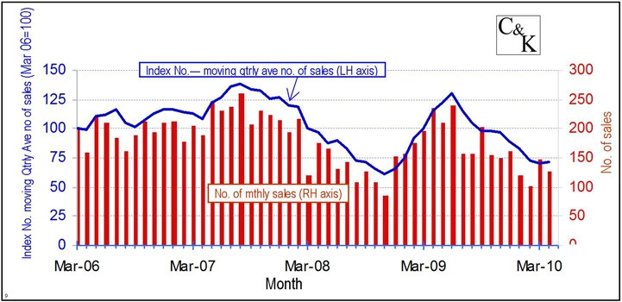

Primary production properties
Sales of primary properties trended downwards since early 2009 when they were already subdued. The declining trend continued and the index for volume of sales n late 2009 is now about one third of its value in May 2006.
While the number of sales continued to fall there was a significant increase in the average value of sales. This change was evident in both the Riverland and the Lower Murray and suggested that some larger properties were selling in the first quarter of 2010.
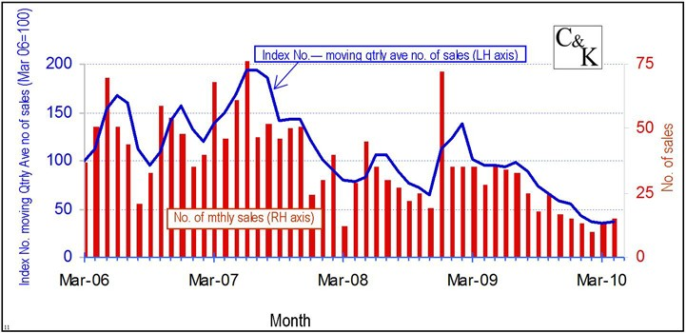
Upper and Lower Murray Primary Production Property Sales

Commercial property sales
Commercial property sales continued their volatility, with the number of properties sold recovering strongly after the declines in the last quarter of 2009.
The recovery is nearly all due to strong sales in the Lower Murray. In addition, the data suggests that a very large sale was made in the Lower Murray in April 2010.
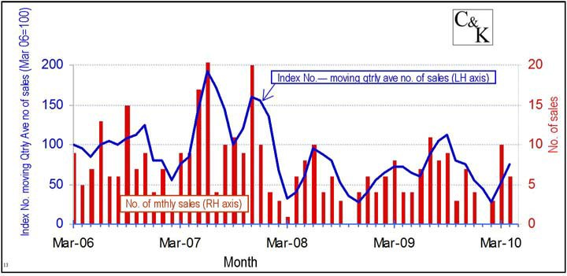
Upper and Lower Murray Commercial & Industrial Property Sales

Rural Financial Counselling Services
In both the upper and lower regions, RFCS clients grew to March 2010 and then declined in April. Overall, the numbers remained significantly lower than at their peak of March 2009. However, in the Riverland numbers seem stuck at levels significantly higher than in April 2007, the start of the time series.

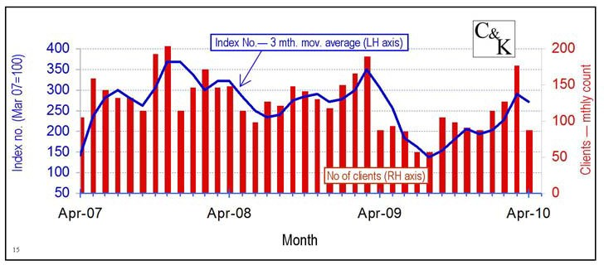
Upper and Lower Murray Rural Financial Counselling Service, Number of Clients

