HACCP PLAN
Manufacturing of Dried Meats for human consumption

Business Name
PIRSA Accreditation Number: XX/XXXX

This is a HACCP template, developed by the Department of Primary Industries and Regions South Australia (PIRSA) for Manufacture of Dried meats for Human Consumption.
An Accredited Producer may identify additional steps or hazards upon undertaking their own hazard analysis and risk assessment of each hazard. If this occurs, the Accredited Meat Producer must discuss this with the PIRSA Food Standards team to ensure that this is reflected in this document and appropriately addressed.
It is the responsibility of the accredited producer to implement and maintain the HACCP plan as part of the approved Food Safety Arrangement.

Table of Contents
1 HACCP PROCESS 3
1.1 PRODUCT SPECIFICATION 4
1.3 FLOW CHART 6
1.4 CCP DECISION TREE 7
1.5 HAZARD ANALYSIS TABLE 8
1.6 HAZARD AUDIT TABLE 10
1.7 CCP WORK INSTRUCTIONS 12
1.8 CCP MONITORING FORMS 16
1.9 PROCESS VALIDATION 18

HACCP PROCESS

To process food safely, producing safe food which complies with relevant legislation, regulations and standards.
OUTCOME

This HACCP plan forms part of the Approved Food Safety Arrangement for the Accredited Meat Producer.
The HACCP team (as identified it the Food Safety Arrangement) is responsible for maintaining this HACCP plan through analysing and improving procedures along with implementing effective controls to manage food safety risks. Each process undertaken by the business needs to be covered by a HACCP plan. This HACCP plan covers:
Dried Meats for Human Consumption
Dried Meat | The drying of meat, for the production of dried meat, achieves a water activity of no more than 0.85.

The following have been taken into consideration in the development of this HACCP plan;
- Primary Produce (Food Safety Schemes) Act 2004
- Primary Produce (Food Safety Schemes) (Meat) Regulations 2017
- AS 4696:2007: Australian Standard for Hygienic Production and Transportation of Meat for Human Consumption
- Meat and Livestock Australia - Guidelines for the Safe Manufacture of Smallgoods – 2nd edition 2015
- Foods Standards Australia New Zealand, Food Standards Code:
  - Standard 1.2 Labelling and other information requirements
  - Standard 1.6.1 Microbial Limits in Food, with Schedule 27
  - Compendium March 2022 (foodstandards.gov.au)
  - Standard 1.6.2 Processing requirements
  - Standard 2.2.1 Meat and Meat Products
  - Standard 4.2.3 for Meat and Meat Products Primary production and processing standard for meat
  - Standard 3.2.2 Food safety practices and general requirements
  - Standard 3.2.3 Food Premises and Equipment

Application for any alternative methods to those identified in the Australian Standard AS4696:2023, must be approved by the Accrediting body.
To produce and sell Dried Meats for human consumption, the operator must hold accreditation and approval for this process. Additional conditions may be required by PIRSA Food Standards Program as part of the approval of this process.

PRODUCT SPECIFICATION

As per the Food Safety Arrangement, Product Specifications detail the product characteristics as listed below and are considered when reviewing the HACCP plan.
General Category Product Specification (example)
Product Category | Dried Meat (e.g., Jerky)
General Composition | Meat (Beef), Preservative, salts, nitrites (Optional), water (Specify any allergens)
Method of Preservation | Low Water Activity (<0.85)
Packaging | Primary | Sealed plastic bag with oxygen scavenger (optional)
 | Secondary | Cardboard carton
Storage Conditions | Shelf Stable
Distribution Method | Direct to Customer – Butcher shop
Shelf Life | TO BE VALIDATED BY OPERATOR  To be determined by Operator:  Sealed shelf life: x days from production.  Shelf life once opened: x days once opened.
Labelling | As per AS4696:2023 and Section 4.1 of FSA; Labels to include:  - Product name  - Accredited business  - Business address and contact details  - Directions for use and storage conditions  - Packaging Date  - Best Before Date (may include batch identification)  - Advisory statement/warning (e.g., allergens)  - Ingredient information (as per recipe)  - Nutrition information  - Country of Origin
Intended Use | Sensitive Customer | Suitable for general population  Not suitable for those with allergies to listed ingredients.
 | Customer Preparation | Ready-To-Eat.
Microbiological Limits | As per FSANZ | As per FSANZ Food Standards code Standard 1.6.1 Microbiological limits in Food

PRODUCT RECIPE (example)
Product Description | Beef Jerky
Product Category | Dried Meats
Ingredients |  | Quantity |  | Country of Origin
Beef
Preservatives (Nitrite)
Salt
Water/ Marinade
Seasoning (herbs and spices)
Processing
Step 1 - Slicing
Step 2 - Marinating - as per supplier specification (Addition of preservative CCP 1)
Step 3 - Drying – applied heat treatment (Heat Treat (including Smoking) product (CCP 2)
Step 4 - Portioning or Dicing product
Step 5 - Packing and Label product (CCP 3)

FLOW CHART
Objective | A step-by-step diagram of the flow of the operation/process with all inputs and outputs identified. Key steps in the process that are critical to food safety are referred to as Critical Control Points, CCP. These are highlighted on the Flow Chart.

CCP DECISION TREE

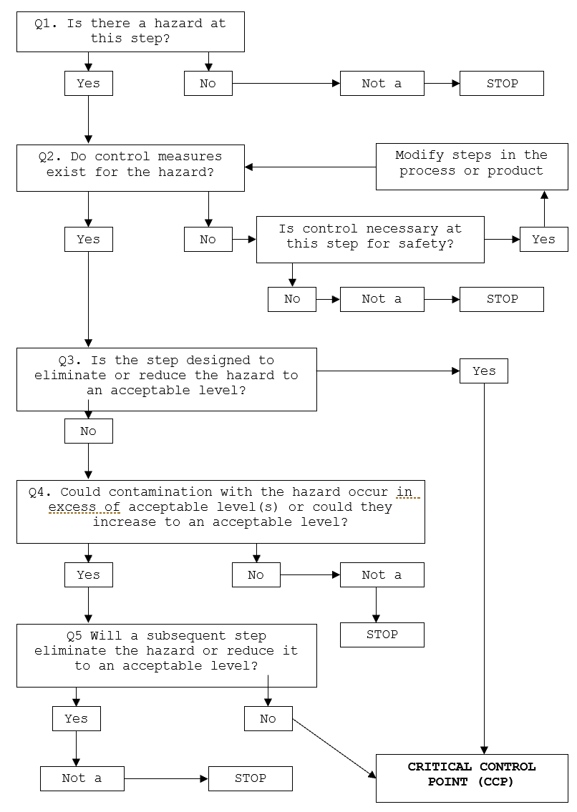

HAZARD ANALYSIS TABLE
Hazard Types: B – Biological; C – Chemical; P – Physical
Objective | A documented review of each step identified in the flow chart and with the importance of each step in the safety of the finished product rated to identify Critical Control Points (CCP).

Process Step | Hazard | Cause | Q1 | Q2 | Q3 | Q4 | Q5 | Preventative measures for hazard control | CCP | CP | GMP | Support Program
- Finished Product from Raw Process | Selection of Finished Product compliant with Raw Process
- Slicing Product | B, C, P –Microbiological, chemical and physical contamination. | Bacterial growth if temperature and time allow  Cross contamination from unhygienic handling of product. | Y | Y | N | Y | Y | Monitor temperature of meat during processing and time in process does not allow multiplication of pathogens  Use of PPE and/or good hand sanitation when handling products
- Marinating and Addition of Preservative | B – Pathogens (Salt Tolerant S. areus) | Poor temperature control could allow growth of pathogen | Y | Y | Y | - | - | Product maintained less than or equal to 5°C under active refrigeration.
 | C – excess chemicals | Preservative level more than permitted level in finished product |  |  |  |  |  | Apply correct amounts as per recipe.  Check correct amounts of preservative have been added and conforms with Food Standards Code Section 1.3.1 (schedule 15) | CCP
Process Step | Hazard | Cause | Q1 | Q2 | Q3 | Q4 | Q5 | Preventative measures for hazard control | CCP | CP | GMP | Support Program
- Drying / Heat Treatment | B – Presence of microbiological pathogens (Listeria monocytogenes | E. coli | S. aureus) | An insufficient thermal process can allow pathogens to survive | Y | Y | Y | - | - | Drying / Heat Treatment  Dry down to a sufficient water activity (0.85) to eliminate some pathogens and inhibit all others.  Point of microbiological concern achieves minimum of 55°C for 20 minutes or an equivalent process. | CCP
- Portioning and Dicing | P – Foreign matter | E.g., Metal fragments | Y | Y | N | Y | Y | Pre-operation equipment inspection.
- Packing | B - Growth of spoilage microorganisms | Inadequate seal or vacuum of bag.  Mould growth | Y | Y | N | Y | Y | Packaging purchased from an approved supplier; food grade packaging used only.  Inspect each bag for seal integrity after application of vacuum (RTE).  Addition of an oxygen scavenger
- Labelling | C – All ingredients date marking or warning statements not listed on packaging. | Inadequate traceability and labelling of finished product. | Y | Y | Y | - | - | Mandatory information included on labels as per FSANZ Food Standards Code Section 1.2 Labelling and other information requirements. | CCP

HAZARD AUDIT TABLE
Objective | Documented controls to be implemented and measured and recorded to demonstrate food made has followed the process to make safe.

Step | Hazard | Critical Limit | Monitoring | Corrective Action | Records
Marinating (under refrigeration)  CCP 1 | B - Pathogen growth  (Salt Tolerant S. areus) | Chiller used to hold product maintained at temperature ≤5°C | What – Chiller temperature | Assess temperature of meat. If greater than 5°C, move product to alternate cold storage if available.  Adjust room temperature setting for product to achieve ≤5°C. Discard product if unable to maintain product temperature ≤5°C.  Repair or replace refrigeration unit. | Daily temperature records
 |  |  | How – Thermometer/ gauge
 |  |  | When – Daily
 |  |  | Who – Trained operator
Addition of preservative (nitrite)  CCP 1 | C - Preservative level more than permitted level in finished product | Preservatives in finished product within permitted levels under the Food Standards Code.  Nitrite addition at no more than 125mg/kg | What: Accurate addition of permitted preservative, as per recipe e.g. Nitrite. | If the incorrect level of preservative is added, the batch is to be discarded and then replace with correct concentration.  If unsure of how much preservative has been added to meat, place batch on hold. Sample of meat can be sent to external NATA laboratory for testing of Nitrite level in final product. If >125mg/kg then discard batch.  Review process. | Batch sheets
 |  |  | How: Visually.
 |  |  | When: Every batch.
 |  |  | Who: Operator
Step | Hazard | Critical Limit | Monitoring | Corrective Action | Records
Drying / Heat Treatment  CCP 2 | B - Pathogen survive, (Salt Tolerant S. areus) | Meat reaches ≥ 55°C for ≥ 20 minutes at point of microbiological concern to achieve Water activity of ≤0.85 (monitored via relationship with weight loss > 40%) – as per validation. | What – Product surface temperature & Product weight | Continue drying until correct temperature is achieved.  Confirm validated levels of weight loss or water activity are achieved via weight loss calculation.  Product not to be packed/sold until weight loss (to achieve required water activity) is achieved.  Review process | Production Records (weight loss)
 |  |  | How – calibrated thermometer & calibrated scales
 |  |  | When – every batch
 |  |  | Who – trained operator
Labelling  CCP 3 | C – All ingredients or warning statements not listed on packaging | Correct mandatory labelling including date marking, applied to finished products as required. | What: Correct Label applied to product | Isolate and hold product with incorrect labels.  Where labelling details are incorrect or inaccurate, the labels shall be removed.  Discard incorrect labels, apply correct details to product.  All previous products from the batch shall be re-inspected for compliance and corrective action taken if found to be incorrect/inaccurate.  All non-complying and used packaging shall be disposed of and not reused.  Release product for despatch once correct labels have been applied and verified. | Raw meat processing record  Annual label review – internal audit.
 |  |  | How: Visually
 |  |  | When: Every batch
 |  |  | Who: Trained Operator

CCP WORK INSTRUCTIONS

Objective | At steps that are critical for the safety of the finished product, checks on the process are completed to confirm the process has met the critical limits and the results recorded. If the check finds the product has not met the critical limit of the process, actions need to be taken to make the product safe. These steps need to be documented in a work instruction.

Table of Work Instructions
- CCP 1 – Marinating and Preservative addition (Optional)
- CCP 2 – Drying and Heat Treatment
- CCP 3 – Labelling

WORK INSTRUCTION | Marinating (salting)
Objective | To marinate product under conditions to minimise microbiological growth and apply marinate/salts (Nitrite preservatives) to product at levels that inhibit the growth of pathogenic bacteria.
Procedure | - Clean and sanitise all food contact surfaces and equipment  - Collect required product and apply marinate/salts at appropriate levels to achieve required concentration of salts (Premix/nitrite added as per recipe so that nitrate/nitrate conforms with Food Standards Code, no more than 125mg/kg when sold)  - Apply measured quantities of preservatives to achieve correct levels within critical limits.  - Return product to chiller for duration of marinating process, confirming product temperature is maintained at ≤ 5°C
Frequency | Every Batch
Records | Dried Meat Production record  Chiller temperature record
Corrective Action | If the incorrect level of preservative is added to the curing mix, the batch is to be discarded and replace curing mix with correct concentration.  If unsure of preservative addition to meat, place batch on hold. Sample of meat can be sent to external NATA laboratory for testing of Nitrite level in final product. If >125mg/kg discard batch.  Review process.  Where product temperature is elevated (>5°C), move to alternate chiller (if available). Repair chiller.  Assess temperature of meat. If greater than 5°C, move product to alternate cold storage if available.  Adjust room temperature setting for product to achieve ≤5°C. Discard product unable to maintain product temperature ≤5°C.  Repair or replace refrigeration unit. .
Responsibility | - The operator is responsible for correct addition of preservative to product and monitoring and documenting each batch.

WORK INSTRUCTION | Drying – Heat Treatment
Objective | To dry and heat treat the product to achieve target water activity that does not support the growth of pathogenic bacteria.
Procedure | - Clean and sanitise all food contact surfaces and equipment  - Take prepared product and load into drier / oven  - Monitor time and temperature of product to confirm limits are achieved.  - Calculate weight loss percentage to confirm limits are achieved.
Frequency | Every Batch
Records | Production Sheet
Corrective Action | - Where product temperature does not achieve critical limit, continue drying until correct temperature is achieved.  - Confirm validated levels of weight loss or water activity are achieved  - adjust temperature of dryer to achieve critical limits.
Responsibility | - The operator is responsible for correct drying and heat treatment to product and monitoring and documenting each batch.

WORK INSTRUCTION | Labelling
Objective | All packaging and labelling comply with the requirements of the Food Standards Code.
Procedure | All food must be accurately labelled for items not sold through assisted display.  - Meats are to be packaged with approved material, suitable for food contact. All packaging shall be new and not used or contaminated.  - An accurate description of the meat product including its ingredients shall be displayed in a prominent position on the packaging.  - A label shall include mandatory information where applicable as per FSANZ Food Standards Code (section 1.2).
Frequency | Every Batch
Records | Dried Meat Production Record
Corrective Action | - Where labelling details are incorrect or inaccurate, the labels shall be removed  - All previous products from the batch shall be re-inspected for compliance and corrective action taken if found to be incorrect/inaccurate.  - All non-complying and used packaging shall be disposed of and not reused.
Responsibility | - The operator is responsible for monitoring and documenting the label application for each batch.

CCP MONITORING FORMS

- Dried Meat Production Record

Date | Product | Start Weight (kg) | Preservative addition as per Specification  (/ ) | Meat Temperature  Exiting chiller  (°C) | Drying / Heat Treatment Process |  | Final Weight (kg) | Weight Loss  (%) | Unpackaged (UP) or  Packaged and Labelled as required (P)  (UP or P) | Best Before date  or  Batch Code | Initials | Corrective action
 |  |  |  |  | Temperature  (°C) | Time  (minutes / hrs)

PROCESS VALIDATION AND VERFICATION
Objective | Confirm the process followed will control the hazards identified, making the product safe for consumption.

CCP / Processes | Validation/Justification
Preservative addition | Refer to work instruction for monitoring records and frequency to confirm validated process has been followed to achieve hazard control.  Theoretical validation – AS4696:2023 Section 13 and FSANZ Food Standards Code Schedule 15  Levels of nitrate added produces product with levels that conform with food standards code
 | Frequency | Verification of nitrite levels in product at development or change in recipe (theoretical or analytical if adding above Maximum Permitted Level)  Or as directed by an authorised officer from the PIRSA Food Standards Program
Drying | Refer to work instruction for monitoring records and frequency to confirm validated process has been followed to achieve hazard control.  Data logger – demonstrate drying cycle achieves core temperature for required time as per critical limits  Water activity ≤ 0.85; relationship between weight loss and water activity.
 | Frequency | Annual Validation Required, measure weight loss of data-logged batch; send product for analysis of water activity to confirm limit set for weight loss achieves required water activity.  Or as directed by an authorised officer from the PIRSA Food Standards Program
Labelling | Refer to work instruction for monitoring records and frequency to confirm validated process has been followed to achieve hazard control.  Theoretical validation – FSANZ Food Standards Code section 1.2  Provide evidence product is labelled with mandatory information to comply with FSANZ Food Standards Code. (Section 1.2).  Annual label review for accuracy (recipe against label content and mandatory requirements – capture via annual internal audit).
 | Frequency | Annual Label review at change in product or ingredient composition.

