ENHANCED ABATTOIR SURVEILLANCE PROGRAM

Arthritis
Arthritis is inflammation of the joints. It is a significant and painful condition that is widespread in sheep around Australia. Lambs are most susceptible to infection. It usually causes lameness and visible swelling of joints. This can significantly affect growth rates on farm, as well as carcase trimming and occasionally condemnation at the processor.

Condition summary
Document Title Here
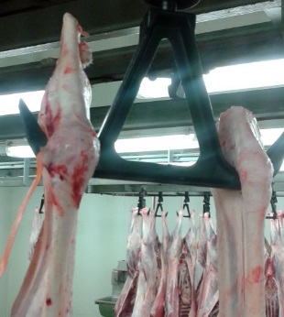
Arthritis is inflammation of the joints, usually in the legs, and leads to permanent joint changes. Most cases of arthritis begin in lambs before weaning, as a result of bacteria entering the body via broken skin either at marking/mulesing or via the umbilical cord at birth.
Significant reductions in growth rate, wool growth and weight loss may be seen on farm, on average up to 2.7kg liveweight*. Animals not able to bear weight normally on all four legs are not fit to load and must not be transported for slaughter, and instead be culled on farm.
Affected joints must be removed, with an average trim weight of 0.7kg*. When multiple joints are affected the carcase is often condemned.
Prevention involves vaccination, rotating lambing paddocks, good hygiene of equipment used in marking, mulesing and shearing, and tailing lambs at the third or lower tail vertebral joint to minimize tail wound size**. Treatment is usually not practical on a flock scale, however treatment can be successful if started early, although it varies depending on the cause.

Swollen joint due to arthritis (above) and trimmed carcase (below)

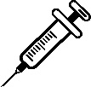
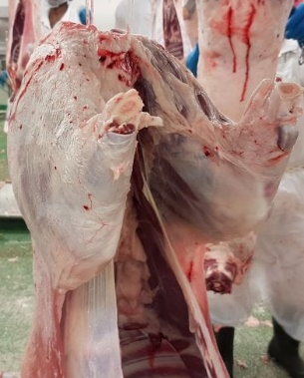

* Joan Lloyd et al (2019) Animal Production Science 59:933-937
** Joan Lloyd et al (2016) Small Ruminant Research 144:17-22

How do sheep get arthritis?
There are many causes of arthritis; the three most common ones are due to infections with the bacteria Erysipelothrix, pus causing bacteria, and the organism Chlamydophila (Chlamydia). Most of these are normal environmental bacteria present on the skin, in faeces and in the soil. The main source of infection to lambs is usually from their own mothers who act as carriers.
These bacteria gain access to the body through broken skin, then enter the bloodstream and settle and multiply in joints. Animals are most susceptible:
- At or soon after birth – via the umbilical cord.
- Any time a wound is created – especially marking/mulesing or shearing but also from contaminated dips, dog bites, grass seeds etc. Mulesing and shearing markedly increases the risk of arthritis by four to seven times.

What might be seen on farm?
In the early stages of disease, lambs or sheep may appear depressed or inactive, with hot, swollen and painful joints, commonly in the knee, elbow, hock and stifle joints. They will prefer to lie down, and will show difficulty rising, a stiff gait and can appear to ‘warm out’ of lameness. Reduced growth rates may delay the time to reach slaughter weight. Chronic arthritis is the more common form and is typically seen in lambs older than 6 months which have thick, swollen joints which contain large amounts of fluid.

How do I prevent arthritis?
- Lambing management.
- Marking/mulesing/shearing management to maximise hygiene and minimise stress.
- Minimising wound size by docking lamb tails at the third or lower vertebral joint.
- Maximising wound healing.
- Vaccinating.

Some handy tips include:
      - Rotate lambing paddocks and reserve ‘clean’, grassy paddocks for lambing.
      - Utilise temporary yards in a clean grassy paddock any time a wound is created, avoiding wet and muddy conditions, or high fly numbers.
      - Place lambs onto their feet when released from the cradle to avoid contamination of fresh wounds.
      - Avoid holding lambs in yards; if unavoidable don’t overcrowd stock as this will increase faecal contamination of fresh wounds.
      - Use sharp, clean and disinfected marking equipment and change disinfectant regularly.
      - Dock tails at the third palpable tail joint to minimize tail wound size.
      - Following any wounds, to maximise healing, keep sheep dry, avoid long wet grass, and allow at least 2 weeks before dipping, ensuring dip fluid is clean (don’t reuse or top up fluid).
      - Consider vaccinating ewes against Erysipelothrix, pre lambing to protect lambs at marking.
      - Vaccinate lambs according to the vaccine label requirements. Excellent results have been achieved through vaccination in cases where Erysipelothrix is the causative agent.
      - Ensure correct vaccination technique and protocol is followed.
IMPORTANT POINTS: Arthritis is a significant animal welfare issue and also an important cause of economic loss both on farm and at the processor. Prevention involves minimising opportunity for any wounds to be contaminated by bacteria, by good hygiene at lambing, marking, mulesing, shearing and dipping. In addition, reducing wound size by tailing lambs at the third palpable tail joint, minimising stress during management procedures, and vaccinating against Erysipelothrix is recommended.

