Management Plan for the South Australian Commercial Abalone Fisheries

Management plan for the South Australian Commercial Abalone Fishery

Information current as of XX XXXXXXXX 2020

© Government of South Australia 2020

Disclaimer

PIRSA and its employees do not warrant or make any representation regarding the use, or results of the use, of the information contained herein as regards to its correctness, accuracy, reliability and currency or otherwise. PIRSA and its employees expressly disclaim all liability or responsibility to any person using the information or advice.

All enquiries

Dr Annabel Jones

Fisheries and Aquaculture  
Primary Industries and Regions SA (PIRSA)  
2 Hamra Avenue, West Beach  
GPO Box 1671, Adelaide SA 5001

Tel: (08) 8226 0900

Annabel.jones@sa.gov.au

Front cover image courtesy of XXX

**Disclaimer**:

This Management Plan has been prepared pursuant to the *Fisheries Management Act 2007* (the Act) for the purpose of the administration of that Act. The Department of Primary Industries and Regions SA (and the Government of South Australia) make no representation, express or implied, as to the accuracy or completeness of the information contained in this Management Plan or as to the suitability of that information for any particular purpose. Use of or reliance upon information contained in this Management Plan is at the sole risk of the user in all things and the Department of Primary Industries and Regions SA (and the Government of South Australia) disclaim any responsibility for that use or reliance and any liability to the user.

**Copyright Notice**:

This work is copyright. Copyright in this work is owned by the Government of South Australia. Apart from any use permitted under the *Copyright Act 1968* (Commonwealth), no part of this work may be reproduced by any process without written permission of the Government of South Australia. Requests and enquiries concerning reproduction of this work should be addressed to the Chief Executive, Department of Primary Industries and Regions SA, 25 Grenfell Street, Adelaide, SA, 5000 (marked attention Executive Director, Fisheries and Aquaculture Division).

**The South Australian Fisheries Management Series**

**Paper number XXX: Management Plan for the South Australian Commercial Abalone Fishery 2019**

**ISBN: xxxx**

**ISSN: xxxx**

Table of Contents

1: Fishery this plan applies to 7

2: Consistency with other management plans 7

3: Term of plan 7

4: Description of the commercial fishery 8

4.1: Biology of key species 8

4.2: Historical overview 8

5: Allocation of the resource between sectors 9

5.1: Commercial sector 10

5.2: Recreational sector 10

5.3: Aboriginal traditional sector 10

5.4: Review of allocations 11

6: Disease risk 11

7: Current management arrangements 12

7.1: Commercial fishery 12

7.2: Recreational fishery 13

7.3: Aboriginal traditional fishery 14

7.4: Economic and social characteristics of the fishery 14

8: Ecosystem Impacts 14

9: Goals and objectives 15

10: Harvest strategy 24

10.1: Framework for annual decision-making process 24

10.2: Conceptual management objectives 26

10.3: Acceptable levels of risk 26

10.4: Operational management objectives 27

10.5: Fishery performance indicators (PIs) 29

10.6: Zonal score 39

10.7: Zonal stock status 40

10.8: Harvest decision rules – determining zonal catch form zone score 41

10.9: Harvest decision rules – adjusting zonal catch using secondary sources of information 44

10.10: Exceptional circumstances 48

10.11: Closures 48

10.12: Review of the harvest strategy 48

11: Research needs and priorities 49

12: Resources required to implement the plan 49

13: References 50

**List of Figures**

Figure 1. Abalone Fisheries of the South Australian commercial Abalone Fishery. Abalone Fisheries are referred to relative to their zones (i.e. Southern zone, Central Zone, and Western zone). 9

Figure 2. The three main components of the decision-making process of the abalone harvest strategy. 25

Figure 3. Schematic diagram of the annual operation of the harvest strategy. Starting with an information workshop (Monitoring phase) and working through the assessment of the performance indicators using the reference points (stock assessment phase) to derive a zonal catch, which is further adjusted by secondary information from the workshop through prescriptive decision rules (harvest decision rules phase) to derive a TACC 28

Figure 4: Map of Western Zone Abalone Fishery spatial assessment units (SAUs) 30

Figure 5. Map of the Central Zone Abalone Fishery spatial assessment units (SAUs). 31

Figure 6. Map of the Southern Zone Abalone Fishery spatial assessment units (SAUs). 32

Figure 7: Schematic diagram of the function used to score performance using the rules described above. Note a score of five (5) which equals the target reference point is comprised of the middle 40% of CPUE range from the reference period and produces a ‘flat’ stable section where a range of CPUE will result in a score of 5. 35

Figure 8: A schematic of the function used to score performance using the rules described above for legal density. A score of five (5) which equals the target reference point is comprised of the middle 40% of legal density from the reference period and produces a ‘flat’ stable section where a range of legal density will result in a score of 5. Note if data is not available between 200-2007 then the maximum score of 10 is determined at 20% higher than the maximum score for the data available to account for the increase in density from 2000-2007. 38

Figure 9. The relationship between Fishing Mortality and Biomass reflecting limit reference points for each classification. 41

Figure 10. Schematic representation of the conversion from zonal score to a zonal catch ± 10%. The zonal score is a representative only. The final TACC recommended from the harvest strategy is a determined after application of the secondary information through the decision rules. 42

List of tables

Table 1. A chronology of important management changes in the South Australian commercial Abalone Fishery since its inception in 1964 from Shepherd and Rodda (2001). 15

Table 2. Summary of management measures for the recreational sector. GL: Greenlip Abalone, BL: Blacklip Abalone. 16

Table 3. Goals, objectives and strategies for the management of the South Australian commercial Abalone Fishery. A summary of key risks, performance indicators and reference points is below. 20

Table 4. Data limited SAUs pooled into a combined regional SAU for each abalone fishery (zone). 38

Table 5. Increases in TACC when stock is recovering for each class of abalone in each zone. 45

Table 6. Information to be considered in recommending the final total allowable commercial catch for the Southern Zone Abalone Fishery 46

Table 7. Information to be considered in recommending the final total allowable commercial catch for the Central Zone Abalone Fishery. 47

Table 8. Information to be considered in recommending the final total allowable commercial catch for the Western Zone Abalone Fishery. 48

**List of acronyms**

AIASA Abalone Industry Association of South Australia Inc.

AVG Abalone Viral Ganglioneuritis

CPUE Catch-Per-Unit-Effort

CZ Central Zone Abalone Fishery

ESD Ecologically Sustainable Development

FAO Food and Agriculture Organisation of the United Nations

FRDC Fisheries Research and Development Corporation

GOS Gross Operating Surplus

GVP Gross Value of Product

ILUA Indigenous Land Use Agreement

PI Performance Indicator

PIRSA Department of Primary Industries and Regions, South Australia

SAFS Status of Fish Stocks

SAU Spatial Assessment Unit

SARDI South Australian Research and Development Institute

SZ Southern Zone Abalone Fishery

TACC Total Allowable Commercial Catch

TEPS Threatened, Endangered and Protected Species

WZ Western Zone Abalone Fishery

# Fishery this plan applies to

This Management Plan for the South Australian Commercial Abalone Fishery applies to the commercial Abalone Fishery constituted by the *Fisheries Management (Abalone Fisheries) Regulations 2017*.

The regulations define the fishery as:

*(1) The following fisheries are constituted:*

*(a) the Central Zone Abalone Fishery;*

*(b) the Southern Zone Abalone Fishery;*

*(c) the Western Zone Abalone Fishery.*

*(2) The Central Zone Abalone Fishery consists of the taking of abalone in the waters of the Central Zone.*

*(3) The Southern Zone Abalone Fishery consists of the taking of abalone in the waters of the Southern Zone.*

*(4) The Western Zone Abalone Fishery consists of the taking of abalone in the waters of the Western Zone.*

# Consistency with other management plans

This management plan has been developed to integrate with Aboriginal traditional fishing management plans or agreements that are made in the future and apply to the waters of this management plan.

# Term of plan

This Management Plan revokes the previous *Management Plan for the South Australia Commercial Abalone Fishery* adopted on 1 September 2012 and applies from XXXX 2020 for a period of 10 years. A review of this Plan may be undertaken at any time or as required pursuant to the *Fisheries Management Act 2007* (the Act). A review of the Management Plan prior to expiry may result in the Management Plan being re-instated for a term of 10 years.

# Description of the commercial fishery

## Biology of key species

Abalone of the Genus *Haliotis* (Family Haliotidae) are gastropods or ear-shaped marine snails which inhabit reefs the subtidal out to approximately 30 m. This reef associated habitat use is reflected in their patchy distribution and genetic stock structures that generally comprise multiple meta-populations.

Greenlip Abalone reach sexual maturity at between 75 and 89 mm standard shell-length (SL), and approximately three years of age. They are synchronous spawners that grow at rates varying between <10 and up to 30 mm per year. Blacklip Abalone reach sexual maturity at between 76 and 109 mm SL, and are asynchronous spawners. The species have lower growth rates than Greenlip Abalone (Mayfield *et al.* 2014) with growth rates varying between <10 and 15 mm per year.

The commercial Abalone Fishery targets Greenlip Abalone (*Haliotis laevigata*) and Blacklip Abalone (*H. rubra*). Roe’s Abalone (*H. roei*) is also taken in areas of the Western Zone.

## Historical overview

Soon after its inception in the mid 1960s, the number of entrants in the commercial fishery had exceeded 100. In 1971, licences were made non-transferable to reduce the number of operators and minimum legal lengths (MLLs) of 130 mm shell length (SL) were imposed on all abalone species to help conserve egg production. In the same year, the fishery was divided into three separate fishery management zones in recognition of the differences in geological and ecological character between the western, central and southern borders of the South Australian coast. These fishery management zones are constituted as the Western Zone (WZ), Central Zone (CZ) and Southern Zone (SZ) Abalone fisheries and are still in operation today (Figure 1).

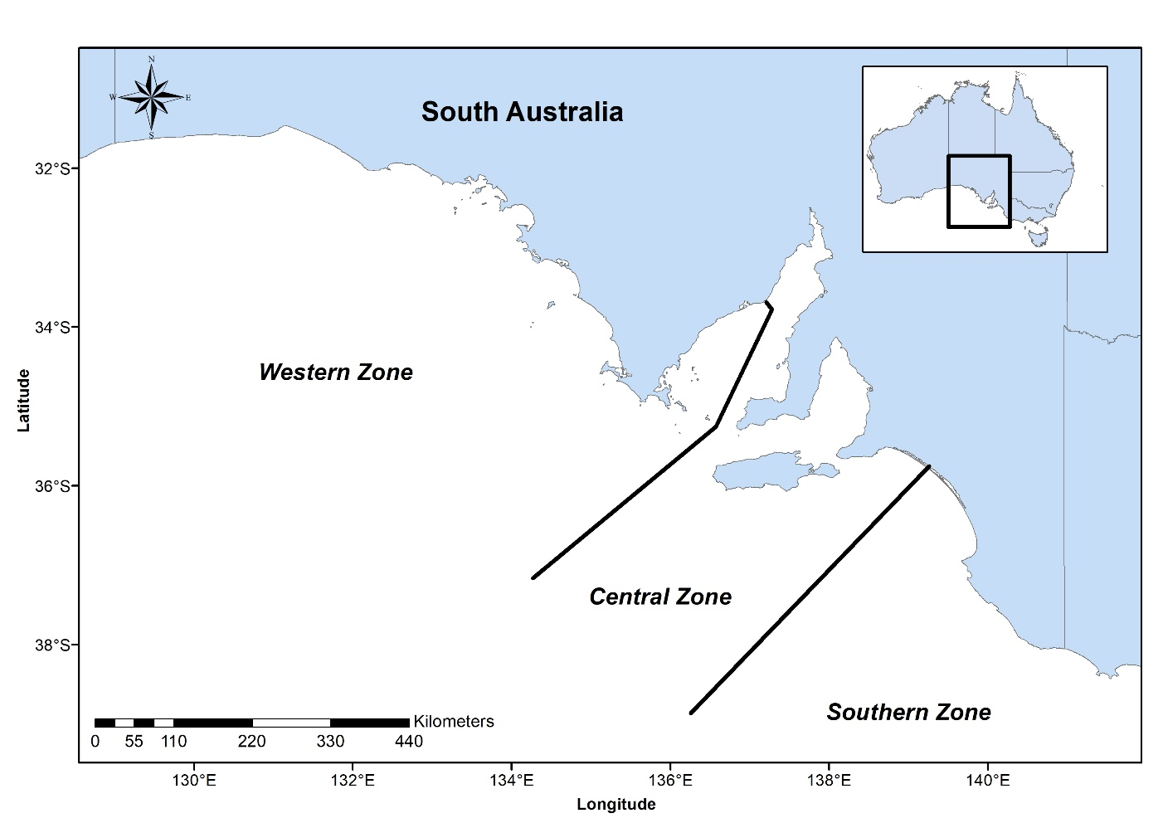Figure 1. Abalone Fisheries of the South Australian commercial Abalone Fishery. Abalone Fisheries are referred to relative to their zones (i.e. Southern Zone, Central Zone and Western Zone).

Commercial abalone divers mostly operate from large trailered boats. Divers use air supplied from the boat and some circulate warm water through their wetsuits, which helps them to operate in cold water for extended periods of time. Some divers use mobile dive cages to mitigate physical interactions with White Sharks (*Carcharodon carcharias*). Divers locate, measure and remove abalone from the reef by hand using an abalone iron. Catches of abalone are raised to the surface in air-lifted mesh bags. Another person operates the boat and usually actively follows the diver and cage, recovers the bags, and for the Western Zone and Central Zone Abalone Fisheries may remove the abalone meat from the shell (shucking). Where the market is live or whole, animals are not shucked from the shell. After landing, the catch is transported to the consigned processors and prepared for markets. Abalone products are usually sold as live, frozen, dried, parboiled and canned products.

# Allocation of the resource between sectors

The *Fisheries Management Act 2007* provides that a management plan must specify the share of the fishery to be allocated to each fishing sector (Section 43(2) (h)). The Act also provides that, in determining the share of aquatic resources to be allocated to a particular fishing sector under the first management plan for an existing fishery, the share of aquatic resources to which that fishing sector had access at the time the Minister requested the preparation of the plan (based on the most recent information available to the Minister) must be taken into account.

Following the *PIRSA Allocation Policy (2011) - Allocation of access to fisheries resources between fishing sectors*; relevant at the time of plan preparation, existing shares are calculated from estimates of the total tonnage of a species taken by a sector divided by the total tonnage taken by all sectors combined. Commercial fishery data are collected from catch and effort logbooks submitted in accordance with regulations and recreational fishery data are sourced from surveys. This Management Plan accounts the share of the South Australian Abalone Fishery that the commercial, recreational and Aboriginal traditional fishing sectors are allocated.

## Commercial sector

Commercial access to Abalone is restricted to commercial licence holders in the Western, Central and Southern Zone Fisheries. The collective share allocated to this sector is equal to 99.74%.

## Recreational sector

Recreational access to the abalone resource is primarily managed using minimum legal length limits and recreational daily bag and boat limits. Any catch taken by the South Australian Charter Boat Fishery is considered to be recreational catch and is allocated as part of that fishing sector. The allocated share to the sector is equal to 0.15%.

## Aboriginal traditional sector

Fishery-related Indigenous Land Use Agreements (ILUAs) or agreements may be negotiated over coming years. Therefore, as appropriate, a review of this management plan that finds a difference between the nominal share put aside and the actual share agreed through the ILUA or agreement can be calculated. Any difference would then be reallocated to or from the relevant sector. Currently, the recreational and Aboriginal traditional sectors have a low likelihood of distinguishing between Greenlip and Blacklip Abalone and therefore, the catches of the two species are currently pooled prior to estimating sectoral shares. Should information on the catches taken for Greenlip and Blacklip Abalone change in the future, allocation may change to reflect the new information. The Aboriginal traditional sector is currently allocated 0.11%.

## Review of allocations

Allocations between sectors are likely to be reviewed periodically in accordance with criteria set out in the Allocation Policy. Quantifying shares in the fishery is principally based on the best available information on the current level of use by all sectors. Currently, the first preference is to manage and contain sector shares within current allocations, however a need for an adjustment of shares between different sectors may be triggered by a number of factors including:

* A review of the allocations between sectors.
* A review of the Management Plan, which will reassess the appropriateness of shares and may trigger an adjustment.
* Outcomes of a resource assessment, which triggers a fisheries management decision that is made primarily to ensure sustainability of the fishery but that may result in a shift in sectorial shares.

Since the commercial sector has a limited number of licences and they are transferred, it may be difficult to assess the value of quota units and fishery licences. For this reason, a voluntary adjustment scheme may not be able to be implemented in the fishery. Therefore, a second voluntary option/step may be required, which would investigate an incentive-based scheme for share adjustment.

Adjustment of shares from the commercial sector to a non-commercial sector may be summarised by the following options or consistent with any future amendment of the *Fisheries Management Act 2007*:

* Purchase commercial access (i.e. quota units) to the resource on the open market.
* Create incentives for the commercial sector to trade access to the resource.
* Compulsory acquisition of commercial access to the fishery, although this would be considered as a last resort. Any compulsory acquisition would include compensation to the commercial sector.

# Disease risk

Abalone Viral Ganglioneuritis (AVG) is a declared notifiable disease under the *Livestock Act 1997*. It is a herpes-like virus that affects the nervous system of Haliotis species, including Greenlip and Blacklip Abalone and their hybrids, and can lead to mortality rates of up to 90%. The AVG virus has not been recorded in South Australia. The disease first appeared in aquaculture farms in southern Victoria and mass mortality events occurred in December 2005. Mass mortality events of the wild stock were subsequently reported in May 2006. The AQUAVETPLAN sets out disease control principles for use in an emergency response to a suspected or confirmed outbreak of AVG at the National level.

At the State level, PIRSA has an AVG Disease Response Plan that provides specific guidelines to prepare and respond to a suspected or confirmed outbreak of AVG in aquaculture or fisheries sectors. Industry were consulted during the development of that plan, which can guide responses to any abalone disease. PIRSA Fisheries and Aquaculture, SARDI and PIRSA Biosecurity South Australia have carried out disease surveillance programs of wild and farmed abalone to demonstrate freedom from AbHV (causative agent of AVG) and support policy in South Australia. PIRSA’s preparedness has also involved simulation and case scenario exercises, provision of information to licence holders, public awareness campaigns, webpages, brochures and media releases.

Perkinsus (*Perkinus olseni*) is a protozoan parasitic disease that causes lesions in the foot muscle of abalone and has led to mass mortality events. Prevalence in the Western Zone has resulted in displaced catch, uncertainties regarding impacts on stocks, and loss of productivity at the processors. Impacts of Perkinsus on abalone fisheries are unquantified and the factors driving prevalence and expression of the disease are unknown.

# Current management arrangements

## Commercial fishery

The main output control used to manage the South Australian Commercial Abalone Fishery is the implementation of annual total allowable commercial catches (TACCs) for Blacklip and Greenlip Abalone target species in each management zone and for Roe’s Abalone in the Western Zone. An annual TACC for each species of abalone is determined based on the most recent stock assessment, the Harvest Strategy and industry consultation in each of the three management zones. Currently, management arrangements for Roe’s abalone occur through a Ministerial exemption pursuant to section 115 of the Act, however these arrangements are being reviewed.

The method of determining the annual catch of each licence holder is prescribed in the *Fisheries Management (Abalone Fisheries) Regulations 2017* and prescribes that the Minister must determine the number of kilograms of abalone that is to be the value of an abalone unit for the fishery, a class of abalone and each quota period, and the conversion value for the fishery and a class of abalone. From time to time, the Minister may vary the conversion value for the fishery and a class of abalone.

The catch of an individual licence holder directly relates to the number of quota units endorsed on their licence for each class of abalone and the value (in kg) of each unit. Quota units are permanently or temporarily transferable within each zone. The fishery has undergone a range of management changes since 1971 with the key amendments listed below (Table 1).

Table 1. A chronology of important management changes in the South Australian commercial Abalone Fishery since its inception in 1964 from Shepherd and Rodda (2001).

|  |  |
| --- | --- |
| **Year** | **Management change** |
| 1964 | Fishing commenced in the Southern Zone Abalone Fishery. |
| 1971 | Licences made non-transferable and MLL of 130 mm SL were imposed on all abalone species for both commercial and recreational sectors. |
| 1976 | 5 additional licences issued, making a total of 35. |
| 1978 | Sub-zones and fishing blocks were replaced by map numbers and codes. |
| 1980 | Licences became transferable. |
| 1984 | Western Zone Abalone Fishery divided into Regions A and B, and MLL of Greenlip Abalone increased to 145 mm SL. MLL for Blacklip Abalone was decreased to 120 mm SL in the Southern Zone Abalone Fishery. |
| 1985 | Quotas introduced into the Western Zone Abalone Fishery. |
| 1988 | Quotas introduced into the Southern Zone Abalone Fishery and Blacklip Abalone MLL increased to a shell length of 125 mm. |
| 1989 | Quotas introduced into the Central Zone Abalone Fishery. |
| 1991 | Combined TACC for Greenlip and Blacklip Abalone introduced into Region B of the Western Zone Abalone Fishery. |
| 1993 | Owner-operator regulation was abolished. |
| 1994 | Four fishdown areas defined in the Southern Zone Abalone Fishery, where abalone between 110 and 125 mm SL could be taken. |
| 1997 | 1st Management Plan for the South Australian Abalone Fishery. |
| 2003 | Separate TACCs for fishdown (known as Area S) and non-fishdown areas into Southern Zone Abalone Fishery. |
| 2004 | 2nd Management Plan for the South Australian Abalone Fishery. |
| 2014 | Amalgamation of Region A and B in the Western Zone Abalone Fishery. |
| 2014 | Finer scale management introduced in the Southern Zone Abalone Fishery. |
| 2015 | Introduction of Marine Parks and the subsequent removal of 1 licence from the Western Zone Abalone Fishery and the reduction of 1.7 tonnes of meat-weight Blacklip and 1.7 tonnes of meat-weight Greenlip Abalone from the Central Zone Abalone Fishery. |
| 2017 | Introduction of weighing catch within 2-hours of landing in the Southern Zone Abalone Fishery. |
| 2020 | Review of the harvest strategy and management plan completed. |

## Recreational fishery

Blacklip and Greenlip Abalone can be taken by recreational fishers either by snorkelling or SCUBA diving. Recreational fishers must measure abalone as soon as they are removed from the seafloor. Undersized abalone must be returned immediately. The meat from abalone can only be removed from the shell when the person has departed from the water and is above the high water mark.

Management of the recreational sector is through a combination of management measures including output and input controls that ensure the total recreational catch is maintained within sustainable limits and that access to the fishery and fishing opportunities are equitably distributed between recreational participants. Input controls currently include spatial restrictions in nearshore reefs where the collection of abalone is restricted to depths greater than < 2 m from high water, and restrictions on permitted fishing devices. Output controls include bag, boat and size limits. Current management arrangements are outlined in Table 2 and include minimum legal lengths, a maximum daily bag limit and a daily boat limit, however these may change as required.

Table 2**. Summary of management measures for the recreational sector. GL: Greenlip Abalone, BL: Blacklip Abalone.**

|  |  |  |  |
| --- | --- | --- | --- |
| ****Management measure**** | ****Southern Zone**** | ****Central Zone**** | ****Western Zone**** |
| Minimum legal length (mm) | BL: 130  GL: 130 | BL: 130  GL: 130 | BL: 130  GL: 145 |
| Daily boat limit (all zones) | 10 | | |
| Daily bag limit per person (all zones) | 5 | | |

## Aboriginal traditional fishery

Access to South Australia’s fisheries resources by Aboriginal communities under the *Fisheries Management Act 2007* is currently provided through Aboriginal traditional fishing management plans. These plans may be developed when an Indigenous Land Use Agreement (ILUA), agreed to resolve a Native Title claim, is in place in relation to a Native Title claim area. Agreements may also inform the way that access to fisheries resources by Traditional communities is defined and implemented.

Holders of Native Title rights (pursuant to *Native Title Act 1993*) undertake traditional activities to satisfy their personal, domestic or non-commercial communal needs, and in exercise or enjoyment of their Native Title rights and interests.

## Economic and social characteristics of the fishery

At the time of preparation of this Management Plan, the economic and social objectives of the fishery are reported within an annual economic report which currently includes economic and social indicators for the South Australian Abalone Fishery. Reports are available at: <https://www.bdo.com.au>. Economic performance indicators used to assess the performance of the fishery include trends in catch, gross value of production (GVP), gross operating surplus (GOS), profit at full equity, economic rent, cost of licence fees, fee/licence, fee/GVP, return on capital, licence value, gross state product, employment, and rent/GVP.

# Ecosystem impacts

The *Fisheries Management Act 2007* requires that ecological impacts be identified and assessed. The Act requires that the following impacts are identified:

* Current known impacts of the fishery on the ecosystem.
* Potential impacts of the fishery on the ecosystem.
* Ecological factors that could have an impact on the performance of the fishery.

The ecological impacts associated with the fishery have been identified and assessed through the process of conducting an ecologically sustainable development (ESD) risk assessment for the fishery. The *National ESD Reporting Framework for Australian Fisheries* (Fletcher *et al.* 2002) was used to conduct the risk assessment. In accordance with the ESD objective in the Act, this approach is aimed at assisting PIRSA with identifying and prioritising all of the important ecological factors effecting the management of the fishery.

Risks and important issues in the fishery were identified in consultation with stakeholders and were prioritised using risk ratings from negligible to extreme. Risks identified as moderate, high or extreme have been summarised in Table 3. Specific management strategies to minimise these risks and associated performance indicators have been developed and are provided in Table 3.

The report titled, ‘*Ecologically Sustainable Development (ESD) Risk Assessment for the South Australian Abalone Fishery’* (PIRSA 2009) provides further detailed information about the fishery and outcomes of the ESD risk assessment.

# Goals and objectives

This Management Plan seeks to ensure the long-term sustainability, optimum use and equitable distribution of Greenlip and Blacklip Abalone stocks in South Australia. The Plan provides goals and objectives for the South Australian commercial Abalone Fishery as required by the *Fisheries Management Act 2007*.

The four goals of this Management Plan are to ensure the:

1. Abalone resource is sustainably harvested.
2. Optimal economic use and equitable distribution of the resource.
3. Impacts on the ecosystem are minimised.
4. Provisioning of cost-effective and participative management of the fishery.

The goals are detailed as follows:

Goal 1 – Ensure the abalone resource is sustainably harvested

The primary operational objectives are to ensure that Greenlip and Blacklip Abalone stocks are harvested within sustainable limits, and that adequate data and information are collected to inform this process. Since the commercial sector has a high allocation, management strategies that control the catch are a key focus of ensuring ecologically sustainable stock levels. Three management strategies adopted to ensure sustainability in the commercial sector include:

* Limited entry.
* Restrictions on the total annual commercial catch through the quota system.
* Minimum legal lengths.

Management strategies that limit the take of abalone by other sectors support the sustainable use of the resource. This includes restrictions on the total recreational catch each year through size, bag and boat limits, and the number of individuals allowed to be taken for brood-stock collection purposes, and compliance activities to monitor and reduce illegal activity (e.g. poaching). The objectives of this Management Plan in relation to sustainability include:

* Maintain the stocks of both species above ecologically sustainable levels.
* Ensure sufficient data and information is gathered to support the Harvest Strategy and inform management decisions.

Goal 2 – Allocate access to Abalone resources to achieve optimum utilisation and equitable distribution of the resource to the benefit of the community

This goal relates to the economic and social sustainability benefits derived from the fishery.

The objectives of this Management Plan in relation to these benefits are to:

* Maintain the stocks at or above a level that will support commercially viable catch rates.
* Maintain a flow of economic benefit from the fishery to the South Australian community.
* Recognise Aboriginal traditional fishing access.

Goal 2 aims to optimise the use of the fishery in an equitable way, within the sustainability constraints of the fishery. Optimising the use of the fishery is addressed in the objectives and strategies in terms of maximising stable economic returns from the commercial fishery and maintaining equitable access to the resource for the non-commercial sectors.

Goal 3 – Minimise impacts on the ecosystem

This goal relates to ecosystem-based fisheries management. Objectives of this Management Plan in relation to ecosystem-based fisheries management include:

* Minimise fishery impacts on by-catch species and the ecosystem.
* Avoid lethal interactions with threatened, endangered and protected species (TEPS).
* Minimise external impacts on stocks associated with broader environmental health (e.g. desalination plant and aquaculture).
* Manage diseases and exotic pests to minimise impacts on abalone stocks.

Goal 4 – Cost effective and participative management of the fishery

This goal relates to encouraging co-management of the fishery, planning of management activities and cost recovery processes. The key objectives of this goal are to ensure that stakeholders and government fisheries administration share responsibility and participate in management decision-making processes, and to ensure the arrangements are complied with. The cost effectiveness of management arrangements also needs to be taken into account in the development process as the costs of management are recovered from fishers in accordance with the Government’s cost recovery policy. Objectives of this Plan in relation to co-management, planning and cost recovery include:

* Promote cost-effective and efficient management of the fishery, in line with the government’s cost-recovery policy.
* Ensure management arrangements reflect concerns and interests of the wider community.
* Promote compliance with management arrangements.

Table 3. Goals, objectives and strategies for the management of the South Australian commercial Abalone Fishery. A summary of key risks, performance indicators and reference points is below.

| **Goal** | **Objective** | **Strategy** | **Addressing Risk** | **Performance indicators** | **Description** | **Reference point** |
| --- | --- | --- | --- | --- | --- | --- |
| *1. Ensure the abalone resource is sustainably harvested* | *1a. Maintain the stocks above ecologically sustainable levels* *for both species in 9 years of every 10* | 1a (i) Conduct annual assessment for each SAU  1a (ii) Develop specific management strategies for individual SAUs, as necessary, following scientific assessment  1a (iii) Set the TACC annually, in accordance with the Harvest Strategy and objects of the *Fisheries Management Act 2007*  1a (iv) Ensure management strategies for the commercial and recreational sectors limit the take of abalone to within sustainable levels and sector allocations and are updated when information is available  1a (v) Adopt the Precautionary Principle when robust information is lacking to make an informed decision | Greenlip Abalone stocks  Blacklip Abalone stocks  Management effectiveness | CPUE from fishery- logbook data | indices of abundance | Refer to Harvest Strategy |
| Density of legal-sized abalone estimated from fishery-independent surveys | Indices of abundance | Refer to Harvest Strategy |
| *1b. Ensure sufficient data and information to undertake Harvest Strategy and inform management decisions* | 1b (i) Collect fine-scale fishery-dependent data through commercial logbooks and/or GPS loggers  1b (ii) Maintain a commercial fisher-based shell measuring sampling program to collect length frequency information where appropriate  1b (iii) For WZAF Greenlip collect meat weight data from processors  1b (iv) Conduct fishery-independent surveys to collect data on size distribution and population density in surveyed SAUs  1b (v) Assess status of Greenlip and Blacklip Abalone stocks using the harvest strategy  1b (vi) Undertake periodic surveys to estimate the catch and effort of the recreational and traditional fishing sectors across the State | Assessment and management information | Catch and effort data provided by all commercial fishers for each day fished  Shell-length data collected for relevant fisheries  Meat weight data provided for all Greenlip Abalone catches in the WZ  Fishery-independent surveys undertaken  Dissemination of relevant fishery and scientific information  Annual fishery stock assessment reports published | Spatial- and species-specific, catch and effort data from all commercial fishers for each day fished  Meat weight grade data from three grades  Fishery-independent estimates of density  Commercial fishers, researchers and management have a shared understanding of stock performance | Essential data and information not collected to inform stock status |
|  |
| 2. *Optimum use and equitable distribution of the abalone resource to the benefit of the community* | *2a*. *Maintain the stock at or above a level that will support a viable commercial catch rate* | 2a (i) Ensure management strategies for the commercial and recreational limit the take of abalone to within sustainable levels  2a (ii) Maintain the current cap on the total number of licences used in the commercial fishery | Fishery remains resilient and profitable | Catch rate monitored annually | Commercial fishers need to maintain catch rates to maximise economic efficiency | Target catch rate |
| *2b. Maintain a flow of economic benefit from the fishery to the South Australian community* | 2b (i) Develop and implement management arrangements that allow commercial operators to maximise operational flexibility, economic efficiency and returns.  2b (ii) Communicate sustainability and economic outcomes of the fishery to the broader community | Fishery remains resilient and profitable  Employment | GVP  GOS  Profit at full equity  Licence value  Value of quota units  Economic rent  Return on capital | GVP is the total catch valued at the landed beach price. Used to determine whole fishery value  GOS gives an indication of the capacity of the operator to remain in the fishery in the short to medium term  Licence value is the market value of abalone licences, as determined by licence holders  Profit at full equity is a measure of the profitability of licence holders.  Economic rent is the difference between the price of a good produced using a natural resource and the unit costs of turning that resource into the good including the opportunity cost of capital.  Return on capital is the economic return to the total investment in capital items | Economic indicators are monitored annually  A decline in economic rent over three consecutive years |
| *2c. Provide equitable public access and recreational fishing opportunities* | 2c (i) Maintain appropriate recreational size, bag, boat and possession limits  2c (ii) Monitor recreational catch and effort levels across the State periodically | Allocation  Recreational fishing | Catch taken by the recreational fishing sector |  | >15% increase above allocation over five years |
| *2d. Provide for Aboriginal traditional fishing access* | 2d (i) Integrate any traditional fishing access prescribed in Aboriginal fishing Management Plans or agreements with the management of the commercial and recreational sectors  2d (ii) Provide fisheries management advice in relation to resolution of native title claims | Allocation  Aboriginal traditional fishing | Catch taken by the Aboriginal traditional fishing sector |  | >15% above allocation over five years |
| *2e. Shares of access to abalone stocks are explicitly allocated between commercial, recreational and the Aboriginal traditional sectors* | 2e (i) Allocate access to abalone resources to commercial and recreational sectors in accordance with the *Fisheries Management Act 2007*  2e (ii) Develop mechanisms for adjusting shares in the future that utilise market tools, in accordance with the *Fisheries Management Act 2007*  2e (iii) Integrate any traditional fishing access prescribed in Aboriginal traditional fishing Management Plans or agreements with the management of the commercial, recreational and charter sectors | Allocation  Access | Catches of all sectors remain within allocated shares | Catches managed within allocations and changes in shares detected and acted on appropriately | The allocation of fishery shares is maintained or altered pursuant to the *Fisheries Management Act 2007* |
| 3. *Minimise impacts on the ecosystem* | *3a. Minimise fishery impacts on by-catch species and the ecosystem* | 3a (i) Ensure new entrants to the fishery are adequately trained in capture of abalone  3a (ii) Promote adoption of any industry codes of conduct | Water quality-oil discharge  Habitat disturbance  Broader environment | Adherence to industry approved code of conducts | Adherence to industry approved codes of conduct ensures product quality is optimal and impacts to habitat disturbance, water quality and broader environment are minimised | Adherence with industry approved codes of conducts |
| *3b. Avoid lethal interactions with TEPS* | 3b (i) Ensure commercial data recording systems capture fishing interactions with TEPS  3b (ii) Develop management measures to avoid interactions with threatened, endangered and protected species, where necessary | TEPS | Number of negative interactions with TEPS | Wildlife Interaction and TEPS logbook | Increasing trend in negative interaction rates over 3 year period. |
| *3c. Minimise any external impacts on stocks associated with broader environmental health* | 3c (i) Ensure advice is provided in response to development proposals and ensure potential adverse impacts on wild abalone stocks are raised and mitigated where possible | Environmental conditions | Development proposals consider impacts on wild abalone populations | Inform the management of non-fishery related impacts |  |
| *3d. Manage diseases and exotic pests to minimise impacts on abalone stocks* | 3d (i) Continue to monitor the movement patterns of AVG and *Perkinsus*  3d (ii) Improve coordination between Government agencies responsible for biosecurity and natural resource management  3d (iii) Adopt the principles outlined in the Emergency Response Plan for AVG | Biological-diseases |  |  | Follow PIRSA Disease Contingency Plan in the event of an outbreak |
| 4. *Cost effective and participative management of the fishery* | *4a. Promote cost-effective and efficient management of the fishery, in line with government’s cost recovery policy* | 4a (i) Develop and implement management arrangements that are effective at achieving management objectives whilst minimising costs  4a (ii) Determine and discuss the real costs of management, research and compliance for the fishery on an annual basis  4a (iii) Recover licence fees from commercial licence holders, sufficient to cover the attributed costs of management, research and compliance of the fishery and report in accordance with cost-recovery policy  4a (iv) Develop options for greater co-management by the commercial sector  4a (v) Influence other management processes that impact on access security | Management effectiveness  Economic drivers  Access | Fee per licence holder  Licence fees as a proportion of total cash costs  Cost recovery undertaken as described in the CRIS document. | Costs of biological monitoring and reporting, policy, regulation and legislation development, compliance and enforcement services, licensing services and research  A breakdown of major cost items as a proportion of total cash costs consistent with current government policy  Progression along the co-management continuum |  |
| *4b. Ensure management arrangements promote interests of the wider community* | 4b (i) Promote stakeholder input to the management of the fishery, through co-management processes and communication strategies  4b (ii) Ensure that social and cultural issues are given appropriate consideration when new management strategies are being developed  4b (iii) Communicate management arrangements to the wider community | Management effectiveness  Communication with community |  |  |  |
| *4c. Management arrangements complied with* | 4c (i) Review management and compliance arrangements for the fishery, as required  4c (ii) Investigate ways to better quantify illegal, unregulated and unreported catch of abalone  4c (iii) Develop and implement clear management arrangements that promote voluntary compliance and assist with successful enforcement  4c (iv) Encourage the community to report offences to Fishwatch | Greenlip abalone stocks  Blacklip abalone stocks | Annual compliance risk assessment  Number of prosecutions |  | Increasing trend in prosecutions over 3 year period |

# Harvest strategy

A harvest strategy provides a framework to ensure that fishery managers, fishers and other stakeholders consider and document responses to various fishery conditions (desirable and undesirable) before they occur. This provides greater certainty and avoids *ad-hoc* decision making (Sloan et al. 2014).

Harvest strategies offer an effective tool to integrate the ecological, social and/or economic dimensions of fisheries management into a single framework for fisheries management decision making. Thus, harvest strategies represent a best-practice approach to fisheries management, as demonstrated by their wide use internationally and throughout Australian fisheries management jurisdictions (FAO 2011; McIlgorm 2013; Smith et al. 2013; Sloan et al. 2014).

The harvest strategy prescribed in this management plan was developed by the Abalone Fishery Harvest Strategy Review Working Group (Working Group) and is consistent with the *National Guidelines to Develop Fishery Harvest Strategies* (Sloan et al. 2014), the South Australian Fisheries Harvest Strategy Policy (PIRSA 2015a) and Guidelines for implementing the South Australian Fisheries Harvest Strategy Policy (PIRSA 2015b).

## Framework for annual decision-making process

The harvest strategy provides a structured framework for decision making that takes into account the complex spatial structure of both stock and fishing mortality and ensures the Ecologically Sustainable Development objective of the *Fisheries Management Act 2007* is adhered to. The framework is based on a set of risk management criteria that have been developed specifically to provide for management at appropriate spatial scales.

The harvest strategy decision-making framework comprises of three main phases; monitoring, assessment and harvest decision rules (Figure 2) that are broken down into the following ten steps:

Monitoring phase

1. Identify spatial assessment units (SAUs);
2. Undertake monitoring program to collect information on performance indicators (PIs) for each SAU (SARDI and Industry contribute information) and relevant secondary fishery information;
3. Hold a workshop to share relevant fishery information for the previous fishing season to inform the harvest decision rules.

Stock Assessment phase

1. Using CPUE score the performance of the fishery in each SAU based on limit reference points and target reference points;
2. Using Legal density score the performance of the fishery in each SAU based on limit reference points and target reference points;
3. Combine the two PI scores for an overall SAU performance score;
4. Aggregate the scores of each SAU to provide an overall zonal score that translates to stock status. Stock status is based on trigger reference points for biomass (or proxy i.e. zone score) and fishing mortality (or proxy i.e. trend in zone score).

*Harvest decision rules phase*

1. Use the zonal score as the measure of overall fishery performance to determine the zonal catch;
2. Consider relevant secondary information and, where appropriate, adjust the catch-contribution from each SAU up or down by a maximum of 10%, then sum to a recommended catch;
3. Formally recommend TACC to the Minister (or delegate).

Figure 2. The three main components of the decision-making process of the abalone harvest strategy.

The Working Group commenced a review of the harvest strategy in 2015 with the aim of simplifying the harvest strategy, addressing discrepancies in stock status between the weight of evidence approach and application of the harvest strategy, and the broad nature of the decision rules. During the review period, a report of the previous harvest strategy was undertaken by Smith (2016) and provided to the Working Group.

The revised abalone harvest strategy integrates fishery-dependent and -independent performance indicators (PIs), and additional secondary fishery and environmental information (e.g. weather). Within the harvest strategy are target and limit reference points based on acceptable levels of risk to the fished component of the abalone stock.

The harvest strategy is to apply to the Southern Zone Abalone Fishery (Blacklip Abalone only), the Central Zone Abalone Fishery (Blacklip and Greenlip Abalone), and the Western Zone Abalone Fishery (Blacklip and Greenlip Abalone).

The harvest strategy will be operated annually for each zone. Discussion and operation is undertaken in conjunction with industry and will commence through an information workshop to bring together fishery-dependent and -independent data from SARDI stock assessments, and secondary information including diver assessments, market considerations, proportion large, % Grade 1 Greenlip Abalone, fisher behavior, etc. that may impact catch-rate (e.g. percentage of the catch sold live) and environmental parameters. The role of the information workshop is to gain a shared understanding of issues and events that have affected the fishery for the season of assessment. Information shared will support the harvest decision rules and final recommendation of the TACC from the harvest strategy.

## Conceptual management objectives

1. Ensure harvesting from the Southern Zone Abalone Fishery, the Central Zone Abalone Fishery, and the Western Zone Abalone Fishery is within ecologically sustainable limits.
2. Provide stability and consistency in the level of catch determined annually.
3. Avoid recruitment impairment with high probability.

## Acceptable levels of risk

To ensure that there is a high likelihood of abalone fisheries remaining sustainable, protected from over-exploitation and not endangered, there should be a high probability of stock recovery from depletion to levels above a limit reference point, within specified timeframes. A primary aim of the harvest strategy is to ensure this occurs through assessing the uncertainty of the data used to assess performance and establishing appropriate limit, trigger and target reference points to direct harvest decision rules.

The merits of each performance indicator used in the harvest strategy is provided under their respective headings below and the reference points reflect the need for a high likelihood that the stock at the zone level remains sustainable, or is classified as sustainable 9-years in every ten (10). The operational objectives provide the criteria for a sustainable stock and directly link the performance indicators and the reference points. Combined with the harvest decision rules, the harvest strategy aims to achieve a sustainable classification 9-years in every ten (10).

## Operational management objectives

1. Maintain the Catch Per Unit Effort (CPUE) score at/above 5 for each SAU.
2. Maintain the Legal Density score at/above 5 for each SAU.
3. Maintain a zonal score at or above a score of one (1) for all abalone fisheries assessed by the harvest strategy for 9-years in every ten (10).

The harvest strategy supports the conceptual and management objectives through the monitoring and annual assessment of performance indicators against the reference points to determine an overall zone stock status. The monitoring and stock assessment phase provides the basis of the zonal catch. The introduction of other secondary fishery information through harvest rules refines the level of catch to be recommended as the annual total allowable commercial catch (TACC). A flow diagram of the key steps and elements of the annual harvest strategy, colour-coded to the annual decision-making process can be found at Figure 3.

Figure 3. Schematic diagram of the annual operation of the harvest strategy. Starting with an information workshop (Monitoring phase) and working through the assessment of the performance indicators using the reference points (stock assessment phase) to derive a zonal catch, which is further adjusted by secondary information from the workshop through prescriptive decision rules (harvest decision rules phase) to derive a TACC



## Fishery performance indicators (PIs)

The performance indicators (PIs) developed for the abalone fisheries are based on an internal report provided to the Working Group undertaken by Dr Tony Smith (2016), the availability of robust scientific information and are derived from fishery-dependent and fishery-independent data. The Working Group, and the review of Smith (2016) identified that PIs with the greatest ability to measure fishery performance for assessing and monitoring the stock status of abalone were **catch-per-unit-effort** (CPUE) and fishery-independent assessments of **legal density**.

It is acknowledged that although the PIs used in the harvest strategy provide the soundest, current measure to assess the performance of each fishery, there is some uncertainty in terms of accuracy and interpretation of the indicators. To ensure additional evidence of performance is integrated into the harvest strategy, the harvest decision rules introduce a secondary level of information using a structured, justifiable and systematic approach ensuring evidence is weighted and used appropriately, particularly where the additional evidence is inconsistent. A key consideration to implementing secondary information in the harvest decision rules was to ensure that the additional evidence served to refine the development of the TACC and not undermine the role of the PIs as the primary means of assessing stock performance. As further investigation on alternative information sources contributing to assessing stock performance occurs, the harvest strategy will be adjusted to accommodate this information to the extent of any demonstrated confidence in the information.

### Spatial Assessment Units

To reflect the spatial structure of abalone stocks within each abalone fishery (zone), the level of assessment of PIs occurs at a finer scale, defined as a spatial-assessment-unit (SAU) (Figures 4-6). The productivity of individual SAUs varies substantially and therefore some SAUs contribute a higher percentage of catch to the fishery. Undertaking a stock assessment at this scale has inherent difficulties. Two primary concerns addressed by the harvest strategy are how to measure relative performance of the stock at a finer-scale, and how to combine a range of stock performances (derived from SAUs) into one-fishery-wide measure of stock performance. The concepts and rules used to develop reference points and measure performance in the harvest strategy are described conceptually below.

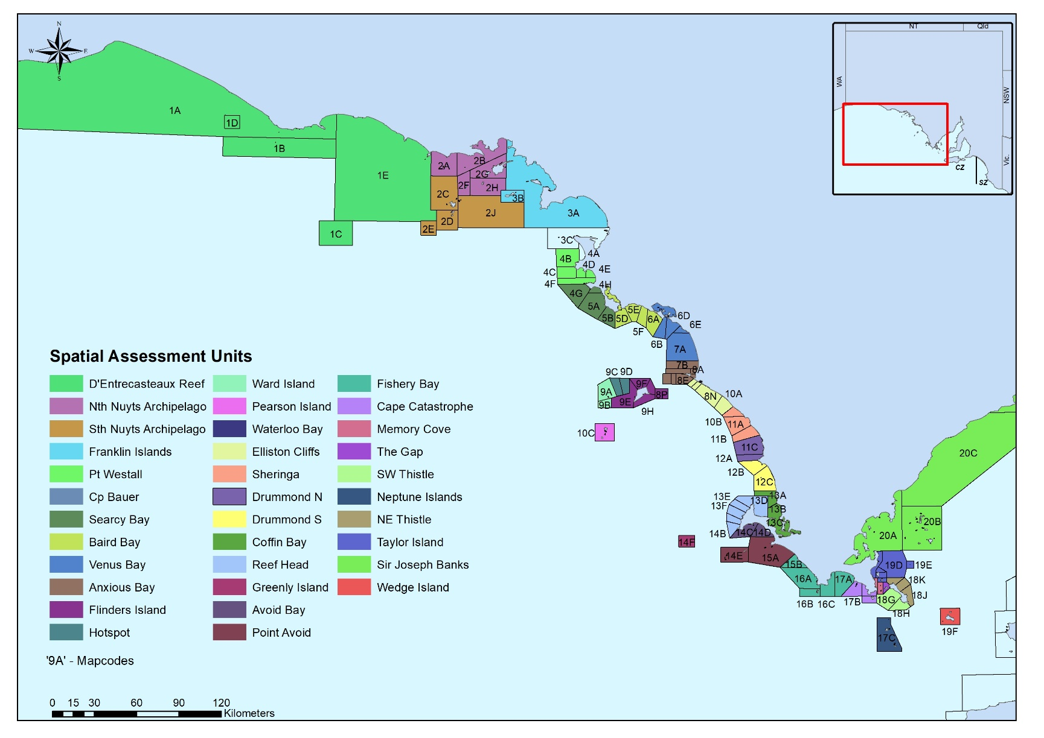

Figure 4: Map of Western Zone Abalone Fishery spatial assessment units (SAUs)

Figure 5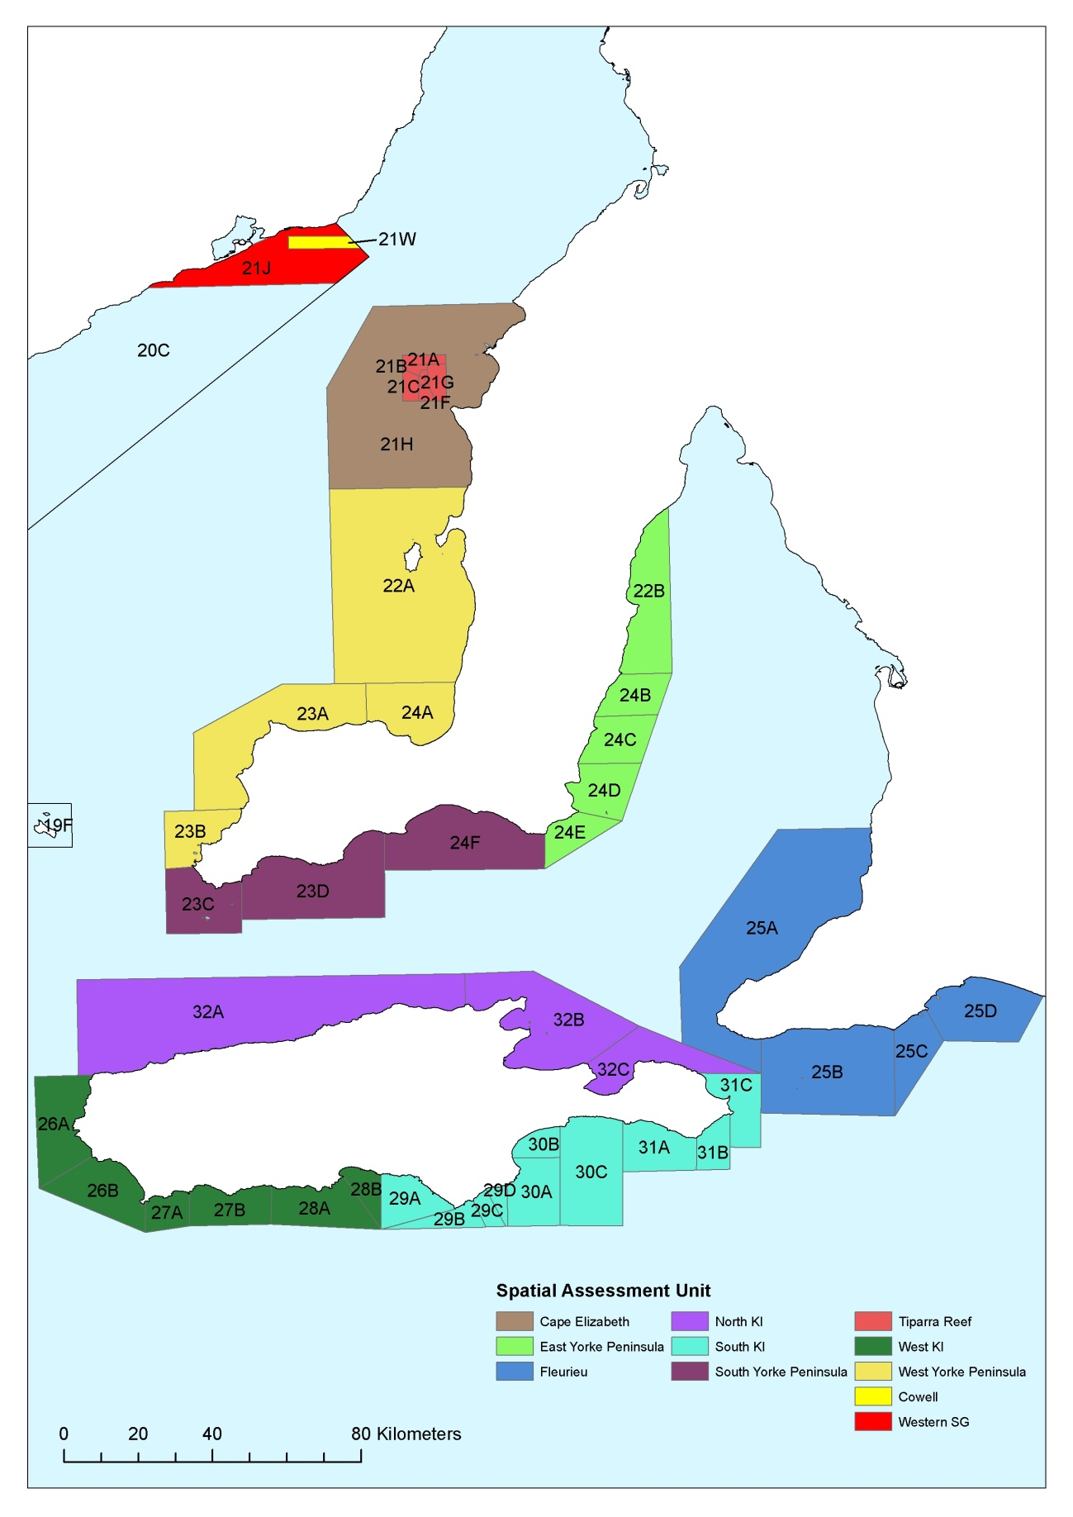. Map of the Central Zone Abalone Fishery spatial assessment units (SAUs).

Figure 6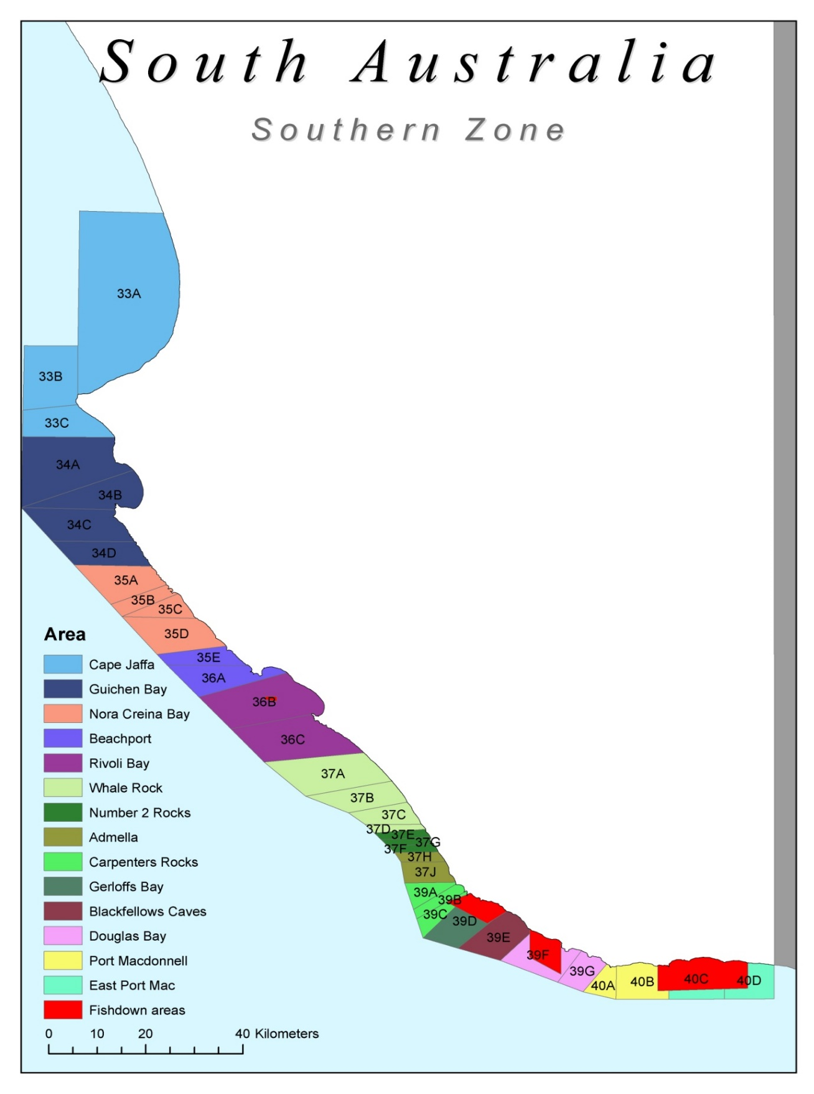. Map of the Southern Zone Abalone Fishery spatial assessment units (SAUs).

### Catch-per-unit-effort (CPUE) (units of kg. hour-1)

The major strengths of using CPUE as a primary indicator for abundance in abalone fisheries is the cost-effective, recording of information derived from all fishers on all fisher days with broad representation of the fished grounds which is used to estimate the CPUE. Units of effort are also recorded independently and along with catch levels are available over an extended time-series allowing a good understanding of changes (trends) in CPUE over time. The ability to evaluate abundance over a spatial assessment area comprising different levels of productivity is a key strength of the CPUE indicator.

Limits to the use of CPUE include the prospencity of the index to be hyperstable, which means that CPUE is unlikely to reflect declines in abundance until they are of magnitude. Therefore when interpreting CPUE there needs to be recognition that the biomass is likely to be declining at a faster rate than the indicator. Additional limitations in the interpretation of CPUE relate to changes in diver behavior such as fishing to the live market that requires a slower fishing-rate, large scale storm events and technology creep (whether increasing or decreasing CPUE).

The following rules guide the assessment of stock performance using CPUE for each SAU:

* For the Western Zone fishery CPUE data derived from the 12 month period prior to July of the assessment year will be used (i.e. financial year). For the Southern and Central Zones, calendar year data from the year prior to assessment will be used.
* The assessment of each SAU occurs independently to recognise the variations in the productivity and catch of an SAU.
* To allow the annual comparison of performance against a historical performance, a defined reference period that reflects a period of fishery stability and average performance is used. This reference period deliberately excludes the period of high productivity the fishery experienced following 2000 and recognises this later period as exceptional for all abalone fisheries and unlikely to reflect long-term sustainable levels of productivity.
* A function equation to score each SAU CPUE performance is used annually. The function equation is shown in Figure 7 and comprises three components:

1. a target range for CPUE equalling a score of 5;
2. a linear reduction in score, from 5 to 0, from the lower end of the target range to the limit reference point; and
3. a linear increase in score, from 5 to 10, from the upper end of the target range to a CPUE value that equates to a score of 10.

Key details of the computation are:

* The highest and lowest data values in the reference period are removed to prevent anomalous values driving the CPUE score function (note, significant testing of data was undertaken to inform this step).
* Reference period of 12 years or the most appropriate assessed for an SAU.
* The middle 40% of the range of the CPUE values within the reference period (or a minimum 2 kg range) is the **target CPUE range and equals a score of 5**.
* 20% below the second lowest value in the reference period is the **limit CPUE reference point and equals a score of 0**.
* 20% above the second highest CPUE value in the reference period equals a score of 10.

Each year the CPUE is calculated for the majority of SAUs and this is used to determine a score using the scoring function described above.

In instances where CPUE data are limited for a SAU (usually where fishing doesn’t occur in a SAU each year or only at low levels) and either an annual score or a function cannot be calculated, data across these SAUs are pooled. A score is then able to be calculated annually for these SAUs collectively, and these SAUs are collectively able to contribute annually to the zonal score. A list of pooled SAUs can be found below in Table 4.



Target Reference Point

**Score Function**

CPUE (kg/hr)



**Target Reference Point** = the middle 40% of values

Score of 5

Reference Period 1990-2000

20% above the second highest value in the reference period

Score of 10.

**Limit Reference Point** = 20% below the second lowest value

Score of 0

**Temporal changes in CPUE**

Year

Figure 7: Schematic diagram of the function used to score performance using the rules described above. Note a score of five (5) which equals the target reference point is comprised of the middle 40% of CPUE range from the reference period and produces a ‘flat’ stable section where a range of CPUE will result in a score of 5.

Table 4. Data limited SAUs pooled into a combined regional SAU for each abalone fishery (zone).

|  |  |  |  |  |  |  |  |
| --- | --- | --- | --- | --- | --- | --- | --- |
| **Fishery Zone** | **Region** | **SAU to be pooled** | **Species** | **Fishery Zone** | **Region** | **SAU to be pooled** | **Species** |
| **WZAF** | Elliston | ELLISTON CLIFFS | BL, GL | **CZAF** | Central Zone | CAPE ELIZABETH | BL, GL |
| PEARSON ISLAND | BL, GL | EAST YORKE PENINSULA | BL |
| SHERINGA | GL | FLEURIEU | BL, GL |
| WATERLOO BAY | BL, GL | NORTH KI | BL, GL |
| Far West | DENTRECASTEAUX REEF | BL, GL | SOUTH YORKE PENINSULA | BL, GL |
| FRANKLIN ISLANDS | BL, GL | TIPARRA REEF | BL |
| NORTH NUYTS ARCHIPELAGO | BL, GL | WEST YORKE PENINSULA | BL |
| SOUTH NUYTS ARCHIPELAGO | BL | WESTERN SG | BL, GL |
| Port Lincoln | CAPE CATASTROPHE | BL, GL | **SZAF** | Southern Zone | BEACHPORT | BL |
| COFFIN BAY | BL, GL | BLACKFELLOWS CAVES | BL |
| FISHERY BAY | BL | CAPE JAFFA | BL |
| GREENLY ISLAND | BL, GL | EAST PORT MACDONNELL | BL |
| MEMORY COVE | BL | NORA CREINA | BL |
| NE THISTLE | BL, GL | SOUTH END | BL |
| NEPTUNE ISLANDS | BL, GL |
| SIR JOSEPH BANKS | BL, GL |
| SW THISTLE | BL, GL |
| TAYLORS ISLAND | BL |
| THE GAP | BL |
| WEDGE ISLAND | BL, GL |
| Streaky | BAIRD BAY | BL |
| CAPE BAUER | BL, GL |
| SEARCY BAY | GL |
| VENUS BAY | GL |

### Legal density

A fishery-independent estimate of the density of abalone that have reached the minimum legal length for each class of abalone in each zone provides another measure of abundance (i.e. biomass) that is independent of the fishery and not influenced by the factors effecting CPUE. The estimate of legal density is undertaken by SARDI scientists using a methodology that is objective, standardised and unbiased. This assessment provides independent measures of relative abundance and trends in the number of individuals recruited into the fishery and can be interpreted without the confounding factors that complicate the interpretation of fishery-dependent information.

A limitation to the legal density indicator is the limited spatial coverage, level of inter-annual variation that may be due to sampling intensity and the potential impact of prior fishing. Increasing the intensity and/or frequency of sampling is likely to result in a decrease in variation and an increase in the precision of the indicator. In addition, overall cost represents one of the most important considerations in sampling design of the surveys, which is a limitation to providing a more comprehensive estimate. As such, there is a need to acknowledge that this trade-off occurs.

An estimate of legal density is derived from multiple diver surveys for surveyed SAUs. To annually assess the performance of legal density for each surveyed SAU, a scoring function based on similar components to the CPUE function above has been calculated. The function equation is shown in Figure 7 and comprises three components:

1. a target range for legal density with a score of 5;
2. a linear reduction in score, from 5 to 0, from the lower end of the target range to the limit density reference point; and
3. a linear increase in score, from 5 to 10, from the upper end of the target reference point to a density value that equates to a score of 10.

Estimates of legal density are available for varying time periods for SAUs depending on when surveys were commenced and undertaken, and therefore a consistent reference period cannot be used. Variations in data available have been taken into account when developing scoring functions for each of the SAUs through the rules as follows:

* A minimum of 4 values is needed for a reference period to develop score function.
* All data are used.
* The middle 40% of the legal density data range within the reference period comprises the **target density range and equals a score of 5**.
* If data are available between 2000 and 2007 or later, score 10 set at maximum value in time series in recognition that this was a period of exceptional fishery productivity.
* If limited data are available between 2000 and 2007, the score 10 is set at 120% of maximum value in time series.
* 80% of the lowest value in the reference period is the **limit density reference point and equals a score of 0**.
* Surveys are biennial; scores carry forward for 1 year. Thus, each survey is used twice in the harvest strategy.

**Target Reference Point** = the middle 40% of values

Score of 5

Highest value between 2000-2008

Score of 10.



Legal Density

**Score Function**



Reference Period

**Temporal changes in legal density**

Avoid Bay

**Lower limit Reference Point** = 80% of the lowest value in the reference period.

Score of 0

Figure 8: A schematic of the function used to score performance using the rules described above for legal density. A score of five (5) which equals the target reference point is comprised of the middle 40% of legal density from the reference period and produces a ‘flat’ stable section where a range of legal density will result in a score of 5. Note if data is not available between 200-2007 then the maximum score of 10 is determined at 20% higher than the maximum score for the data available to account for the increase in density from 2000-2007.

### Final Score for each SAU

The scores from the two performance indicators of CPUE and legal density are combined to achieve a final SAU score, which is a measure of overall stock performance for that particular SAU. The performance indicators are combined as follows:

* If both CPUE and legal density scores are available for an SAU then a final score is calculated using a 50:50 weighting.
* In cases where the CPUE score is not available, the CPUE score is computed using a weighted mean of the available data from the previous three years and then the final score is calculated using a 50:50 weighting.
* In cases where the legal density score is not available, the legal density score is carried forward from the previous year and then the final score is calculated using a 50:50 weighting.
* In cases where only the CPUE scores is available, the CPUE score equals the final score.
* In cases where only the legal density scores is available, the legal density score equals the final score.
* In cases where neither legal density nor CPUE scores are available, the last valid score is carried forward until a new score is available. There is no limit to how long scores can be carried forward. Note this is likely to occur in a very limited number of SAUs.

## Zonal score

The annual zonal score is the aggregate of the SAU scores derived from the process above. To ensure SAUs contribute to the final zone score in the same proportion as their importance to the fishery, the score for each SAU is catch weighted before aggregation.

Catch weighting is calculated using the following steps:

* Calculate the proportion of catch from each SAU for the previous 12 years.
* The proportions are subsequently used for the catch weightings. For each SAU, the final score is multiplied by the catch weighting. The resultant catch-weighted scores from each SAU are then summed.

The sum of the weighted scores is the zonal score in the assessment year. Scores are not rounded given the decision rules are based on ranges rather than whole numbers.

## Zonal stock status

The Status of Australian Fish Stocks (SAFS) provides the overarching framework to support the determination of the biological status of Australian fished stocks. The determination does not take into consideration broader ecological or economic considerations.

The Status of Australian Fish Stocks classification framework uses two factors; biomass, and fishing mortality to establish the status of a stock as sustainable, depleting, recovering or depleted.

To derive an annual zonal stock status under SAFS for abalone fisheries where direct measures of biomass and fishing pressure are not available it is necessary to use proxies. The zonal score will be the proxy for biomass and the linear trend (slope) of the zonal score over four years will be the proxy for fishing mortality. The use of trend in zonal score in this way has assumed that non-fishing factors effecting total mortality remain constant (e.g. productivity, disease, recruitment, and environment) and therefore fishing mortality represents any overall change in total mortality.

A relationship between the impact of fishing mortality and biomass will be established annually. When fishing mortality does not impact the biomass to a level that restricts recruitment then the stock is not being overfished. If, however, fishing mortality is too high and the biomass is below what is required for recruitment to the fishable stock to replace the fish caught then the stock is being overfished. Consistent with the scores developed to determine abalone stock performance at the SAU scale, the limit reference point for overfishing (F-limit) is set at a score of <5 and the biomass limit reference point (B-limit) is set at a score of 1 or below. This framework allows the status of a stock to be tracked annually and adjustments made to the total allowable commercial catch where necessary to adjust fishing pressure (Figures 8 and 9). Limit reference points provide the transition junctures between classifications as follows;

* Biomass limit reference point of 1 or below determines biomass at a very low level and will result in either a recovering or a depleted classification depending on the trend in fishing mortality.
* Fishing mortality of <5 determines a level of fishing mortality resulting in overfishing (noting that a negative slope assigns a low score) and will result in either a depleting or sustainable classification depending on the biomass reference point.

Figure 9. The relationship between Fishing Mortality and Biomass reflecting limit reference points for each classification.

5

**Zone Score trend**

(Proxy for fishing mortality)

**Zone Score**

(Proxy for biomass)

5

1

Depleted

Depleting

Sustainable

Recovering

## Harvest decision rules – determining zonal catch form zone score

The recommended TACC is linked to the status of the stock. This ensures that the level of fishing mortality recommended for a fishery from the harvest strategy reflects the performance of the fishery and allows for stock recovery, if required, consistent with addressing acceptable levels of risk. The harvest decision rules are applied to a pre-determined target zonal catch that reflects a catch level considered to be biologically sustainable over the long-term and aims to ensure stocks are not classified as depleted for more than 9-years in every 10-years.

The target zonal catches for each species in each fishery is as follows;

* Southern Zone Abalone Fishery – Blacklip 132,000 kg whole weight
* Central Zone Abalone Fishery – Greenlip 46,040 kg meat-weight
* Central Zone Abalone Fishery – Blacklip 9,000 kg meat-weight
* Western Zone Abalone Fishery – Greenlip 78,000 kg meat-weight
* Western Zone Abalone Fishery – Blacklip 77,000 kg meat-weight

The harvest decision rules result in a positive adjustment to zonal catch when zonal scores are greater than 7.0. For zone scores >7.0, an increase in zonal catch of 10% for every additional increase of 1.0 zone score may be applied. It is not essential for an increase in zonal catch to be taken. Conversely, a reduction in zonal catch is applied when a zone score is below 5 reflecting a lower level of stock performance (Figure 9). The decision rules will limit fishing mortality when required, although it should be noted that a reduction in stock performance may not be caused by fishing mortality and may be a result of changes to productivity, environment, fishing access or other unquantified factors.

An additional meta-rule is included to require a recovering zonal stock to have higher catches increase incrementally back to the target zonal catch level by preventing large increases in fishing mortality between years. The stock-recovery rule is a maximum increase in zonal catch with an increased zone score of no more than:

* 5% of the target zonal catch for a score of 1.0-2.5, and
* 15% of the target zonal catch for a score of 2.6-4.9.

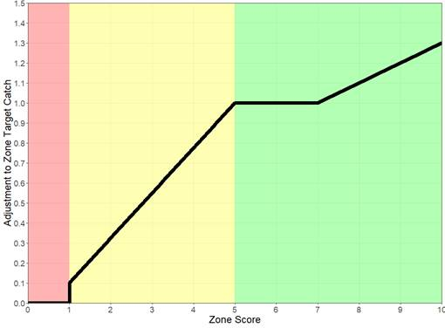

Figure 10. **Schematic representation of the conversion from zonal score to a zonal catch ± 10%. The zonal score is a representative only. The final TACC recommended from the harvest strategy is a determined after application of the secondary information through the decision rules.**

An additional meta-rule is included to require a recovering zonal stock to have higher catches increase incrementally back to the target zonal catch level by preventing large increases in fishing mortality between years. The stock-recovery rule is a maximum increase in zonal catch with an increased zone score of no more than:

* 5% of the target zonal catch for a score of 1.0-2.5, and
* 15% of the target zonal catch for a score of 2.6-4.9.

For ease, the stock-recovery rule will equate to the following for each species in each zone (Table 5);

Table 5. Increases in TACC when stock is recovering for each class of abalone in each zone.

|  |  |  |  |  |  |  |
| --- | --- | --- | --- | --- | --- | --- |
|  | **Target catch** | **77 (meat-weight)** | **78 (meat-weight)** | **9 (meat-weight)** | **46 (meat-weight)** | **132 (whole weight)** |
| Score | Maximum catch increase | WZ Blacklip | WZ Greenlip | CZBL Blacklip | CZGL Greenlip | SZBL Blacklip |
| 1.0-2.5 | 5% | 3.9 | 3.9 | 0.5 | 2.3 | 6.6 |
| 2.6-4.9 | 15% | 11.6 | 11.7 | 1.4 | 6.9 | 19.8 |

A key component to the decision rules includes 10% variance around the zonal catch value. The % change to the adjustment value within this 10% limit is informed by the secondary sources of information provided at the data workshop.

The decision rules will limit fishing mortality when required although it should be noted that a reduction in stock performance may not be caused by fishing mortality and may be a result of changes to productivity, environment, fishing access or other unquantified factors.

## Harvest decision rules – adjusting zonal catch using secondary sources of information

A key component to the decision rules includes an overall 10% variance (i.e. up and down) around the zonal catch value. The potential overall changes to the zonal catch value are assessed at the SAU level (i.e. 10% variance around SAU catch contribution to the zonal catch value), that are then accumulated. Potential adjustments to SAU catch contributions are informed by multiple secondary sources of information for each SAU that are provided at the data workshop for each zone (Tables 6-8). These secondary sources of information are then considered collectively by PIRSA - Fisheries and Aquaculture, PIRSA - SARDI and the industry for evidence-based adjustments to SAU catch contributions. The relevant secondary information is to be assessed based on its merits using a weight of evidence approach requiring such information be evidence based, credible, verifiable, and rigorously documented.

Table 6. Information to be considered in recommending the final total allowable commercial catch for the Southern Zone Abalone Fishery

|  |  |  |  |  |  |
| --- | --- | --- | --- | --- | --- |
| **Indices** | **Description** | **Source** | **Evidence weighting** | **Interpretation** | **Application** |
| Severe storm events | Large waves and surge impacts access to some SAUs. This may result in some areas not fished and reduced access to the fishery. | Industry and SARDI/BOM | Strong | The impact of severe storm events is known to impact diver access in the Southern Zone. | Where SAUs were not accessed and CPUE was impacted, may adjust the SAU catch upwards in proportion to the average catch contribution of the SAU. Use 2016 as a reference. |
| Catch caps | Industry establish and monitor catch caps for each SAU and indicates where fishing pressure is highest. | Industry | Strong | Changes to catch caps will impact diver behavior. | If catch caps are exceeded then an adjustment in catch caps to decrease pressure in some areas may be required. |
| Minimum legal limits (MLL) | Minimum legal limits are determined for each SAU. | PIRSA | Strong | A change in SAU size limit is designed to change fisher behavior and this will impact catch and effort information. | A decrease in CPUE as a result of a stable or decease in MLL may adjust the SAU catch down by 5%. The converse may adjust the SAU catch up by 5%. |
| Access to Middle Point | If Middle Point is not fished early in the season then it is unlikely to be accessed due to weather. | Industry and SARDI | Strong | If Middle Point cannot be accessed early in the season due to weather then the TACC may not be caught in that year. | The SAU catch for Middle Point may be adjusted upwards to reflect average catch if weather prevented access. |
| New/Old Divers and injuries | Diver health can have an impact on catch rates at some SAUs, particularly when there are a limited number of licence holders. | Industry | Medium | SARDI will statistically assess the CPUE at SAU scale to determine if there is a variation from the medium CPUE for that SAU. | May adjust the SAU catch based on the outcomes of SARDI assessment for the SAUs dived by 2.5%. |
| Access to launch sites (e.g. East Pt Mac) | Access to launch sites impacts where fishing will occur and is used in conjunction with catch cap information to understand annual fishery dynamics. | Industry | Medium | Some SAUs may not be fished at the same frequency and this should not be interpreted as low abundance. | Consider the catch of SAUs with poor access and if the SAU scores <5 may adjust the SAU catch to reflect the average catch. |
| Fish kill | May be environmentally or disease driven. This index relates only to an environmentally driven event. | Industry and SARDI | High | A fish kill will have an impact on abundance and in the past the extent of the impact has not been understood for years. | May adjust the impacted SAU catches down to account for a reduced abundance due to an environmental impact on the fishery. This adjustment may be more than 10%. |

Table 7. Information to be considered in recommending the final total allowable commercial catch for the Central Zone Abalone Fishery.

|  |  |  |  |  |  |
| --- | --- | --- | --- | --- | --- |
| **Indices** | **Description** | **Source** | **Evidence weighting** | **Interpretation** | **Application** |
| Severe storm events | Large waves and surge impacts access to some SAUs. This may result in some areas not fished and reduced access to the fishery. | Industry and SARDI/BOM | Strong | The impact of severe storm events is known to impact diver access in the Central Zone. | Where SAUs were not accessed and CPUE was impacted, adjust the SAU catch upwards in proportion to the average catch contribution of the SAU. Use 2016 as a reference. |
| Weather/wind/ swell period | Generally day-to-day weather will impact when and where diving can occur. This may result in less than ideal conditions for diving. Divers will generally select good days to dive and SAUs that are accessible. | Industry | Low | There is likely to be some impact of weather on a day-to-day basis. | SAU catch may be adjusted to a maximum of 2.5% as a result of weather (noting that this does not include storm events). |
| GPS logger data | Provides a greater understanding of spatial fishing activity within an SAU. | SARDI | Strong | GPS logger data will identify spatial extent of fishing activity and identify areas of high and low fishing pressure. | SAU catch may be adjusted up or down when logger data metrics contradict CPUE for an SAU. |
| New/Old Divers and injuries | Diver health can have an impact on catch rates at some SAUs, particularly when there are a limited number of licence holders. | Industry | Medium | SARDI will statistically assess the CPUE at SAU scale to determine variation from the medium. | Adjust SAU catch based on the outcomes of SARDI assessment for the SAUs dived by 2.5%. |
| Access to launch sites including Hanson Bay | Access to launch sites impacts where fishing will occur and may result in fewer fisher days at a location and not necessarily fishery performance. | Industry | Medium | Some SAUs may not be fished at the same frequency and this should not be interpreted as low abundance. | Consider the catch of SAUs with poor access and if the SAU scores <5 adjust the SAU catch to reflect the average catch to no more than 10%. |
| Fish kill | May be environmentally or disease driven. This index relates only to an environmentally driven event. | Industry and SARDI | Strong | A fish kill will have an impact on abundance and in the past the extent of the impact may not be understood for years. | Adjust the impacted SAU catches down to account for a reduced abundance due to an environmental impact on the fishery. This adjustment may be more than 10%. |
| Season of harvest | There is a strong seasonal component to weight recovery for abalone. | SARDI/Industry | Strong | Harvesting outside of the season is likely to mean more abalone harvested for the same weight. | Adjust each SAU catch up if the majority of fishing occurred outside the peak season if a zone score ≥5. |

Table 8. Information to be considered in recommending the final total allowable commercial catch for the Western Zone Abalone Fishery.

|  |  |  |  |  |  |
| --- | --- | --- | --- | --- | --- |
| **Indices** | **Description** | **Source** | **Evidence weighting** | **Interpretation** | **Application** |
| SAU CPUE | Diver assessment of abundance considering experience and number of dives. | Industry | Strong | Data are collated and analyzed by AIASA and provides a comprehensive snapshot of the SAU from all licences. | If divers provide this information and it is in opposition to the PI trend then adjust the relevant SAU catch in accordance with the diver assessment. |
| SAU average density | Diver assessment of average density standardized by experience and number of dives. | Industry | Strong | Data are collated and analyzed by AIASA and provides a comprehensive snapshot of the SAU from all licences. | If divers provide this information and it is in opposition to the PI trend then adjust the relevant SAU catch in accordance with the diver assessment. |
| SAU average legal size | Diver assessment of average size of abalone standardised by experience and number of dives. | Industry | Strong | Data are collated and analyzed by AIASA and provides a comprehensive snapshot of the SAU from all licences. | If divers provide this information and it is in opposition to the PI trend then adjust the relevant SAU catch in accordance with the diver assessment. |
| SAU number of juvenile | Diver assessment of pre-recruits standardized by experience and number of dives. | Industry | Strong | Data are collated and analyzed by AIASA and provides a comprehensive snapshot of the SAU from all licences. | If divers provide this information and it is in opposition to the PI trend then adjust the relevant SAU catch in accordance with the diver assessment. |
| SAU overall performance | Diver assessment of the SAU against the divers previous experience at that SAU standardized by experience and number of dives. | Industry | Strong | Data are collated and analyzed by AIASA and provides a comprehensive snapshot of the SAU from all licences. | If divers provide this information and it is in opposition to the PI trend trend then adjust the relevant SAU catch in accordance with the diver assessment. |
| Severe storm events | Large waves and surge impacts access to some SAUs. This may result in some areas not fished and reduced access to the fishery. | Industry and SARDI/BOM | Medium | The impact of severe storm events is known to impact diver access in the Western Zone. | Where SAUs were not accessed and CPUE was impacted, adjust the TACC in proportion to the average catch contribution of the SAU. |
| Weather/wind/ swell period | Generally day-to-day weather will impact when and where diving can occur. This may result in less than ideal conditions for diving. Divers will generally select good days to dive. | Industry | Low | There is likely to be some impact of weather on a day-to-day basis. | SAU catch can be adjusted to a maximum of 2.5% as a result of weather (noting that this does not include storm events). |
| Market Changes | Harvesting will reflect market demand and price. In particular fishing for live abalone increases the time to select and harvest abalone. | SARDI/Fish Processor | Strong | If harvesting for live abalone increases there is likely to be a decrease in the CPUE. SARDI will statistically assess the impact of the live market (by removing abalone landed whole) to determine if there is a variation in SAU CPUE from the mean. | If there is a positive variation in the mean adjust the SAU catch up in proportion to the increase. |
| Proportion Large (Grade1) | The proportion of large abalone in the catch provides valuable information on the quality of abalone available and market drivers. | SARDI/Fish Processors | Strong | A consistent or high proportion of large abalone in the catch indicates that fishing down to size is not occurring.  A decreasing proportion of large abalone in the catch may indicate fishing down to size or changes in market. | If SAU trend changes, compare with FIS SAU data. If both trending down, adjust SAU catch down. If trend stable or increasing adjust SAU catch upwards. |
| New/Old Divers and injuries | Diver health can have an impact on catch rates at some SAUs, particularly when there are a limited number of licence holders. It is likely that the impact of these changes will have an effect when multiple licences are impacted at the same time. | Industry | Medium if multiple licences | SARDI will statistically assess the CPUE at SAU scale to determine variation from the medium. | Adjust SAU catch based on the outcomes of SARDI assessment for the SAUs dived by no more than 10%. |
| Access to launch sites | Access to launch sites impacts where fishing will occur and may result in fewer fisher days at a location and not necessarily fishery performance. | Industry/SARDI | Medium | Some SAUs may not be fished at the same frequency and this should not be interpreted as low abundance. | Consider the catch of SAUs with poor access and if the SAU scores <5 adjust the SAU catch to reflect the average catch to no more than 10%. |
| Fish kill | May be environmentally or disease driven. This index relates only to an environmentally driven event. | Industry and SARDI | Strong | A fish kill will have an impact on abundance and in the past the extent of the impact may not be understood for years. | Adjust the impacted SAU catches down to account for a reduced abundance due to an environmental impact on the fishery. This adjustment may be more than 10%. |
| Season of harvest | There is a strong seasonal component to meat-weight recovery for abalone. | SARDI/Industry | Strong | Harvesting outside of the season is likely to mean more abalone harvested for the same weight. | Adjust each SAU catch up if the majority of fishing occurred outside the peak season if a zone score ≥5. |

## Exceptional circumstances

The development of this harvest strategy requires that considerations are made for exceptional circumstances. These circumstances may include stressors on the stock fisheries that are deemed outside the impacts considered as a part of the harvest strategy at the time of development and amongst others may include mass mortality events, disease out-breaks, market failure, large-scale fleet transformation, natural or human-induced disasters. In these instances it may be necessary to temporarily amend management arrangements to address these exceptional circumstances.

## Closures

If the zone score is 1.0 or below, and the fishing mortality score is 4.9 or lower, the risk to the stock is deemed to be unacceptably high, and the stock within a zone will be classified as depleted. This would trigger temporal closure(s) of the fishery zone(s), or within-zonal SAUs to mitigate the risk. Catch levels developed for post-closure situations should be extremely precautionary and may incorporate fishery-independent and fishery-dependent surveys, and structured fishing to provide for the development and testing of alternative strategies and monitoring of stock recovery.

Uncertainties requiring precautionary exploitation rates may include:

* Potential disconnects between the genetic population structure, spatial trends in commercial fishing, and the spatial management boundaries.
* Hyper-stability of trends in CPUE and recognition that CPUE is likely to overestimate abalone abundance.
* Extent of the impacts of disease (e.g. Perkinsus) or severe weather events.
* Data available to assess stock biomass.

## Review of the harvest strategy

The Harvest Strategy is structured to facilitate the integration of improved data and information when it becomes available in the future. Improved data are likely to include additional fishery-dependent information gathered from diver-GPS logger data and data derived from commercial diver assessment surveys or transformation of the fishing fleet. Amendments to the harvest strategy developed to incorporate improved information is intentional and the incorporation of such information will follow an investigation and review of the harvest strategy in consultation with industry and any committee established to oversee the review. Such a change to the harvest strategy including the decision rules may occur if approved by the Minister, and is considered a change of a specified kind for the purposes of section 46(1)(d) of the *Fisheries Management Act 2007*.

# Research needs and priorities

The research themes described below are the key considerations for the management of the Abalone fisheries and require additional investigation. The inclusion of these priorities may require additional funding to undertake.

* Ensure the principle of constant improvement is embraced by all stakeholders in support of the adaptive management of abalone stocks.
* Use of spatially derived information as a potential harvest strategy performance indicator.
* Use of a comprehensive diver assessment survey to integrate into the harvest strategy.
* Understanding the extent and triggers to expressions of Perkinsus in the Western Zone.
* Develop a program of stock enhancement including an analysis of varying approaches.

# Resources required to implement the plan

In fulfilment of the objects of the *Fisheries Management Act 2007*, South Australian commercial fisheries currently operate in accordance with the Government’s cost recovery policy. Costs of policy development, management, research and compliance programs are recovered through licence fees to reflect that South Australia’s aquatic resources are owned by the State and managed by PIRSA on behalf of the South Australian community. Any costs associated with Government services that arise as a direct result of commercial access and benefit from resources, are recovered from commercial licence holders. The fees are currently collected through a base licence fee and a fee-per-unit of quota endorsed on the licence.

# References

FAO (2011). EAF planning and implementation tools. Harvest Strategies and Control Rules. EAF Tool fact sheets. Text by EAF Toolbox Team. [online]. Rome. Updated 29 November 2011. http://www.fao.org/fishery/eaf-net/eaftool/eaf_tool_49/en.

Fletcher, W.J., Chesson, J., Fisher M., Sainsbury, K.J., Hundloe, T., Smith, A.D.M. &. Whitworth, B. (2002). National ESD Reporting Framework for Australian Fisheries: The ‘How To’ Guide for Wild Capture Fisheries. FRDC Project 2000/145, Canberra, Australia. 120 pp.

*Fisheries Management Act 2007*

[*https://www.legislation.sa.gov.au/LZ/C/A/Fisheries%20Management%20Act%202007.aspx*](https://www.legislation.sa.gov.au/LZ/C/A/Fisheries%20Management%20Act%202007.aspx)

*Fisheries Management (Abalone Fisheries) Regulations 2017 — 15. 1. 2018.*

[*https://www.legislation.sa.gov.au/LZ/C/R/FISHERIES%20MANAGEMENT%20(ABALONE%20FISHERIES)%20REGULATIONS%202017/CURRENT/2017.220.AUTH.PDF*](https://www.legislation.sa.gov.au/LZ/C/R/FISHERIES%20MANAGEMENT%20(ABALONE%20FISHERIES)%20REGULATIONS%202017/CURRENT/2017.220.AUTH.PDF)

*Livestock Act 1997*

<https://www.legislation.sa.gov.au/LZ/C/A/LIVESTOCK%20ACT%201997.aspx>

Mayfield, S., Ferguson, G., Carrol, J. Dent, J. (2014). Central Zone Abalone (*Haliotis laevigata* and *H. rubra*) Fishery. Fishery Assessment Report to PIRSA Fisheries and Aquaculture. South Australian Research and Development Institute (Aquatic Sciences). SARDI publication No. F2007/000611-5. SARDI Research Report Series No. 810. 77 pp.

McIlgorm A. (2013). Literature study and review of international best practice, fisheries harvest strategy policy approaches. A report to the Department of Agriculture Fisheries and Forestry (DAFF), Canberra, by ANCORS, University of Wollongong, Australia.

*Native Title Act 1993* [*https://www.legislation.gov.au/Details/C2019C00054*](https://www.legislation.gov.au/Details/C2019C00054)

PIRSA (2009). Ecologically Sustainable Development (ESD) Risk Assessment of the South Australian Abalone Fishery. Primary Industries and Resources, South Australia. 81 pp.

*PIRSA Allocation Policy (2011) - Allocation of access to fisheries resources between fishing sectors*. <https://pir.sa.gov.au/__data/assets/pdf_file/0003/254523/Allocation_Policy.pdf>

PIRSA (2012). Management Plan for the South Australian Commercial Abalone Fishery (2012). The South Australian Fisheries Management Series. PIRSA Fisheries and Aquaculture. Paper number 60. 89 pp.

PIRSA (2015a). South Australian Fisheries Harvest Strategy Policy. Primary Industries and Resources, South Australia. 17 pp.

PIRSA (2015b). Guidelines for implementing the South Australian Fisheries Harvest Strategy Policy. Primary Industries and Resources, South Australia. 15 pp.

Sloan, S. R., Smith, A.D.M., Gardner, C., Crosthwaite, K., Triantafillos, L., Jeffries, B. and Kimber, N. (2014). National Guidelines to Develop Fishery Harvest Strategies. FRDC Report – Project 2010/061. Primary Industries and Regions, South Australia, Adelaide, March. CC BY 3.0

Smith, T. (2016). Options for integrating the State Harvest Strategy Guidelines into a revised South Australian Abalone Harvest Strategy. Preliminary final report to the South Australian Abalone Fishery Harvest Strategy Working Group 18 July 2016. 22 pp.

Smith A.D.M., Smith D.C., Haddon M., Knuckey I., Sainsbury K.J. and Sloan S. (2013). Implementing harvest strategies in Australia: 5 years on. – ICES Journal of Marine Science, doi:10.1093/icesjms/fst158.

