HACCP Plan
HACCP plan for production and sale of live Bivalve Molluscs (Shellfish).
HACCP Plan based on principles of CODEX Alimentarius HACCP.
Business Name
PIRSA Accreditation Number: 20/XXXX

This is a HACCP template, developed by the Department of Primary Industries and Regions South Australia (PIRSA) for Bivalve molluscs (Shellfish).
It is the responsibility of the accredited producer to implement and maintain the HACCP plan as part of the approved Food Safety Arrangement.

Table of Contents
1 HACCP PROCESS 3
1.1 SCOPE 3
1.2 PRODUCT SPECIFICATION 4
1.3 FLOW CHART 5
1.4 CCP Decision Tree 6
1.5 HAZARD ANALYSIS TABLE 7
1.6 HAZARD AUDIT TABLE 10
1.7 CCP WORK INSTRUCTIONS 13
1.8 CCP MONITORING FORMS 15
1.9 PROCESS VALIDATION 18

HACCP PROCESS

To produce shellfish safely, producing safe shellfish which complies with relevant legislation, regulations and standards.
OUTCOME

The HACCP team (as identified it the Food Safety Arrangement) is responsible for maintaining this HACCP manual through analysing and improving procedures along with implementing effective controls to manage food safety risks. Each process undertaken by the business needs to be covered by a HACCP plan.

SCOPE

This HACCP plan covers all steps in the process for the harvesting of Bivalve Molluscs (Shellfish) for human consumption.
The following have been taken into consideration in the development of this HACCP plan;
- Primary Produce (Food Safety Schemes) Act 2004
- Primary Produce (Food Safety Schemes) (Seafood) Regulations 2017
- Foods Standards Australia New Zealand, Food Standards Code:
- Standard 1.6.1 Microbial Limits in Food, with Schedule 27
- Standard 4.2.1 Primary production and processing standard for seafood
- Standard 3.2.2 Food safety practices and general requirements
- Standard 3.2.3 Food Premises and Equipment
- Australian Shellfish Quality Assurance Program Export Standards 2004 Edition. 0662 - Shellfish book (awe.gov.au)

PRODUCT SPECIFICATION
As per the Food Safety Arrangement, Product Specifications detail the product characteristics as listed below and are considered when reviewing the HACCP plan.
Batch is defined as oysters harvested within a 24-hour period from the same harvest area.
General Category Product Specification
Product Category | Pacific Oysters
Form | Live in shell  Shucked (for those businesses accredited for this activity) (delete if not accredited)
Method of Preservation | Live: Refrigeration – chilled at or below 10°C  Shucked: Refrigeration – Chilled at or below 5°C
Packaging | Primary | Hessian/Polly bags; Lined Foam boxes (with cold pack)
Storage Conditions | Live: Keep refrigerated at or below 10°C  Shucked: Keep refrigerated at or below 5°C
Distribution Method | Direct to Customer  Live: Wholesale via refrigerated transport at or below 10°C  Shucked: Wholesale via refrigerated transport at or below 5°C
Shelf Life | To be determined by producer:  Chilled, Live: up to x days at less than 10°C  To be determined by producer/processor:  Chilled, Shucked: 5 days at less than 5°C  Frozen: months
Labelling (bag tag) | - Species of Oyster (Pacific Oysters)  - Food Safety Accreditation Number:  - Aquaculture Licence number  - Name and address (optional) of this business  - Date of oyster harvest  - Name of the Area as specified by SASQAP from where oysters were harvested  - Quantity of oysters in the shipment e.g. dozen or bag, (optional, as may appear on sales invoice)  - Storage/transit temperature control requirements for storage (no more than 10°C).
Intended Use | Sensitive Customer | Not suitable for vulnerable populations or those with shellfish allergy
 | Customer Preparation | Ready-To-Eat, no preparation required prior to consumption.  Product may be eaten raw.  Product may be cooked prior to consumption
Micro and Maximum Residue Limit (MRL) | As per FSANZ | Managed by South Australian Shellfish Quality Assurance Program (SASQAP).

FLOW CHART
Objective | A step-by-step diagram of the flow of the operation/process with all inputs and outputs identified. Key steps in the process that are critical to food safety are referred to as Critical Control Points, CCP. Hazards at Control Points (CP’s) are required to be controlled which may be achieved through the GMP or Support Program defined in the table (and referenced in the Food Safety Arrangement). These are highlighted on the Flow Chart.

CCP Decision Tree

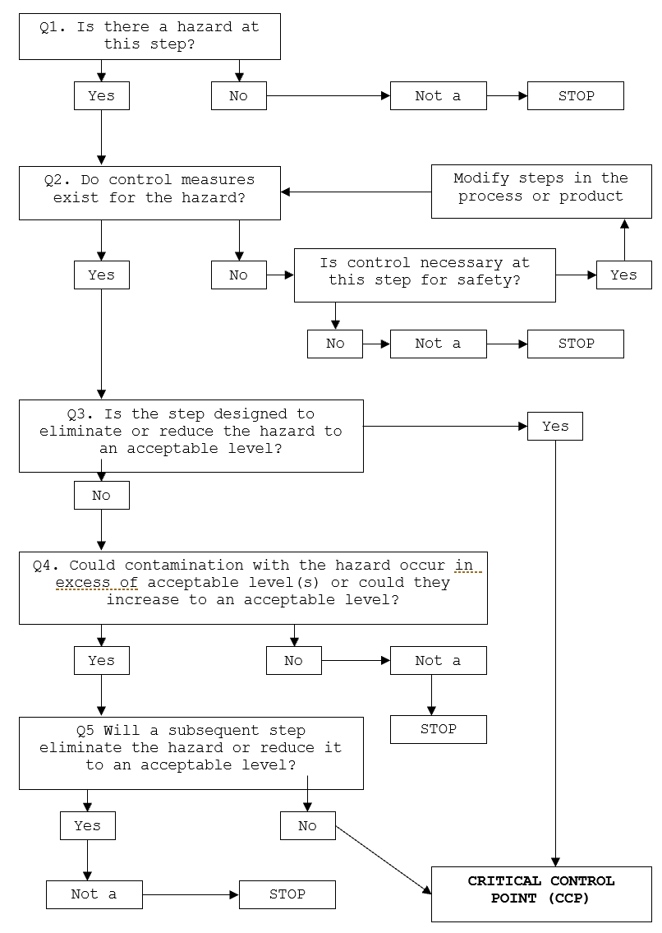

HAZARD ANALYSIS TABLE
Hazard Types: B – Biological; C – Chemical; P – Physical
Objective | A documented review of each step identified in the flow chart with the importance of each step in the safety of the finished product rated to identify Critical Control Points (CCP).

Process Step | Hazard | Cause | Q1 | Q2 | Q3 | Q4 | Q5 | Hazard control measure | CCP | CP | GMP | Support Program (as per FSA)
- Pre-Harvest | Environmental contamination from harvest area from on-grown oysters |  | Y | Y | N | N |  | Purchased from approved supplier. | CP | Approved Suppliers
 | Contaminated oysters relocated via relay request from closed bay | Harvesting of relocated oysters prior to completion of withholding period. | Y | Y | N | N |  | Compliance with Seafood Scheme regulations on movement of oysters from one growing area to another. | CP | Relay authorisation
- Harvest | B, C – Microbial or chemical (including biotoxins) contamination from harvest area | Elevated levels of microorganisms (e.g. rain fall event)  Environmental chemical contamination | Y | Y | N | Y | N | Compliance with SA Shellfish Quality Assurance Program (SASQAP), including biotoxin management plan.  Harvest only from approved area with Open Status. | CCP | SASQAP notices  Harvest procedures
- Transport to Accredited Facility | B - Microbial growth of Vibrio Parahaemolyticus | Extended exposure to extreme temperature | Y | Y | N | N |  | Guidelines: Under shade within 4 hours of harvest and under active refrigeration within 7 hours. | CP | Monitored on Harvest monitoring form
Process Step | Hazard | Cause | Q1 | Q2 | Q3 | Q4 | Q5 | Hazard control measure | CCP | CP | GMP | Support Program (as per FSA)
- Grading | B - Microbial contamination from water.  P - dead/damaged stock | Elevated levels of microorganisms | Y | Y | N | Y | N | Use approved water source or potable water. | CCP | Testing program and results
 |  | Contamination from dead or sick oysters | N |  |  |  |  | Sort and discard dead, damaged and dying oysters during grading. | CP | Support Program - Staff Training
- Packing | P – contamination from packaging material  B – Microbial contamination from staff | Inappropriate storage  Staff hygiene practices | Y | Y | N | N |  | Use food grade packaging, stored in a manner to prevent contamination  Observe good hygienic practices | CP | Approved Suppliers  Packaging Storage  GMP/GHP
- Labelling | Preservation of Identity – Loss of traceability  Resulting in the potential for Co-mingling of oysters from different Harvest areas | Incorrect labelling or no labelling | Y | Y | Y |  |  | Labelling, invoices and tags to contain:  - Species of Oyster (Pacific Oysters)  - Food Safety Accreditation Number:  - Aquaculture Licence number  - Name and address (optional) of this business  - Date of oyster harvest  - Name of the Area as specified by SASQAP from where oysters were harvested  - Quantity of oysters in the shipment e.g. dozen or bag, (optional, as may appear on sales invoice)  - Storage/transit temperature control requirements for storage (no more than 10°C). | CCP | Bag tag/label  Invoice
Process Step | Hazard | Cause | Q1 | Q2 | Q3 | Q4 | Q5 | Hazard control measure | CCP | CP | GMP | Support Program (as per FSA)
- Chilling | B – Microbial growth of Vibrio Parahaemolyticus | Product not into chiller in a timely manner | Y | Y | Y |  |  | Internal product temperature to be less than or equal to 10°C within 24 hours from harvest. | CCP | Harvest monitoring form  Product Cooling Validation
- Storage | B – Microbial growth of Vibrio Parahaemolyticus | Air temperature above 10°C | Y | Y | Y |  |  | Product stored under air temperature control to maintain internal product temperature of less than or equal to 10°C. | CCP | Support program (Calibration)
 | P,C – Product contamination | Storage facilities not clean, product stored with non-food items | N |  |  |  |  | Storage facilities clean and product not stored with non-food or other possible contaminants. Storage facilities free from vermin and insects. | CP | Support Programs
- Despatch | B – Microbial growth of Vibrio Parahaemolyticus | Air temperature above 10°C | Y | Y | Y |  |  | Product despatched under air temperature control to maintain internal product temperature of less than or equal to 10°C. | CCP | Harvest monitoring form
 | P,C – Product contamination | Transport vehicle not clean (product transported with chemicals, fertiliser, animals). | N |  |  |  |  | Transport vehicle clean and product not transported with non-food or other possible contaminants | CP | Support Programs (Vehicle & Vessel; Approved Suppliers)
- Distribution | B – Microbial growth of Vibrio Parahaemolyticus | Temperature control not maintained | N |  |  |  |  | Approved supplier, capacity to maintain cold chain throughout transport. Product transported under temperature control to maintain internal product temperature of less than or equal to 10°C. | CP | Approved supplier

HAZARD AUDIT TABLE
Objective | Documented controls to be implemented and measured and recorded to demonstrate compliance to process to make safe food.

Step | Hazard | Critical Limit | Monitoring | Corrective Action | Records
- Harvest  CCP 1a | Microbial or chemical (including biotoxins) contamination from harvest area | Harvest area OPEN  Only harvest when the harvesting area is declared open by SASQAP | What: Harvest area status | If area closed, cease harvest and return any stock harvested from closed area to water. | Harvest area open and closure notices from SASQAP.  Harvest Monitoring Record
 |  |  | How: Check notifications from SASQAP
 |  |  | When: Prior to harvesting
 |  |  | Who: Manager or trained person
- Grade  CCP 1b | B - Microbial contamination from water | Use approved water source or potable water. | What: water used is potable | Cease use of water and return impacted product to approved waters.  Returned product cannot be harvested for 48 hours.  Adjust water treatment and re-test water.  Increase frequency of water testing | Laboratory test results  Water Treatment monitoring records
 |  |  | How: Water treatment results and laboratory test results
When: prior to washing (for treatment)
Annual for microbial verification of treatment for non-mains source of water.
 |  |  | Who: Manager

Step | Hazard | Critical Limit | Monitoring | Corrective Action | Records
6. Labelling  CCP 2 | Preservation of Identity – Loss of traceability | Labelling, invoices and tags to contain:  - Species of Oyster (Pacific Oysters)  - Food Safety Accreditation Number:  - Aquaculture Licence number  - Name and address (optional) of this business  - Date of oyster harvest  - Name of the Area as specified by SASQAP from where oysters were harvested  - Quantity of oysters in the shipment e.g. dozen or bag, (optional, as may appear on sales invoice)  - Storage/transit temperature control requirements for storage (no more than 10°C). | What: Include mandatory information on BOTH product label and invoice | Isolate any unidentified or incorrectly labelled product.  Discard incorrect labels and apply correct details. | Harvest Monitoring record  Bag tag/label  Invoice
 |  |  | How: Apply label to packaged product. Add to invoice supplied with product.
 |  |  | When: for each bag/box in every batch
 |  |  | Who: Manager
7. Chilling  CCP 3 | Microbial growth of Vibrio Parahaemolyticus | Internal product temperature to be less than or equal to 10°C within 24 hours from harvest. | What: Internal muscle temperature and time. | If product temperature does not reach 10°C within 24 hours from time of harvest, return product to harvest area.  Returned product cannot be harvested for 48 hours | Harvest Monitoring Record
 |  |  | How: Calibrated thermometer
 |  |  | When: Within 24 hours from time of harvest
 |  |  | Who: Trained operator

Step | Hazard | Critical Limit | Monitoring | Corrective Action | Records
8. Storage  CCP 4a | Microbial growth of Vibrio Parahaemolyticus | Air temperature less than 10°C | What: Air temperature | If above 10°C, confirm internal muscle temperature remains ≤10°C.  If product is >10°C, return product to harvest area.  Returned product cannot be harvested for 48 hours | Harvest Monitoring Record
 |  |  | How: Calibrated gauge/ thermometer
 |  |  | When: When in use
 |  |  | Who: Trained operator
9. Despatch  CCP 4b | Microbial growth of Vibrio Parahaemolyticus | Air temperature less than 10°C | What: Air temperature | If above 10°C, confirm internal muscle temperature remains ≤10°C.  If product is >10°C, do not despatch product.  Return product to harvest area.  Returned product must not be harvested for 48 hours | Harvest Monitoring Record
 |  |  | How: Calibrated gauge/ thermometer
 |  |  | When: At point of despatch
 |  |  | Who: Trained operator

CCP WORK INSTRUCTIONS

Objective | At steps that are critical for the safety of the finished product, checks on the process are completed to confirm the process has met the critical limits and the results recorded. If the check finds the product has not met the critical limit of the process, actions need to be taken to make the product safe. These steps need to be documented in a work instruction.

WORK INSTRUCTION | Harvest/Storage/Transport/Despatch
Objective | Manage conditions of harvest, processing, storage and distribution for the control of Vibrio.
Procedure | CCP 1a – Status of harvest bay; Open.  Oysters are only harvested from Open, classified and approved areas.  Under no circumstances must shellfish be placed in water outside of the approved area or have contact with a with non-approved water source.  CCP 1b – water used for grading/in contact with product for sale to be potable.  Under no circumstances must shellfish be placed in water outside of the approved area or have contact with a with non-approved water source.  CP – guideline for product within active refrigeration (recommend less than or equal to 5°C) within 7 hours from first oyster harvested.  * As a guide, time into active refrigeration starts from when oyster is out of the water. If oysters are harvested from intertidal areas during a low tide event, the time of harvest commences when the shellfish is first out of the water as the water is receding during a tide event. As this time may vary from site to site, the approximate time of the oysters emerging from the water must be recorded and will be taken as the commencement time of the harvest.  Additional practice to reduce risk include:  - Harvesting at hours in the day when the air temperature is the lowest  - Reducing the number of harvest hours  - Shading the product  CCP 2 – Labelling, invoices and tags to contain:  The information on the label included:  - Species of Oyster (Pacific Oysters)  - Food Safety Accreditation Number:  - Aquaculture Licence number  - Name and address (optional) of this business  - Date of oyster harvest (Mandatory Invoice Requirement)  - Name of the Area as specified by SASQAP from where oysters were harvested  - Quantity of oysters in the shipment e.g. dozen or bag, (optional, as may appear on sales invoice)  - Storage/transit temperature control requirements for storage (no more than 10°C).  CCP 3 – Harvested product intended for sale must achieve an internal product temperature of less than or equal to 10°C within 24 hours from harvest.  CCP 4a – Harvested product intended for sale must be stored under active refrigeration with air temperature to be less than or equal to 10°C.  CCP 4b – Approved supplier to maintain active refrigeration during supply chain.  Where product is packed and transferred to third party logistics company (3PL) for storage and transport within the processing times listed, an arrangement must be in place between the producer and the 3PL to maintain product under active refrigeration, internal muscle temperature is 10°C within 24 hours of harvest and not despatch products until the internal muscle temperature of the oyster is less than or equal to 10°C at time of despatch.
Frequency | Every harvest; Every load to 3PL
Records | Harvest Monitoring Record; 3PL agreement and despatch records
Corrective Action | - CCP 1a; if status of bay changes during harvest, all stock must be returned to harvest location until the bay is reopened.  - CCP 1b; Cease use of water and return impacted product to approved waters.  - CCP 2; Isolate any unidentified or incorrectly labelled product.  - CP - If product not within temperature control within required time (7 hours), return product to harvest area.  - CCP 3; If product internal muscle temperature is greater than 10°C after 24 hours, do not despatch product, retain under active refrigeration. Return product to harvest area. Returned product cannot be harvested for 48 hours.  - CCP 4a and 4b; If storage conditions are above 10°C, confirm internal muscle temperature remains ≤10°C. If product is >10°C, return product to harvest area. Returned product cannot be harvested for 48 hours.
Responsibility | The trained operator is responsible for the completing necessary checks and corrective actions associated with this Work Instruction.  The accredited producer is responsible for verifying the satisfactory documentation of these activities for each batch.

CCP MONITORING FORMS

Form 1a – Harvest Monitoring Form (same day despatch)
Form 1b – Harvest Monitoring Form (next day despatch)

Harvest |  |  |  |  |  | Time under cover | Time into chiller | Chiller temp °C | Correct LABEL and INVOICE | Despatch
Date | Time | Area Status Open  | X | Licence # | Area | Oyster submerged  Y | N |  |  |  |  | Date | Time | Internal Muscle Temp °C | Supplied to | Sign  /Initials

Corrective actions/Comments:  If product does not achieve ≤10°C within 24 hours, return to harvest area.  If storage conditions are above 10°C, confirm internal muscle temperature remains ≤10°C. If product is >10°C, return product to harvest area. Returned product cannot be harvested for 48 hours | Date of initial harvest | Date returned to harvest area | Date stock re-harvested

Harvest Area Monitoring | Signature |  | Signature
No closures occurred during the month |  | No harvest for sale occurred during harvest period
Harvest Area …………. ……..Closed from …………….. to ……………

Good Manufacturing Practice | Signature |  | Signature
Vessel condition clean for harvest |  | Cool room / chiller cleaned (no pooled water) …………..
Benches, Equipment, etc cleaned and sanitised on day of harvest |  | No evidence of pest activity; Secure pest proof conditions for packaging.
Floors clean (No pooled water in sales area) |  | No Dogs on premises or vessel

Harvest |  |  |  |  |  | Time under cover | Time into chiller | Chiller temp °C | At 24 hours from harvest |  | Correct LABEL and INVOICE Applied | Despatch
Date | Time | Area Status Open  | X | Licence # | Area | Oyster submerged  Y | N |  |  |  | Date | Time | Internal Muscle Temp |  | Date | Time | Chiller Temp °C | Supplied to | Sign  /Initials

Corrective actions/Comments:  If product does not achieve ≤10°C within 24 hours, return to harvest area.  If storage conditions are above 10°C, confirm internal muscle temperature remains ≤10°C. If product is >10°C, return product to harvest area. Returned product cannot be harvested for 48 hours | Date of initial harvest | Date returned to harvest area | Date stock re-harvested

Harvest Area Monitoring | Signature |  | Signature
No closures occurred during the month |  | No harvest for sale occurred during harvest period
Harvest Area …………. ……..Closed from …………….. to ……………

Good Manufacturing Practice | Signature |  | Signature
Vessel condition clean for harvest |  | Cool room / chiller cleaned (no pooled water) …………..
Benches, Equipment, etc cleaned and sanitised on day of harvest |  | No evidence of pest activity; Secure pest proof conditions for packaging.
Floors clean (No pooled water in sales area) |  | No Dogs on premises or vessel

PROCESS VALIDATION
Objective | Confirm the process followed will control the hazards identified, making the product safe for consumption.

Step | Critical Limit | Validation
CCP 1a: Harvest | Harvest only from approved area with Open Status. | SASQAP approved harvest areas and testing program.  Receiving notifications from SASQAP of harvest area status. Current status of harvesting areas - PIRSA
CCP 1b: Water | Potable water. | Potable water  Note – water from non-potable source to be used on oysters must be treated and validated to confirm treatment is effective in rendering water potable.
CCP 2: Labelling | Labelling, invoices and tags to contain:  - Species of Oyster (Pacific Oysters)  - Food Safety Accreditation Number:  - Aquaculture Licence number  - Name and address (optional) of this business  - Date of oyster harvest  - Name of the Area as specified by SASQAP from where oysters were harvested  - Quantity of oysters in the shipment e.g. dozen or bag, (optional, as may appear on sales invoice)  - Storage/transit temperature control requirements for storage (no more than 10°C). | Legal requirements, FSANZ Food Standards Code, Part 1.2  Requirements as listed under the approved Food Safety Arrangement with PIRSA.
CCP 3: Chilling | Internal product temperature to be less than or equal to 10°C within 24 hours from harvest. | Process validation, reflective of process and quantity of stock harvested.  Validation to capture:  - all infrastructure used for cooling.  - All packaging types and configurations used  Refer to Post Harvest Cold Chain Verification and Validation Table.
CCP 4: Storage and Despatch temperature control | CCP 4a – Harvested product intended for sale must be stored under active refrigeration with air temperature to be less than or equal to 10°C.  CCP 4b – Approved supplier to maintain active refrigeration during supply chain. | Process validation, reflective of process and quantity of stock harvested.  Validation to capture:  - all infrastructure used for cooling.  - All packaging types used  Refer to Post Harvest Cold Chain Verification and Validation Table.

VERIFICATION & VALIDATION | Post Harvest Cold Chain
Objective | Apply verification and validation actives to obtain objective evidence to demonstrate food safety outcomes have been meet as described the PIRSA food safety arrangement.
Requirement | Each accredited producer must demonstrate the requirements of the approved food safety arrangement have been achieved to control Vibrio Parahaemolyticus (VP). This can be achieved via the collection of data to support this.  Verification: to monitor and confirm specifications have been achieved during the post-harvest process through to despatch and transport of live oysters.  Validation: to obtain evidence that the standard operating process has been achieved during the post-harvest process through to despatch and transport of live oysters.
Verification | Monitor and Confirm Specifications:  Documentation of critical control points (CCP) as listed in the HACCP plan and associated work instructions.  - See attached - Form 1a and Form 1b harvesting monitoring record:  - CCP 1a; Bay status  - CCP 2; Labelling for traceability  - CCP 3; Internal muscle temperature less than or equal to 10°C within 24 hours from harvest.  - CCP 4: Air Temperature control, temperature less than or equal to 10°C.  - Water test results for water potability (CCP1b)  - Invoicing to capture all mandatory information required for labelling tags (refer to CCP 2).
 | Frequency | Every harvest
Validation | Obtain evidence of the standard operating process:  Mandatory:  - Manual or Electronic plotting of the oyster muscle temperature during the initial cooling phase and demonstrate compliance with the time/temperature requirements. Logging of product cooling phase to be completed regardless of facility used to cool product.  Additional information to support:  - Refrigeration index calculation (Determine the chillers capacity and the refrigeration unit’s capability to reduce the oyster to the specified temperature within the specified time).  - Maximum temperature of ingoing product should be taken into consideration when validating process. (i.e. validate process for worst-case scenario; seasonal variation).  Third Party Logistics (3PL) for product cooling:  - Provide evidence of arrangement in place between producer and 3PL to maintain product under active refrigeration and not despatch products until the internal muscle temperature of the oyster is less than or equal to 10°C at time of despatch. Validation of product cooling will be demonstrated via mandatory logging of cooling phase.
 | Frequency | Minimum requirement, annual validation of cooling or at change in process (i.e. new chiller, change in product packaging (hessian/poly bags), etc.).  Validation to cover seasonal variations in temperature. Minimum three validation tables to be presented each year.
Procedure | Post-harvest practice for rapid chilling:  - Oysters harvested to be placed in active refrigeration ASAP or within the times specified in the PIRSA work instruction.  - Storage configuration of oysters in chiller:  - Initial chilling in baskets.  - Chilling once packed in hessian or poly bags (Consider the poly bag weave or perforation to allow air flow).  - If stacking product on pallets, consider the stacking format to maximise air flow to facilitate cooling.  - Where possible minimise the need to wrap pallets prior to internal muscle temperature achieving 10°C.

WORK INSTRUCTION | Oyster Chilling Validation
Validation | Provide evidence of the following requirements and oyster chilling parameters to demonstrate implementation and compliance to the Vibrio parahaemolyticus (Vp) management program.
Provide evidence of the following:
  - Demonstrate cooling curve (data log, plotted, infrared), repeated minimum 3 times representative of sales day process (heat load in chiller)
  - Review infrastructure to support cold chain compliance (provide photo and dimensions of chiller)
  - Refrigeration index report (desired but not essential) – from refrigeration technician

Initial Validation - 3 representative runs where each run is a different harvest day, at a minimum this must include:
- Refrigeration index and One validation of a chiller to be performed prior to selling and Two validations during selling days.
or
- If no refrigeration index is available, two validations of a chiller to be performed prior selling and One validation during selling day.
Complete the attached table for manual plotting of oyster cooling data, 3 separate days are required with a heat load representative of a sale for example a bulk bin or oysters in baskets. (Stock returned to water).

Ongoing Validation – 3 representative runs where each run is a different harvest day. Stock suitable for sale if Critical Control Points are met.

Test oysters in the middle of bagged oysters either stacked in line (3 bags) or palletised over minimum 2 layers.
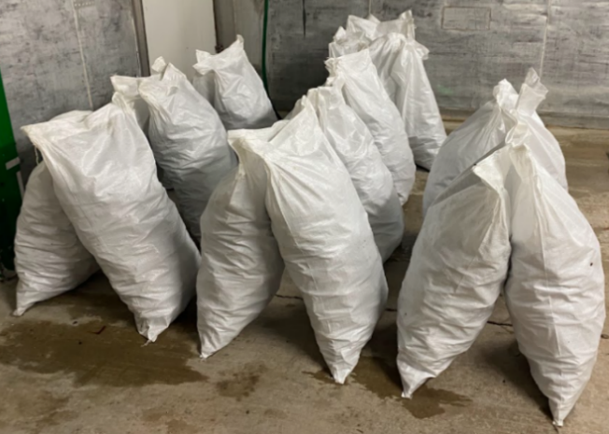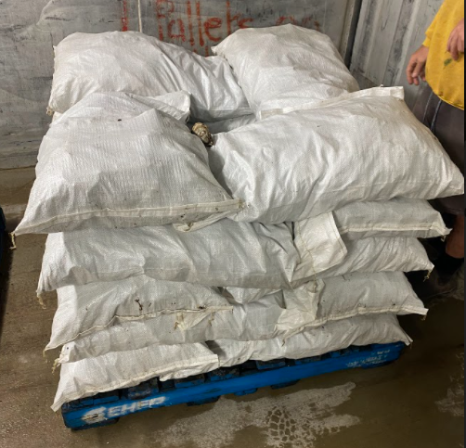

Oyster Chilling Validation Table
HARVEST DATE |  | / / |  | OYSTER TEMP |  | WATER TEMP |  | AIR TEMP
HARVEST TIME |  |  |  | °C |  | °C |  | °C
UNDER COVER TIME
 | TIME INTO CHILLER |  | OYSTER TEMP |  | CHILLER TEMP |  | COMMENT
INITIAL |  |  | °C |  | °C
1HR |  |  | °C |  | °C
2HR |  |  | °C |  | °C
3HR |  |  | °C |  | °C
4HR |  |  | °C |  | °C
5HR |  |  | °C |  | °C
6HR |  |  | °C |  | °C
7HR |  |  | °C |  | °C
8HR |  |  | °C |  | °C
9HR |  |  | °C |  | °C
10HR |  |  | °C |  | °C
11HR |  |  | °C |  | °C
12HR |  |  | °C |  | °C
13HR |  |  | °C |  | °C
14HR |  |  | °C |  | °C
15HR |  |  | °C |  | °C
16HR |  |  | °C |  | °C
17HR |  |  | °C |  | °C
18HR |  |  | °C |  | °C
19HR |  |  | °C |  | °C
20HR |  |  | °C |  | °C
21HR |  |  | °C |  | °C
22HR |  |  | °C |  | °C
23HR |  |  | °C |  | °C
24HR |  |  | °C |  | °C
DESPATCH  TIME  DATE |  |  | °C |  | °C

