Southern Coastal Research Vessel Fleet

Application Number (auto generated)
Application Form

Applicant
Lead Principal Investigator

Application Form
Fully funded grants of sea time of up to 14 days per voyage are available from January 2027 to June 2028 on vessels in the Southern Coastal Research Vessel Fleet through the NCRIS-funded project, Southern Coastal Research Vessel Fleet, supported by the Department of Education (DESE).

In this round funded sea time is also available for one voyage across northern Australia on the RV Solander, the Australian Institute of Marine Science’s 35 m research vessel, with several predefined voyage options available, each with fixed timing and destination:

Gulf of Carpentaria (voyages between Queensland and Northern Territory)
- 3 days of science time added to a transit voyage. Voyages depart from/arrive at Cairns, Cooktown, Thursday Island or Darwin, scheduled for March/April 2027, September/October 2027, or March/April 2028.

Joseph Bonapart Gulf (voyages between Northern Territory and Western Australia)
- 3-days of science time added to a transit voyage. Voyages depart/arrive from Darwin or Broome, scheduled for March/April 2027, September/October 2027, or March/April 2028.

Please note:
Each voyage includes a transit component as the RV Solander is being moved between states. Successful applicants will have 3 days of dedicated science time, but the total voyage duration may be up to 10 days to allow for transit. The location of the science component may also be limited by how far the vessel can travel from its transit route and return within the available time. As a result, voyages to the base of the gulfs cannot be supported due to the additional steaming time required.

Available sea time
Please note that this call covers 18 months of available sea time. Funded sea time does not include vessel transit to the agreed departure port. Sea time starts when researchers board the vessel at the agreed departure port and the voyage begins. Applicants should include the time needed to travel to the first sampling location and return to the arrival port within their requested sea time.

There will be approximately 60 days of sea time available across SCRVF vessels, in addition to 3 dedicated science days available on one voyage aboard the RV Solander, to support this funding call.
Multiple applications for funded sea time will be supported. Applicants may indicate a vessel preference in the application form (if they have one); however, for voyages operating in southern Australia, vessels will be assigned by the review committee, depending on availability and suitability. For voyages operating in northern Australia, RV Solander is the only vessel option.

The Southern Coastal Research Vessel Fleet (SCRVF) is a partnership between the South Australian Research and Development Institute (SARDI) and the Department of Primary Industries and Regional Development (DPIRD), with funding from the National Collaborative Research Infrastructure Strategy (NCRIS) and support from the CSIRO Marine National Facility (MNF), to provide the marine research community with better access to coastal research vessels in southern Australia.

For any enquires please contact:
Jane Ham (SARDI)
Email: PIRSA.SCRVF@sa.gov.au

Acknowledgement of Traditional Owners and Country

The SCRVF acknowledges the Traditional Owners of the lands and seas that we live and work on across Australia and pays respect to their Elders past and present. We honour and celebrate the spiritual, cultural and customary connections of Traditional Owners to Country and its surrounding seas and oceans.

Project contacts

Applicant
Please check your details. You can change your details in 'My Profile' on the main page.
Full Name:
Organisation:
Are you the Lead Principal Investigator?
Yes / No

Lead Principal Investigator
Name:
Organisation:

Privacy Statement
Your privacy: SCRVF and CSIRO are committed to your privacy and will use your personal information in accordance with the Privacy Act 1988 (Cth). By filling out and submitting this application, you consent to the collection of this information by SCRVF and CSIRO. SCRVF and CSIRO will collect and use this information for the purpose of assessing your application for sea time, associated communications, and for the purpose of voyage planning. The information may be provided to assessment and governance committees, external reviewers, MNF and SCRVF staff.

If you have any questions or if you would like to access your personal information held by CSIRO in relation to this application, please contact us at privacy@csiro.au. For further information about CSIRO’s privacy policy, see http://www.csiro.au/en/Privacy.aspx.

Project summary

Research stream
A definition of the four different research streams available is listed on the PIRSA website.
Only one Stream per project can be selected. Researchers applying for sea time with the Southern Coastal Research Vessel Fleet must select the application Stream that applies to their project. If you believe your project could fit under more than one Stream, you must select the most appropriate Stream, given the Stream objectives and definitions provided here.

Stream 1. Policy-driven research. To address critical policy needs for Australia.

Stream 2. Discipline-driven research. To advance scientific knowledge and promote Australia’s science excellence.

Stream 3. Strategic partnerships. To support publicly funded national programs that rely on Marine National Facilities capabilities.

Stream 4. Technology and innovation. To promote development and innovation in marine research and industry technology.

Project title
Please provide a short descriptive title for your project (including the area in which you intend to work if applicable). Avoid the use of acronyms and quotation marks and minimise the use of uppercase characters.
This title is used to uniquely identify your voyage throughout the application.

Project abstract
In plain language, summarise the project objectives, methods, expected outcomes and their significance. In answering this question, please summarise in 400 words or less:
- What do you propose to do, how you propose to do if, and why
- What outputs are desired to answer specific questions
- How has the project been co-conceived with next-and/or end-users?
- Was engagement with Aboriginal and Torres Strait Island peoples and communities considered, if so, how?
- What are the expected outcomes and impacts of the research?

Project timelines
When is the overall project expected to conclude?
When do you expect to commence publishing research outputs relating to the research conducted on this voyage?

Research classification
Please provide an Australian and New Zealand Standard Research Classification (ANZSRC) Fields of Research (FoR) code.
These are a set of categorisations developed for use in the measurement and analysis of research statistics in Australia and New Zealand.
Please provide at least one ANZSRC FoR for your project. You can add up to three research classifications per application via the ‘look up’ button [only available online].

Long-term projects
Is this project likely to seek to undertake voyages in future years (for example to obtain long-term datasets or to maintain / collect equipment deployed on an initial voyage)?
Yes / No

If so, how many additional voyages are linked to this project and what is the key purpose of the additional voyages? Please note that is for information only. At this stage, multi-year applications are not available on the Southern Coastal Research Vessel Fleet.

Application history
Has this application, or very similar, been submitted for consideration in a previous year?
Yes / No

Linked applications
In which year(s) did you apply, what was the application’s title(s), and what was the outcome(s) (successful or unsuccessful)?

Related projects
Is this application part of a larger national or international study that will involve coordinating your project with other groups?
Yes / No

If so, briefly provide details.

Funding
Does your proposed research rely on funding, in-kind support or any other dependency within the time period applied for?
Source Name:
Amount:
Secured (Y/N):
If not yet secured, expected announcement date:

Acknowledgement Compliance
If you have previously participated in a voyage onboard a vessel in the Southern Coastal Research Vessel Fleet, your demonstration of compliance with the SCRVF Acknowledgement requirements and completion of the SCRVF Post Voyage Report, including voyage photos, metadata and feedback forms, will be used as part of the assessment process.
Have you participated on a voyage or voyages on a vessel in the SCRVF?
Yes / No
If you answered Yes, please identify previous voyages (for example: SCF2026_NG_V01 – if known).
Research Quality

Assessment criteria

Applications for sea time onboard the Southern Coastal Research Vessel Fleet are assessed against criteria under two merit principles: Research Quality and Research Benefit.

The feasibility of your research application will be assessed by the Southern Coastal Research Vessel Fleet Operations Working Group.

Research delivered is expected to be of the highest research quality and offer the greatest national benefit.

Merit Principle: Research Quality

Supported research should have a robust disciplinary rationale, clear and appropriate objectives, sound methods, demonstrable feasibility, the prospect of informative results, and be being done by people with appropriate expertise.
This merit principle will be independently assessed by members of the CSIRO Marine National Facility Research Advisory Committee (RAC). RAC membership is comprised of marine research experts from diverse backgrounds.
For further information about the RAC’s role, membership, and Terms of Reference visit link.

RQ1 - Research Concept

Please outline your research objective, rationale, methodology and expected outcomes.
In answering this question, you should:
- Clearly identify your objective – a statement of your hypotheses as your opening sentence is an excellent start.
- Explain the scientific reasons for doing this research - What scientific need does your project address and how has the project been developed to address that need (eg co-designers, input from stakeholders, etc).
- Outline the research approach, including sampling, experimental programmes and proposed analyses, that is robust and sufficient to meet project objectives.
- Articulate the project’s expected outcomes – ensure this discussion focusses on outcomes and not outputs.

Maximum: 1500 words

RQ2 - Research Execution

Please outline your research objective, rationale, methodology and expected outcomes.
Describe your voyage plan (including pre/post voyage activities) and the suitability of the project team to execute the plan.
In answering this question, you should:
- Outline your end-to-end project plan – include activities prior to, during and after the voyage.
- Demonstrate the efficient use of the resources involved – in particular, that the sea time portion of the project can be completed within the resource allocation (sea time and/or berths) and within the activities of the primary project.
- Provide evidence of research capability and research delivery for each team member (relative to opportunity). Attach up to date CV for the voyage leader and PIs.
- Demonstrate the execution of your project is robust and worthy through adherence to standards, use of best practice, new or innovative methods.

Maximum: 1500 words

Research benefit
Assessment criteria

Applications for sea time onboard the Southern Coastal Research Vessel Fleet are assessed against criteria under two merit principles: Research Quality and Research Benefit.

The feasibility of your research application will be assessed by the Southern Coastal Research Vessel Fleet Operations Working Group.

Research delivered is expected to be of the highest research quality and offer the greatest national benefit.

Merit Principle: Research Benefit

Supported research should align with national interests, be likely to deliver upon national needs, have a path to impact and the right team to deliver benefit to justify investment of SCRVF resources. This merit principle will be independently assessed by members of the National Benefit Advisory Committee (NBAC). NBAC membership is comprised of user groups including government, industry, and research institutes from diverse backgrounds.
For further information about the NBAC’s role, membership, and Terms of Reference visit link.

RB1 - Benefit Need

Demonstrate the project’s alignment with end-user needs and benefit for the nation.
In answering this question, you should:
- Open by stating the objectives of the research in the context of the benefits to be delivered – identify the need (policy, regulatory, innovation or industry) that the proposed research will address.
- Identify the stakeholders for the research including next- and end- users and how their needs have been factored into the delivery plan.
- Outline a plan for delivering the intended benefits to stakeholders.

Maximum: 1500 words

RB2 - Benefit Delivery
Articulate the pathway to impact for the project outcomes.
In answering this question, you should:
- Outline key engagement activities for promoting and assisting adoption of project outputs.
- Describe the consideration you have given to what effective delivery will look like.
- Provide evidence that the project team includes people with demonstrated capability to deliver benefits effectively to end-users.
- Articulate education, training and or capacity building activities incorporated to the project plan.

Maximum: 1500 words

Logistics

Proposed methods
Please detail your proposed methods for project activities at sea.
Where system deployments and/or other sampling activities are planned, please provide as much detail as possible in relation to timing, frequency, location etc.
Please note that any diving activities in Western Australian waters must comply with Workplace Health and Safety Regulations 2022. The lead organisation must provide suitably qualified staff and a dive policy that complies with this standard.
Any drone operations must be conducted by a licensed pilot and comply to Civil Aviation Safety Authority (CASA) standards.
Maximum: 1000 words

Vessel
Please explain your choice of preferred vessel. Please note that while preferences are considered when scheduling approved voyages, the vessel offered may be different to that selected.
Please select an option below regarding preferred vessel.
Please explain your choice of preferred vessel. Please note that while preferences are considered when scheduling approved voyages, the vessel offered may be different to that selected.
MRV Ngerin
RV Naturaliste
RV Djildjit Kaartadjiny
RV Linnaeus
RV Solander
Maximum: 100 words.

Requested days
Please indicate the number of days being requested, noting that the total number of days cannot exceed 14 days (excludes mobilisation and demobilisation).
Total sea time: sea time begins when the researchers board the vessel from the agreed port of departure and commence their voyage. The time required to get to the first sampling point and return to the port of arrival after sampling is completed needs to be included in the total sea time.

Total sea time

Maximum: 40 Words

Preferred sail dates
Please select the dates of your proposed voyage, up to a maximum of 14 days. Use the remarks section to explain the choice of preferred sail dates and reasoning for any restrictions.
Note: while preferred sail dates are considered when scheduling approved voyages, offered sea time may fall outside of these dates.
Add as many as necessary
Start: XXXX End: XXXX

Dates Not Possible to Conduct the Science
Some research is time or season dependent, so it is important that any constraints on when the research is carried out are clearly indicated. If no constraints leave blank.
Start: XXXX End: XXXX
Briefly provide details (Maximum: 100 words)

Voyage location
Please define your preferred port of mobilisation and demobilisation. Give a short reason on your choice.
Preferred port of mobilisation:
Reason (Maximum 20 words)

Preferred port of demobilisation:
Reason (Maximum 20 words)

Please draw the voyage location on the map below. You can draw an area or transect or select single sampling stations.

Please contact PIRSA.SCRVF@sa.gov.au if you wish to upload a voyage plan separately.

Voyage Analysis

Below is a visual summary of your proposed voyage and shows the EEZ and Marine Parks. You can view additional map layers. No other action is required on this page.
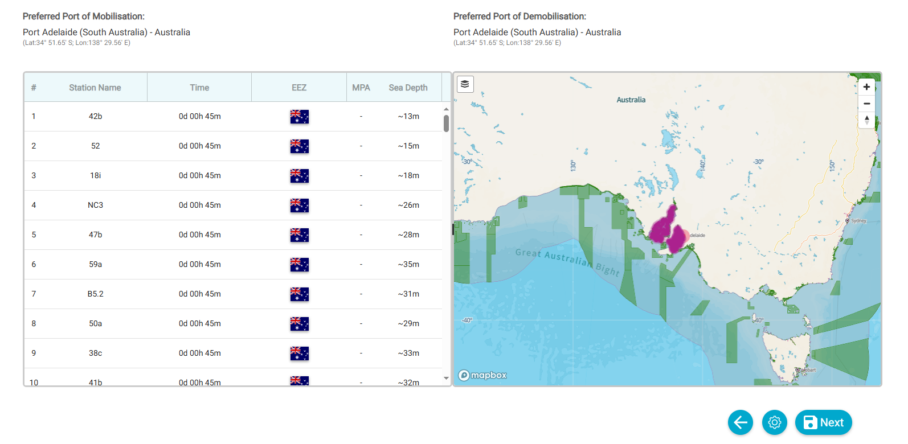
Visual analysis as referred to above.

Exclusive Economic Zones
Country | EEZ Name | Stations
Australia | Australian Exclusive Economic Zone | Research Area
 | Australian Exclusive Economic Zone | Sampling Station
 | Australian Exclusive Economic Zone | Research Area - 2
 | Australian Exclusive Economic Zone | Sampling Station -2
 | Australian Exclusive Economic Zone | Sampling Station - 3
 | Australian Exclusive Economic Zone | Sampling Station - 4
 | Australian Exclusive Economic Zone | ROV

Marine Protected Areas
MPA | MPA Regions | Stations
Cape Le Grand | National Park | Research Area

Southern Coastal Research Vessel Fleet supplied equipment

Available Equipment

Please note that the core research platform (RV Naturaliste or MRV Ngerin) is provided with the following capability:
RV Naturaliste | MRV Ngerin
- 1,100nm range between refuelling  - Surveyed for 200nm from mainland  - Length 22.6m  - Beam 6.88m  - Draft 3.5m  - Displacement 200tonne  - Desalination and provisions for around 14 days at sea  - 5 crew and 6 scientific personnel for overnight  - 5 crew and 11 scientific personnel for single day voyages  - Laundry facilities | - Length 24.80 m  - Beam 7.17 m  - Draft 3.26 m  - Displacement 122.8 tonne  - Fuel 27,916 litres  - Survey USL 2B  - Engine Cummins 316 Kilowatts (KW)  - Range 3200 Nautical Miles (NM)  - Speed 8.0 Knots  - 3,200 nm range between refuelling  - Surveyed for 200nm from mainland  - 24-hour operations  - Desalination and provisions for around 14 days at sea  - 4 Crew and 10 Scientific personnel for overnight voyages
Capabilities | Capabilities
- Trawling booms and winches for 2 x 8 fathom nets (nets/sleds not included)  - Single stern trawl capacity  - Longline winch  - Pot winch capable of pulling BRUV’s/fishing/lobster traps  - 1 tonne crane on bow  - A-Frame on stern for deploying and retrieving heavy research/mooring equipment  - 2kw and 1kw transducer  - Olex 3D depth/substrate mapping system  - C-Plot and TimeZero navigation systems  - Refuelling capabilities to support multiple smaller vessels  - Multiple hydraulic attachment points  - VSAT satellite data connection with Wi-Fi  - 4.8m tender with a 5nm survey for 4 personnel  - Freezer and cool room capacity  - Live/chiller tank (500L)  - Wet Lab with independent navigation system | - C-Plot and TimeZero navigation systems  - 3kw Transducer  - A-Frame on Starboard side for deploying and retrieving research/mooring equipment  - 10 Ton Crane  - Longline winch  - Multiple hydraulic attachment points  - Trawling booms and winches for 2 x 8 fathom nets  - 4.8m tender with a 5nm survey for 4 personnel  - Refuelling capabilities to support multiple smaller vessels
Please note additional scientific/fishing equipment is subject to availability and there may be a hire fee associated with some equipment. Please select additional equipment below. Applicants are encouraged to make contact to discuss equipment needs prior to submitting applications.

MRV Ngerin
Equipment Name
  - Long Line Winch
  - Gillnet Drum and Winch
  - Fish Traps (4 x large)
  - Trawls Nets & Trawl Doors
  - Rigid A Frame
  - Gill Nets (Various)
RV Naturaliste
Equipment Name
  - Line Reel
  - Twin Drum Winch
  - Trawl Nets
  - Fish Traps

User Supplied Equipment

Please add all third party (non-SCRVF) equipment that is critical for you to bring to the ship.

The SCRVF takes safety very seriously.
If you intend to incorporate user supplied equipment, please contact us before submitting your application to discuss your equipment.
Please ensure that any user supplied equipment is safe and fit for purpose. All power leads are to be tagged and tested. User to provide specifications and information on power requirements and connections. All equipment is to be approved by the Ships Master or Engineer prior to use.
If unable to meet the requirements, SCRVF reserve the right not to approve the equipment for use on the science voyage.

Name | Type | Est. value AUD$ | Serial Number | Barcode | Links

Science Team
Estimate number of people in each of the following categories. Please note that maximum number of berths available (excluding crew) is 10 berths for MRV Ngerin and 6 berths for RV Naturaliste.
- Principal investigators
- Students
- Project staff
- Specialist Technicians
- Other

If you have any additional comments please include below (maximum: 200 words).
Text box: Maximum 200 words.

Principal Investigators
Only enter details of PI’s that have indicated their agreement to commit to the project if successful.
Title | Name | Surname | Email | Organisation | ORC ID | Days committing to project | On voyage

Compliance and authorisation
I acknowledge by submission of my application that I have read and understood the SCRVF Data and Sample Management Policy requirements and agree to be bound and represent that my organisation (if relevant) agrees to be bound by the terms set forth in those documents if my application is successful. It is further understood and agreed by myself and my organisation that no changes or amendments to the terms of the project agreements or policies will be considered if my application is successful.
I declare that:
- the project research agency and any other agencies integral to the success of this research supports this application
If successful in being awarded sea time, I acknowledge and accept:
- the project will be bound by the requirements of related SCRVF policies, including the SCRVF Data and Samples Management Policy
- the grant of sea time is to be acknowledged in all project outputs as prescribed
- the DOI for all project outputs is provided to the SCRVF as soon as possible after their publication
- all voyage media and public information activities are to be conducted in collaboration with the relevant SCRVF state government departments (i.e. the Department of Primary Industries and Regions South Australia (PIRSA) Communications or Department of Primary Industries and Regional Development Western Australia (DPIRD) and voyage partners
- responsibility to submit a Post Voyage Report, metadata, feedback, and updates on the outcomes of the project as requested by SCRVF.
I have read and agree to the Compliance and Authorisation statement.
Irrespective of the outcome of this application, applicants may be invited to respond to surveys for the purposes of continual improvement and research.
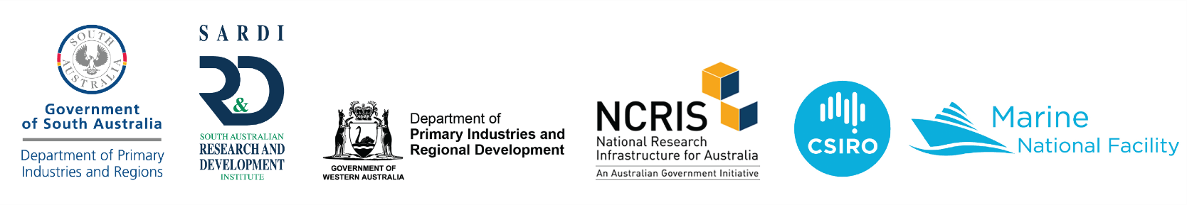
Last updated: 19 June 2026

