eCatch Quick Reference Guide for Fish Processors
This guide provides a quick reference tool to assist Fish Processors to meet their obligations in relation to the submission of eCatch records for the purchase, transfer or sale of Rock Lobster from the Southern Zone Rock Lobster Fishery.
The requirements for registered Fish Processors in relation to immediately completing and submitting eCatch records for any purchase, transfer or sale of Rock Lobster are set out in Regulation 15 of the Fisheries Management (Fish Processors) Regulations 2017 and the Minister’s Determination.
The following will assist you to meet your obligations under the Fisheries Management Act 2007.

In this guide
- Reporting to eCatch
- Purchasing Southern Zone (SZ) Rock Lobster
- Accepting a sale from another fish processor
- Transferring SZ Rock Lobster between premises
- How to respond to an error message
Please note: Required fields are marked with *

Reporting to eCatch
To report your SZ Rock Lobster purchases, sales and transfers:
- Log into eCatch at www.pir.sa.gov.au/ecatch or
- Call 1800 eCatch (1800 322 824).

Purchasing SZ Rock Lobster
From the ‘Processor Dashboard – SZ Rock lobster’ locate the TripID and select ‘Submit’
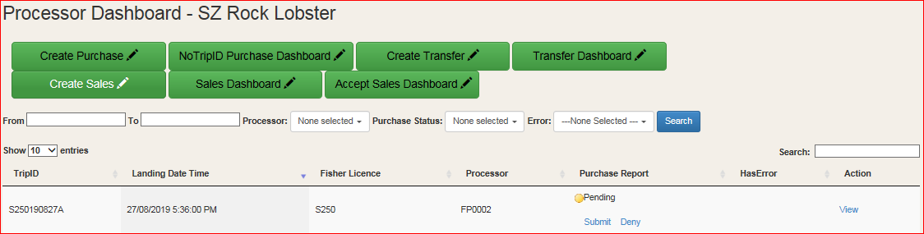

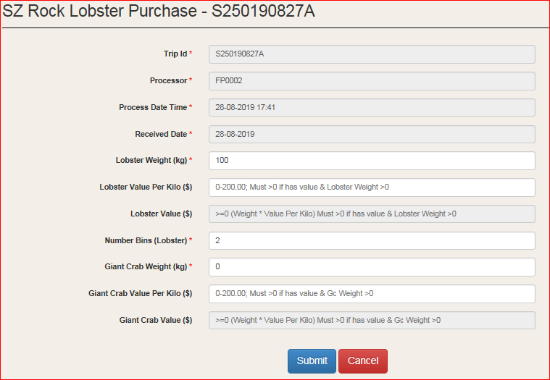
Check the information entered is correct, then select ‘Submit’

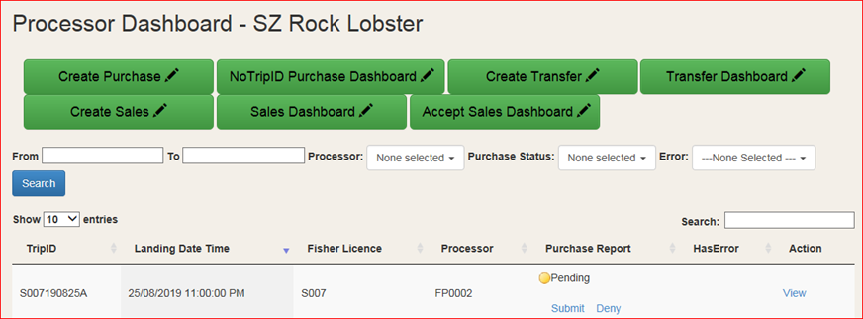
If you receive a consignment from a fisher in error, from the ‘Processor Dashboard – SZ Rock Lobster’ locate the TripID and select ‘Deny’
If you have not received a notification to accept consignment prior to the fisher departing the registered factory or vehicle, a Purchase Report must be created.
From the ‘Processor Dashboard – SZ Rock Lobster’, select ‘Create Purchase’
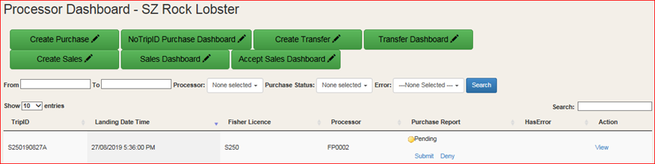
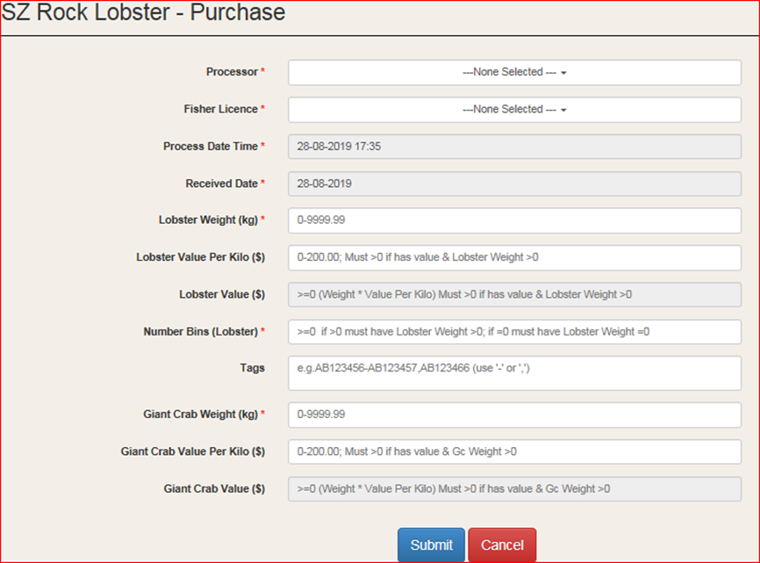
Complete the required fields, then select ‘Submit’

Selling SZ Rock Lobster
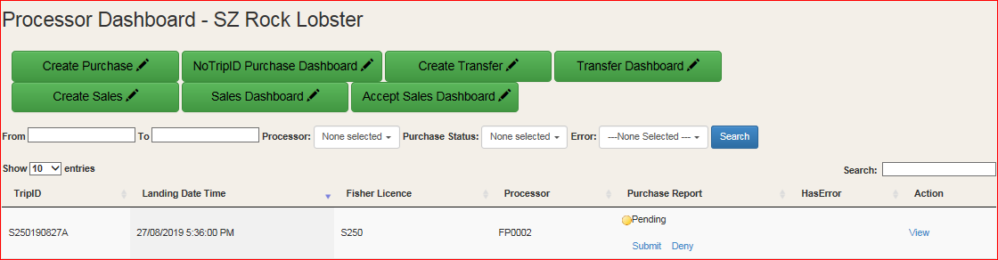
Weigh the SZ Rock Lobster and complete ‘Create Sales’ report
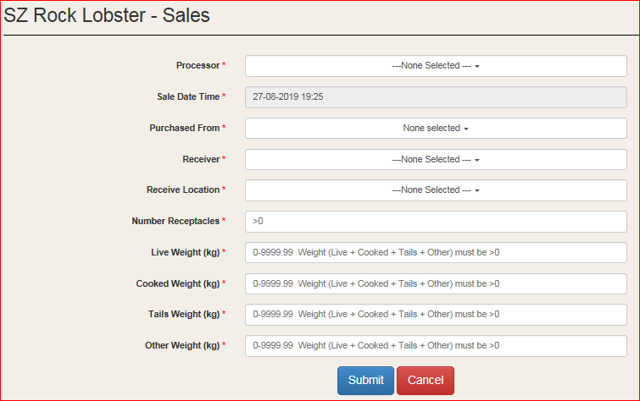
Complete the required fields, then select ‘Submit’

Accepting a sale from another fish processor
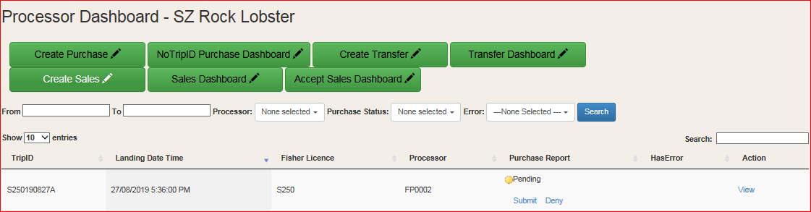
Select ‘Accept Sales Dashboard’ located on the ‘Processor Dashboard – SZ Rock Lobster’
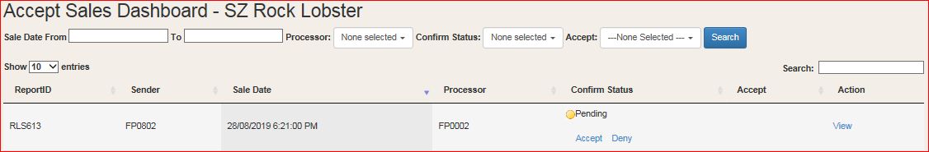
Select ‘View’ located on the ‘Accept Sales Dashboard – SZ Rock Lobster’ and check details are correct
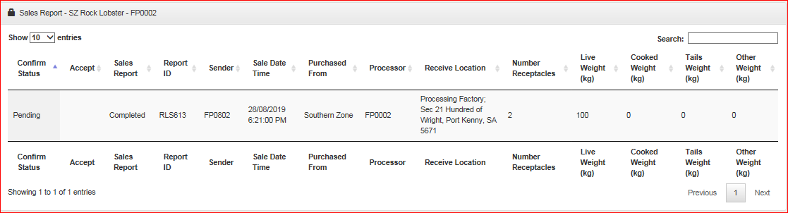
Select ‘Accept’ located on the ‘Accept Sales Dashboard – SZ Rock Lobster’ to confirm receipt of the SZ Rock Lobster

Transferring SZ Rock Lobster between premises (internal only)
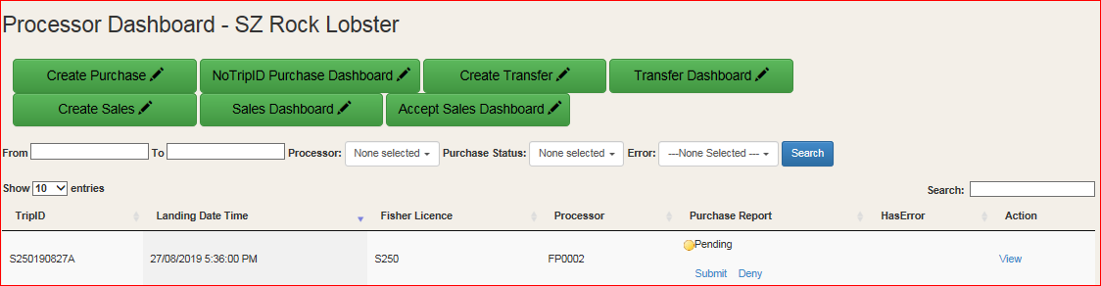
Select ‘Create Transfer’ from the ‘Processor Dashboard – SZ Rock Lobster’
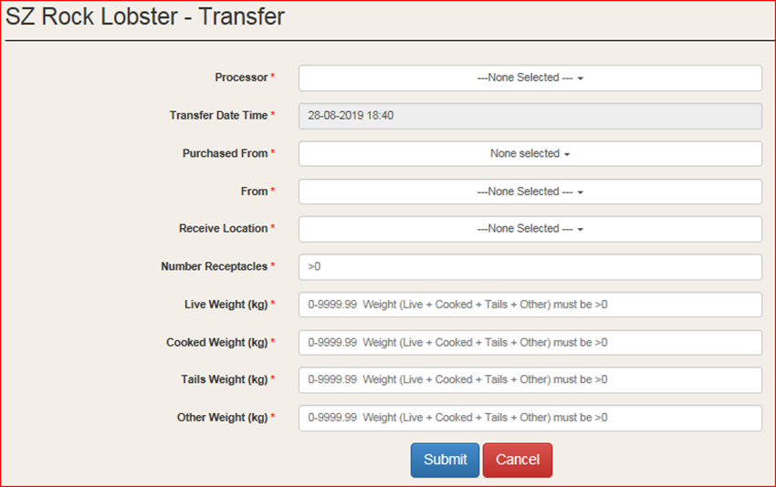
Immediately weigh the SZ Rock Lobster and complete a ‘Create Transfer’ report, select ‘Submit’ to finalise transfer

How to respond to an error message (inaccurate details)
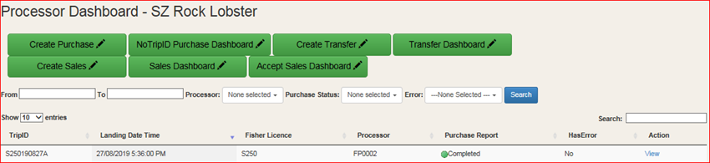
From ‘Processor Dashboard – SZ Rock Lobster’ locate the TripID and select ‘View’

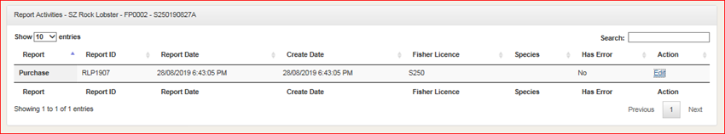
Select ‘Edit’
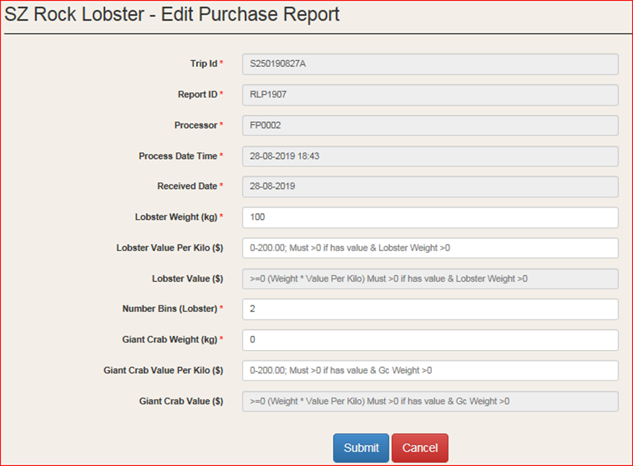
After amending the error select ‘Submit’

More information
For more information about myPIRSA or eCatch, please contact:
- Your local PIRSA Fisheries Officer or
- Fishwatch via 1800 eCatch (1800 322 824).

